UN-Spain MDG Achievement Fund Initiated Joint Programme on Protecting and Promoting the Rights of China’s Vulnerable Young Migrants
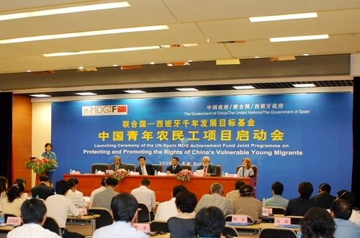
19 May 2009, Beijing -- The United Nations System Resident Coordinator for China, Khalid Malik, together with His Excellencies Vice Minister Wang Xiaochu from the Ministry of Human Resource and Social Security (MoHRSS), Vice Minister Yi Xiaozhun from the Ministry of Commerce and the Spanish Ambassador Mr Carlos Blasco Villa launched today a joint programme on Protecting and Promoting the Rights of China’s Vulnerable Young Migrants.
China’s domestic migrant workforce of approximately 150 million represents the largest movement of people in modern history. Many young migrants end up in poor working and living conditions. Their vulnerability is compounded by a lack of access to social protection and social exclusion.
The Chinese government attaches great importance to the protection of the rights and interests of this group. China’s vision of building a harmonious, xiaokang society places a high priority on addressing the inequalities between the urban, rural and migrant populations. In recent years, a series of new laws and policies have been promulgated and implemented to improve migrant workers’ access to equal labour rights, civil rights, basic public services, and social security.
However, the sheer scale and complexity of the challenge means that progress remains gradual, uneven, and experimental. Further rights-based interventions are needed to accelerate the implementation of the new policies, legislation and programmes. To do so, China is looking to the UN for a diverse, cross-sectoral range of international expertise and good practices to demonstrate an integrated rights-based approach to protecting the rights and interests of migrants.
The UN - Spain MDG Achievement Fund joint programme on Protecting and Promoting the Rights of China’s Vulnerable Young Migrants thus brings together nine UN Agencies (ILO, UNDP, UNESCO, UNFPA, UNICEF, UNIFEM, WHO, UNIDO, UNV) in close coordination and partnership with over twenty government counterparts (including the Ministry of Commerce, Ministry of Human Resources and Social Security, National Development and Reform Commission, Ministry of Public Security, Ministry of Health, Ministry of Civil Affairs, etc.) and civil society.
This Joint Programme has three main aims: first, to improve policy frameworks and policy implementation, with full stakeholder participation. This will be achieved by developing a platform for migration research information exchange and strengthening advocacy and capacity building among key stakeholders. This will also support the testing of policy implementations through piloting of models involving participations of migrants in policy dialogue through civil society organizations.
The second aim is to promote better access to decent work for vulnerable young people through pre-employment education and training. This will be achieved by improving access to non-formal education and vocational training in order to prevent premature entry to the labour force, increase decent work opportunities and promote self-employment. A comprehensive safe migration information and life-skills training package will be developed and delivered in pilot areas.
The third aim is to protect the rights of vulnerable young migrants through improved access to social and labour protection. This will be achieved by promoting registration system for migrant children under the age of 16, establishing model community service centers in pilot cities to provide comprehensive services, promoting use of appropriate health services by migrant youth, and strengthening implementation and enforcement of existing legislation for migrant workers.
The Joint Programme provides an unprecedented opportunity to ensure that the response to the largest movement of people in modern times is rights-based, poverty-focused, and fully informed by international good practice in China. It is also a significant step forward in the continuing process of UN reform to “deliver as one” at country level.
For more information please contact:
Yi DONG, Ms.
Interim UN Joint Programme Coordinator
Beijing, China
Tel.: +86 (010) 8466 1107
Email: yi.dong@undp.org

