***Baseline Investigation of Horticulture Value Chain in Upper Egypt***

***Final Report***

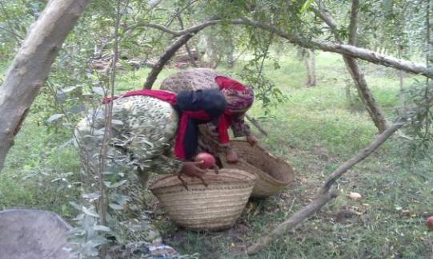

**Presented to**

*The United Nations Development Programme*

*(UNDP)*

**Presented by**



Entrust Development &

Management Consultants

*May 2011*

Research Team

|  |  |
| --- | --- |
| **Technical Team** | **Researchers** |
| **Khaled Hassanein**  Agronomist/Horticulture Specialist | **Lamia Bulbul**  Senior Researcher/Gender Expert |
| **Ussama El Rouby**  Agronomist/Post-harvest Specialist | **Khaled Abdel Fatah**  Senior Researcher |
| **Muhammad El Khouly**  Institutional Development Specialist | **Adel Shaaban**  Senior Researcher |
|  | **Christiane Wissa**  Statistician |
|  | **Ghadi El Helaly**  Junior Researcher |
| **Tamer El-Meehy**  Team Leader | |
|  | |
|  | |

List of Acronyms

|  |  |
| --- | --- |
| GDP | *Gross Domestics Product* |
| GOE | *Government of Egypt* |
| TOR | *Terms of Reference* |
| PHC | *Post-harvest Center* |
| FA | *Farmer Association* |
| HDI | *Human Development Index* |
| UNIDO | United Nations Industrial Development Organization |
| ETRACE | Egyptian Traceability Centre for Agro-Industrial Exports |
| USAID | *United States Agency for International Development* |
| ACDI/VOCA | *Agricultural Cooperative Development International and Volunteers in Overseas Cooperative Assistance* |
| AERI | *Agricultural Exports and Rural Incomes* |
| HEIA | [*Horticultural Export Improvement Association*](http://www.heia.org.eg/) |
| RPT | *Refrigerated Perishables Terminal* |
| MOU | Memorandum of Understanding |
| MALR | Ministry of Agriculture and Land Reclamation- Egypt |
| MDG | Millennium Development Goals |
| ICT techniques | [Information Communications Technology](http://www.google.com.eg/url?sa=t&source=web&cd=5&ved=0CDUQFjAE&url=http%3A%2F%2Fshop.bsigroup.com%2Fen%2FBrowse-by-Subject%2FICT%2F%3Ft%3Dr&ei=MzKUTbPWGO6z0QGd5pjlCw&usg=AFQjCNHlKsqpYqDt3tp6m02wmONNEThnFg&sig2=ionlwNnkgbqOJPOuSA854Q) |
| NGO | Non-governmental organization |
| CAPMAS | Central Agency for Public Mobilization And Statistics- Egypt |
| FGD | *Focus Group Discussion* |
| ISO | *International Organization for Standardization* |
| CASP | *Central Administration for Seed Production* |
| CDA | *Community Development Association* |
| UPEHC | *Union of Producer and Exporters of Horticulture Crops* |
| VCA | *Value Chain Analysis* |
| PBDAC | *Principle Bank for Development and Agriculture Credit* |
| SFD | Social Fund for Development |
| UNOPS | United Nations Office for Project Services |
| NRC | *National Research Center* |
| ARC | *Agricultural Research Center* |
| BRC standards | British Retail Consortium |
| ISO | *International Organization for Standardization,* |
| HACCP | Hazard Analysis Critical Control Point |
| TSS | Toxic Shock Syndrome |
| GM | *General Manager* |
| GMP | *Good Manufacturing Practices* |
| PNA | *Participatory Needs Assessment* |

# Executive Summary

The “pro poor Horticulture Chain in Upper Egypt project” is a joint programme between specialized agencies and entities of the United Nations working in collaboration with national counterparts. The overall objective of the project is to enhance the efficiency and productivity of Upper Egypt’s male and female small farmers and agricultural workers, and also to build the capacity of small Farmers’ Associations (FAs). Entrust was commissioned to carry out a baseline investigation of horticulture value chain in Upper Egypt, aiming at providing a better understanding of small farmers’ situation and conducting a comprehensive gap assessment of the local Farmers Associations and PHCs.

The baseline investigation was carried out in six governorates in Upper Egypt; Sohag, Minya, Bani Suef, Assiut, Luxor, and Qena, during the period between October 2010 and January 2011. The investigation combined quantitative and qualitative data collection techniques.

**Key findings**

The findings of the baseline investigation were organized in accordance with the stages identified in the mapping of the horticulture value chain. These are: input supply, production, harvesting and post-harvesting and marketing. The analysis paid special attention to the relationships between various actors and small farmers.

**Inputs supply**

* The main problems that inputs suppliers encounter in their work are related to inadequate infrastructure, and inability to respond to growing demand among farmers.
* Farmers mistrust suppliers because they sell low quality inputs for higher prices
* The existence of an active FA help farmers to overcome their problems with inputs suppliers, particularly female farmers.

**Farms & production**

* The main problems facing the farmers & workers are related to the production inefficiencies due to farmers & workers’ lack of expertise and technology in land preparation and crop management; High costs of input supplies; lack of sufficient extension services, market information, labor training, source of finance, and trust in written contracts due to the Egyptian judicial system; rudimentary infrastructure; low wages and limited work opportunities; in addition to the rigid gender division of labor.

**Institutional capacity assessment**

* Farmers’ Association falls under the “Developing Stage”, as they lack leadership, assessment of performance, proper financial recording systems and independent audits or external financial reviews. The research team recommended a number of FAs to serve as partners of the project.
* As for the PHCs their infrastructure is good but there is a need for developments, maintenance and some constructions that are yet to be completed so as to meet requirements of international standards and customers.

**Marketing & market Channels**

* Long-term and strong relationship exists between farmers and trader; as they serve as the main source of market information, and financial support.
* The challenges faced by exporters including: unpredictable variance in crop price, inadequate infrastructure, lack of the quality standards and control systems applied either among farmers or in PHCs.
* Food processing companies are more likely to work in an area where technical support and efficient extension services are being provided to farmers.
* For supermarkets, sourcing horticulture crops from Upper Egypt is an advantage to secure continuous supplies all over the year. However, agreeing on the crop specifications (quality) and price remains the main problem in dealing with farmers/traders.
* Lack of a master plan for agricultural investment, the insufficient incentives for investors, lack of extension training services, insufficient infrastructure, lack of market information, and unidentified investment zones are factors that hinder investors to work in the horticulture sector in Upper-Egypt.
* All the actors interviewed; expressed their willingness to work with farmers in Upper Egypt farmers provided that that they receive the required training on the administrative and marketing.

**Key Recommendations**

***FAs***

* Conduct a comprehensive capacity building program for farmers associations according to their needs to include:
* Establish an agriculture extension department
* Establish legal department to provide legal support on contracting

***Farmers***

* Develop and deliver a scientifically-based integrated training and extension program covering all stages of agricultural production, harvesting and post-harvesting processes, with specific attention to the seven crops identified in the study.
* Problems with high cost, unavailability and low quality of supplies can be tackled through active involvement of the farmer’s associations by collective purchase of input supplies from trustworthy sources, thus assuring the quality and reducing the final cost to the small farmers.
* Conducting joint orientation/training sessions with exporters, input suppliers, traders, food processors, supermarkets …etc.

***Marketing***

* Improve the market information delivery and dissemination by developing a user-friendly marketing information system and packaging collected information into extension messages on economic returns, where to sell and quality control.
* Providing training and orientation sessions to farmers on marketing of horticulture products and quality standards of different buyers.

***Policy measures***

1. ‏Government should play a stricter supervisory role in the input supply system
2. ‏Establish an arbitration system for settling disputes between farmer associations and exporters, as well as other buyers.
3. Develop a tax incentive package that encourages businesses to invest in cold chains for horticultural produce in Upper Egypt
4. Reconsider the application of the 15% export subsidies given to exporters.
5. Revise the law governing cooperatives in order to allow them more autonomy.

Table of Contents

Executive Summary 6

I. Introduction 13

1. Project Background 13

2. Purpose of the Report 14

3. Organization of the Report 14

II. Agriculture and Poverty: The Egyptian Context 15

1. Introduction 15

2. Horticulture in Upper Egypt 16

3. Assessment of Horticulture Projects in Upper Egypt 19

4. Agricultural Policies and Strategies 23

III. Methodology 27

1. The Study Sites: A profile 27

2. The Baseline Survey 29

3. The Institutional Capacity Assessment of FAs & PHCs 42

4. The In-depth Study 45

5. The Implementation Process 45

IV. Findings of the Baseline Investigation 46

1. Mapping the Value Chain 46

4. Institutional Capacity Assessment 88

5. Marketing & Market Channels 114

V. Conclusions & Recommendations 125

1. Summary of key findings 126

2. Recommendations 131

Appendices 138

List of Figures

Figure 1: Economic Growth Rates and Poverty Incidences between 1982- 2009 15

Figure 2: Distribution of the farmers & workers sample by governorates (%) 32

Figure 3: Distribution of workers’ sample by gender 33

Figure 4: Farmers distribution by age (%) 34

Figure 5: Distribution of Workers by age (%) 35

Figure 6: Workers Age by gender 36

Figure 7: Farmers educational level 36

Figure 8: Workers educational level 37

Figure 9: Farmers Housing conditions 37

Figure 10: Distribution of land ownership by size & governorate 38

Figure 11: Farmers’ average monthly income by governorate (%) 39

Figure 12: Contribution of agricultural activities to household income (%) 40

Figure 13: Workers Household monthly income 40

Figure 14: Average monthly wage by age and gender 41

Figure 15: Farmers type of debts 41

Figure 16: Workers type of debts 42

Figure 17: Horticulture Value Chain Diagram 48

Figure 18: Top five crops by cultivated area 54

Figure 19: Number of Farmers Cultivating the Top 5 Crops as First Crops 56

Figure 20: Share of costs items in average total crop cultivation per Feddan (%) 57

Figure 21: Farmers’ use of fertilizers by crop (%) 59

Figure 22: Use of fertilizers by size of landholding 60

Figure 23: Supervision of Technical operations (%) 61

Figure 24: Supervision of technical operations by land size 61

Figure 25: Supervision of Technical Operation – by Crop 62

Figure 26: Supervision of technical operations by governorate 63

Figure 27: Production-related problems 64

Figure 28: Production related problems by governorate 65

Figure 29: Use of machinery in agriculture operations 65

Figure 30: Employment related problems 66

Figure 31: Employment related problems by governorate 67

Figure 32: Harvesting & Post-harvest problems 68

Figure 33: Harvesting and post-harvest problems by governorate 68

Figure 34: Crop grading by governorate 69

Figure 35: Crop grading by crop 69

Figure 36: Packages used in harvesting by governorate 70

Figure 37: Material Used in Packaging by Crop 70

Figure 38: Place of packing by governorate 71

Figure 39: Sources of agriculture information trusted by farmers 71

Figure 40: Sources of agriculture information trusted by governorate 72

Figure 41: Source of trustworthy information: Small vs. Large Farms 73

Figure 42: Sources of farm and production finance 73

Figure 43: Farmers’ Needs 74

Figure 44: Distribution of workers by type of work 75

Figure 45: Distribution of Workers by Governorates and gender 76

Figure 46: Average Number of Working Days by Activity, Type of Labor and gender 77

Figure 47: Average wage by type of activity and gender 78

Figure 48: Work related problems 78

Figure 49: Determinants of wage levels 79

Figure 50: Problems encountered by female workers 85

Figure 51: Female workers health problems by governorate 85

Figure 52: How female workers situation can be improved 86

Figure 53: Decision making in farmers households 87

Figure 54: Decision making in workers households 87

Figure 55: impact of farmer’s membership in FAs on their profit by land size 93

Figure 56: impact of farmer’s membership in FAs on their profit by governorates 93

Figure 57: services provided for Farmers 94

Figure 58: Farmers assessment of FA services by Governorate 94

Figure 59: Farmers assessment of FA services by size of landholding 95

Figure 60: Shortcomings of the FAs 96

Figure 61: Farmers’ opinion regarding the transformation of FA by land size 96

Figure 62: Farmers’ opinion regarding the transformation of FA by governorate 97

Figure 63: Preferred Marketing Channels for Farmers (%) 115

Figure 64: Marketing related problems 115

Figure 65: Source of Market Information 117

Figure 66: Market & prices source of information- by governorate 118

Figure 67: the Five Main Crops Export Volume in 2009 119

List of Tables

Table 1: Distribution of survey sample by governorates & FAs 31

Table 2: Distribution of Farmers sample by governorate & gender 33

Table 3: Distribution of in-depth subsample by governorate and gender 34

Table 4: Workers household welfare index 39

Table 5: Farmers household welfare index 39

Table 6: Characteristics of FAs sample 43

Table 7: Main characteristics of the PHCs 44

Table 8: Inputs supply problems by governorate 52

Table 9: Inputs supply problems by size of landholding 52

Table 10: Average production of selected crops (Tons) 55

Table 11: Average Cost Breakdown of agriculture processes per Feddan by Crop (LE) 56

Table 12: Percentage of Farmers Using Various Fertilizers 58

Table 13: Farmers Needs by Governorates (%) 75

Table 14 : Basic Demographic Characteristics of Female Farmers &Workers 81

Table 15 Current Product by Governorate & Season 102

Table 16: Main Crops Export Volume in 2009(tons) 120

# Introduction

Agriculture continues to be a vital sector in the Egyptian economy. Although the contribution of agriculture has fallen for about 17% of GDP and 20% of total exports and foreign earning, it is still providing livelihood for 55% of the population and directly employing 30% of the labor force, and hence the fact that it is in rural Upper-Egypt, where agriculture sector contributes 40% of rural income.

Recently, more attention by government and international donors has been directed to agriculture sector in Upper Egypt. Such interest has accompanied the shift of the Egyptian economy towards export-oriented system in horticulture.

Many agribusiness projects have been implemented in Upper Egypt. The main reasons behind targeting these governorates are the widespread of deep poverty, high rates of illiteracy, and high unemployment in most rural communities. Moreover, Upper Egypt is an attractive region from which to source high-value produce because along the length of the Nile River Valley; from Giza to Aswan. Efforts have been exerted to develop the agricultural sector in Upper Egypt, yet with partial success.

## Project Background

The project document states that the aim of the “pro poor Horticulture Chain in Upper Egypt” is to enhance the efficiency and productivity of Upper Egypt’s small farmers and agricultural workers. Strong attention will be given to the capacity building of small farmers’ associations and to gender equality and women participation and their presence throughout the project. It is a joint project between specialized agencies and entities of the United Nations working in collaboration with national counterparts, namely the Ministry of Trade and Industry, Ministry of Investment, Ministry of International Cooperation, and Ministry of Foreign Affairs.

***Objectives of the project***

The joint progamme aims at accomplishing the following outcomes:

1. Small farmers and agriculture workers are more equitably integrated into domestic and international value/supply chains of horticulture products through enhanced efficiency, productivity and viable business partnerships with private sector investors.
2. Entrepreneurial forms of organization established by small farmers
3. Policy and regulatory changes to promote private sector-based growth in Upper Egypt’s horticultural sector identified and discussed with the GOE

To ensure that the programme is based on sound knowledge of small farmers’ situation on the ground and the existing challenges and opportunities, Entrust was commissioned to carry out a baseline investigation of horticulture value chain in Upper Egypt. Furthermore, the results of the baseline study will serve as a tool to trace and measure changes and consequently assess the impact of future interventions.

According to the Terms of Reference (TOR, the main objectives of the baseline investigation are:

1. Review available information and existing research with regard to horticulture value chain in Upper Egypt including relevant legislation and governorate development policies.
2. Conduct a comprehensive gap assessment of the local Farmers Associations and PHCs and identify 3 FACs and 3 PHCs to receive capacity development
3. Collect information in the field and conduct complementary assessments and analyses
4. Conduct Women Needs Assessment as farmers and workers

## Purpose of the Report

The current report presents the findings of baseline research study carried out during the period between October and December 2010 in six governorates identified in the TOR; Sohag, Minya, Bani Suef, Assiut, Luxor, and Qena. The investigation comprised three separate research studies. The first, a Farmers and Worker Baseline Survey; the second, an Institutional Capacity Assessment of the 17 Farmers Associations (FAs) and the three Pack House Centers (PHCs) located in Qena, Bani Suef and Minya; and the third, a qualitative study of a number of actors along the value chain including suppliers, traders, exporters, private businesses, and government officials.

## Organization of the Report

In addition to this introduction, the report consists of eight sections. Section II attempts to situate the study into its national context through a review of available literature on agriculture, poverty and horticulture in Egypt. The review will also assess the existing horticulture initiatives targeting small farmers in Upper Egypt. Section III outlines the methodology employed in carrying out the investigation including sampling and description of the samples. Section IV is devoted to the findings of the baseline investigation organized in accordance with the horticulture value chain map. Section 1 outlines the horticulture value chain map, section 2 focuses on agriculture inputs supply; section 3 examines the production stage presenting the findings of the farmers and workers baseline survey, section 4 addresses the processes related to harvesting and post-harvesting, special attention will be given to the results of the institutional capacity assessment of both FAs and the PHCs, and section 5is devoted to marketing stage. This section draws mainly on results of the in-depth interviews with selected actors along the chain. The last Section draws main conclusions and recommendation for future intervention.

Following the final section there are three appendices organized as follows: Appendix A reports the relevant baseline results to the results framework indicators. Appendix B includes the research instruments (baseline survey questionnaires and in-depth study guides). Appendix C provides basic information on the persons interviewed in the in-depth study. Appendix D includes a set of data tabulation.

# Agriculture and Poverty: The Egyptian Context

## Introduction

Egypt is the largest Arab country in the Middle East with population of 83 million in 2009[1]. In 2010, Egypt’s Human Development Index (HDI)[2] gives the country a rank of 101 out of 169 countries worldwide with comparable data.

Poverty, based on the national poverty line, has steadily risen since 2000 despite economic reforms and high rates of GDP growth since 2004, as shown in Figure 1. The economic crisis that hit the world economy in September 2008 led to a sharp decline in the economic growth rate for 2008/2009, thus reversing the trend of poverty reduction in that year (21.6 % of the population lived in poverty) and confirming that economic growth remains the strongest driver of poverty fall.

**Figure 1: Economic Growth Rates and Poverty Incidences between 1982- 2009**



Source: Ministry of Economic Development and the World Bank. The 2009 figure has been calculated based on HIECS 2008/09.

In Egypt, regional disparities in poverty incidences are significant. Poverty is mainly an agrarian phenomenon since nearly 77% of the total poor live in areas where the poverty rate is more than 2.5 times the corresponding rate in urban areas. Rural Upper Egypt is the most vulnerable region where the poverty incidence is almost doubles the national average, falling close to 40%[3]; While Upper Egypt represents 25% of the population, it has 66% of the extreme poor and almost 95% of the poorest villages.

Disparities are also noticeable between Governorates. While the overall national poverty rate was, estimated to be 19.6% in 2005; it increases to 32.5% in Upper Egypt and 39.1% in rural Upper Egypt in comparison to 14.5% in Lower Egypt and only 5.7% in urban governorates. Moreover, the poverty rate was the highest in Assiut (60.6%), followed by Bani Suef (45.4%) and Sohag (40.7%), whereas the corresponding figures in Suez, Damietta, and Cairo were 2.4, 2.6, and 4.6%, respectively.

Most governorates in Upper Egypt are characterized by high rates of illiteracy, school dropouts, infant mortality, underweight children, poor access to safe water and sanitation. Among the poor households, the female-headed households, which account for 20%, are the most disadvantaged. Recently, the government has directed its effort to these governorates. However, the accumulated deficits in Upper Egypt governorates entails more effort and public spending to catch up with Lower Egypt and to achieve similar levels of human development.

Agriculture can be a main engine for poverty reduction. Over one half of all movements out of poverty during 2005-2008 were accounted for by those employed in agriculture. In rural Upper Egypt the employment in the agriculture sector accounts for 63% of total employment and it contributes to 40% of rural income.

## Horticulture in Upper Egypt

Horticulture crops are produced in sufficient quantities to meet domestic demanded to provide some surplus for export. Vegetables are grown on about 560, 000 feddan and contribute 10.5% of the value of horticulture crops. The main vegetable crops are potatoes, tomatoes, watermelons, beans, peas, onions garlic, pepper, cucumbers, and leaf vegetables. Fruits crop is grown on approximately 0.4 million ha. The main fruit crops are citrus, grapes, mangoes, bananas, and olives.

Production is a major challenge in Upper Egypt, already hindered by the high degree of land fragmentation. With 65% of Upper Egypt's agriculture value coming from holdings less than 5 feddans in size, production is hindered by the high degree of land fragmentation. A recent study conducted by UNIDO's ETRACE (Egyptian Traceability Centre for Agro-Industrial Exports) programme revealed that the average plot size in Bani Suef was 1.1 feddans and in Minya and Qena 1.3 feddans[4]. This results in the loss of economies of scale, leading to higher production costs, inefficiencies and difficulties in marketing. Moreover, usually low yield and impure traditional varieties are used, thus reducing potential gains. In addition, the uncalculated use of fertilizers and pesticides (often fraudulent) results in economic inefficiencies as well as problems with quality and food safety, thus impeding exports. Furthermore, extension services are undeveloped and largely irrelevant to farmers' and market needs. Finally, Egyptian agriculture suffers from the failure to link research to production[5].

Due to the high fragmentation of the land, farmers lack market power and are thus unable to participate effectively in the governance of the supply chain. In addition, many growers suffer from insufficient information on the various links of the chain, thus adversely affecting their involvement in the governance of the supply chain. There is a general need for more transparency and available market information for producers in order to help them respond efficiently to changes in the market, reducing risks and increasing income. Input usage, including fertilizers, pesticides and water often relies on tradition and not on up-to-date extension services. This frequently causes inefficiencies and quality loss, and points to the need for effective training and technical assistance on production. Harvest and post-harvest treatments are also a major source of losses and inefficiencies in the horticultural supply chain[6].

While cropping patterns do not differ greatly across governorates, available literature suggests that there are specific horticultural crops that seem to benefit from some comparative advantages in each governorate. For example, in Bani Suef Onions and Garlic have comparative advantage benefiting from local processing. In Minya, potatoes production is visibly dominant and tomatoes cultivation is widely produced. The supply chains for both of these crops in Minya however are underdeveloped and suffer from significant post-harvest losses and. In the case of fruits however grapes are a main produce of Minya, with a relatively developed supply chain, including post-harvest treatments and export. Pomegranate production is widespread in Assiut, despite its remoteness and lack of infrastructure, especially post-harvest centers; which in turn hamper trade and increase post-harvest losses and waste. In Sohag, vegetable production, especially tomatoes, is dominant. Yet as is the case with Assiut, remoteness and lack of infrastructure are major obstacles. Qena’s horticultural production is also dominated by tomatoes, followed by eggplants. As for fruits, Bananas, Citrus and Mango are the most common. Luxor’s advantage of being a touristic governorate provides its farmers with great opportunities for marketing that are yet to be seized. In addition, the newly established perishable terminal at the airport creates potential for trade in agricultural products[7].

However, Upper Egypt’s advantages in production are more than offset by its disadvantages in market access, notably for perishable products that are highly sensitive to transport conditions. It is estimated that up to 20 percent of Upper Egypt’s hit and 40 percent of its vegetable products are lost in transport to the wholesaler. Poor post-harvest technologies and handling (e.g., proper cooling and packaging facilities) and transportation conditions are largely to blame-there are no functional fleets, for aged, poorly maintained fleet. This can be explained is by the high tariffs on imported repair parts, a highly fragmented market supply, and weak regulation and enforcement. It is estimated, for example, that the informal sector transports 80 percent of Egypt’s road freight. The fact that operating costs for trucks are 30-50 percent higher in Egypt than Lebanon and Jordan puts Egypt’s peripheral farms at a particular disadvantage”[8].On the other hand, the weakness of post-harvest marketing chains forces Upper Egyptian farmers to keep on growing low-value but easily marketed staple cereals, while their counterparts in Lower Egypt have been quicker to move into higher-value cropping[9].

Value Chains in Upper Egypt are somewhat complex with farmers having several options to market their produce. These include directly selling to consumers of local markets, to traders, go to auctions, and engage into contract farming or selling through farmers associations. Marketing patterns on the other hand seem to vary across crops. While tomatoes are sold through all of the above channels, potatoes are mainly sold through contract farming. Some products such as Medicinal and Aromatic plants are preprocessed before they are sold, and some others (e.g. grapes) go through post-harvest treatments before they are exported. In general, fresh produce can be directly sold in local, regional and international markets, while produce for processing is often procured though contract farming. After processing it is either sold at the local market, or exported via traders[10].

Nevertheless, “Horticultural produce has a very special nature, when compared to other industries. Their perishable characteristics, sensitivity to handling, special storage requirements regarding temperature and humidity as well as seasonality and the fact that they are consumed fresh, reveal their need for special treatment”[11]. With the current infrastructural disadvantages of Upper Egypt governorates which is very damaging to product quality.

## Assessment of Horticulture Projects in Upper Egypt

Many agribusiness projects have been implemented in Upper Egypt. The main reasons behind targeting these governorates are the widespread of deep poverty, high rates of illiteracy, and high unemployment in most rural communities. Moreover, Upper Egypt is an attractive region from which to source high-value produce because the region runs along the length of the Nile River Valley; from Giza to Aswan. Efforts have been exerted to develop the agricultural sector in Upper Egypt, yet with partial success. This section presents a brief overview of the recent development in infrastructure to agribusiness sector and of main horticulture projects implemented in Upper Egypt shedding light on both the positive and negative aspects of such interventions.

Many of the recent interventions targeted smallholder farmers with the aim of reducing poverty and increase productivity and stimulate wider economic growth in rural governorates particularly Upper Egypt. This seems a logical area for support as the majority of farmers in Upper Egypt are smallholders. In what follows a brief description and assessment of these interventions is presented.

**Agricultural Cooperative Development International and Volunteers in Overseas Cooperative Assistance (ACDI/VOCA)**

ACDI/VOCA an economic development organization, H.J. Heinz Company and USAID form the Alliance for Progress in Egyptian Horticulture. The joint project is based on public-private partnership designed to improve the tomato production and value-added horticulture in Egypt. This 7 million USD five years program started in March 2008 and will end in September 2012. It applies a market-driven value chain approach; investing in the vast unrealized potential of thousands of Upper Egypt’s small farmers to meet modern-day market demands for product quality and quantity.

ACDI/VOCA is strengthening horizontal and vertical linkages in the horticultural chain to achieve higher levels of productivity and quality through:

* Transferring appropriate technologies and best practices to smallholders
* Encouraging information flows and partnerships to increase coordination along the horticulture value chain
* Facilitating development of commercial business service providers in production, post-harvest processing and marketing.

During the 5-year timeframe, the program will build the capacity of 8,000 smallholder farmers to profitably serve as reliable suppliers. This will be accomplished by increasing farmer organization; improving product quality and quantity through extensive training in good agricultural practices and targeted on-farm support; and developing sustainable linkages to the market and support services. Production planning, post-harvest and marketing services will be expanded to include high-value horticulture crops for export, grown in rotation with tomatoes.

The program is founded as a Global Development Alliance and as a USAID instrument to create partnerships among public sector, private sector and NGOs to achieve the program objectives. Funded by USAID and implemented by ACDI/VOCA, the project depends on the H.J. Heinz Company and its affiliates to provide technical expertise, training and seasonal purchase contracts for the process tomatoes. The intervention has a wide geographical coverage including governorates in both Upper and Lower Egypt. These are Luxor, Sohag, Qena, Minya, Asyut, Bani Suef, Giza and Faiyum, and also in the farms along the Cairo-Alexandria desert road and the Delta in Lower Egypt.

**Agricultural Exports and Rural Incomes (AERI)**

In late 2003, USAID awarded CARE a grant of 57.3 million USD under the Agricultural Exports and Rural Incomes (AERI) program to develop high value horticulture production in Upper Egypt by focusing mainly on small farmers (who own 5 feddans or less). The overall goal of the project is to increase on-farm and agribusiness jobs that will raise rural household incomes. Moreover, the project aims to strengthen the competitiveness of Egypt’s agriculture.

The four-year project has five components designed to provide technical assistance, training and commodities through: (1) grants to support infrastructure and equipment needs of small farmers; (2) support to Egyptian agricultural trade associations; (3) support to smallholders; (4) support for international linkages between Egyptian and American scientists; and (5) technical assistance for the design of a legacy program to ensure the sustainability of achievements attained under the AERI project.

A remarkable progress was achieved by the USAID project "Agricultural Exports and Rural Income, AERI" (2004-2007).The project helped in establishing and developing 105 community-based service associations in the 9 governorates of Upper Egypt. The services offered included institutional assistance, technical advisory services, market linkages and funding the build-up of 3 packing houses for 3 farmer associations in Bani Suef, Minya and Qena Governorates. The commissioning and start-up activities for these packinghouses were finalized in the end of 2008. The farmers associations have a strong potential for providing competent services, but with substantial assistance to reach sustainability. Furthermore, through the AERI project a total of 1.8 Million USD was awarded as grants to sixteen smallholder groups in Upper Egypt. The project formed thirty three associations in three governorates within the livestock industry and the grants offered by the project promised higher agriculture production and more jobs. Finally, AERI builds bridges between Agriculture universities and private sector.

However, the evaluation of the project indicated that the project has neither increased jobs nor rural household incomes of its participants as planned. Moreover, the project was criticized for lacking an adequate reporting about the progress in meeting the goals stated. Finally, the USAID/Egypt’s Monitoring Plan reported inaccurate information on the increase in the number of jobs[12].

**Agriculture and Natural Resources Management Program CARE**

In CARE programming the realization of people’s rights and access to land, water, markets, and knowledge of efficient, ecologically sustainable production methods are crucial. The rationale behind the Agriculture and Natural resources Management Program is to address the root causes of poverty including degradation of environment and land conditions, water scarcity, competition for access, and the use and distribution of services.

Scarcity, mismanagement and poor governance systems only intensify inequitable access to natural resources and services. They also contribute to a deteriorating environment and impede the economic development of the marginalized. Poor access and feelings of inequity give rise to disputes and conflicts. They lead to land deterioration and low productivity and hence increased poverty. This is exacerbated by high population growth rates, rapid urbanization, and increasing demands on limited resources for agricultural and industrial production.

The stated goal of the Program is “By the year 2020 CARE will have contributed to increasing sustainable and equitable access to natural resources and services for rural families in upper Egypt that depend on farming or agriculture based industries as their main source of income”. To this end, CARE targets families living below poverty line, defined as those rent/ own less than 5 feddans of old land, or ten feddans of new land, or own five heads of cattle or less with the following priorities:

* Female farmers headed households.
* Small farmers.
* Small farmer’s wives.
* Agricultural workers.

The program enhances the livelihoods of the above families through promoting the following strategies:

* Good governance and civil society participation
* Culture of rights and responsibilities
* Public awareness and partnerships
* Equitable economic development
* Gender equity
* Conflict mitigation

**Horticultural Export Improvement association (HEIA)**

HEIA is a not-for-profit association established under the rules of the Ministry of Insurance and Social Affairs. It aims to expand its membership and extend its services to Middle and Upper Egypt governorates in order to provide technical assistance, consultants, training, quality certification, observational trips (local and abroad), information, participation in trade exhibitions, business networking, and advocacy in order to expand horticultural exports. The main goals of HEIA are:

1. To change agriculture in Upper Egypt from traditional to advanced and technological agriculture and increase the diversity of the agricultural crops produced and exported from Upper Egypt.
2. To provide the marketing opportunities; considered as the missing link in Upper Egypt.
3. To provide practical and theoretical training in agricultural production
4. Employment creation.
5. Increase national income by increasing agricultural exports.
6. Enhancing women's development in Upper Egypt by providing job opportunities in horticulture.

During the past years HEIA has made significant accomplishments in expanding its membership, staff development, technical support, training, and other services provided to its members. It also succeeded in establishing the Refrigerated Perishables Terminal (RPT) at the Cairo Airport. The combination of all of these factors has contributed to the significant expansion of Egypt’s horticultural exports.

However, it appears that current membership falls short of including the majority of growers and exporters of the crops that HEIA covers. It seems that HEIA does not recognize or acknowledge the diversity of these groups, and thus could not resolve conflicts that arose between them. The evaluation of the project explained that “it would aid membership expansion and retention if the association was to identify the needs of each group and develop specific strategies for addressing them”[13].

There are strong complementarities between HEIA’s goals and activities and those of the other projects such as AERI. HEIA is currently working to consolidate its presence in Upper Egypt in order to expand its “market window” with early- and late-season exports from that area. The majority of farmers in Upper Egypt are smallholders, who constitute the main target for HEIA. The project has signed a MOU with the EL SHAMS project that is being implemented by CARE Egypt to provide services to small farmer associations. The objective stated in the memorandum is to share resources and technology for “achieving the mutual objective of increasing horticultural exports from Upper Egypt.” Consequently, HEIA has begun to provide some training services for EL SHAMS. Moreover, it is planning to setup cooling facilities at Luxor airport to facilitate the logistics for the exported crops.

**Enhanced Livelihood from Smallholder Activities Managed Sustainability (EL SHAMS)**

The main goal of the “Enhanced Livelihood from Smallholder Activities Managed Sustainability” project (ELSHAMS) is to increase on-farm and off-farm jobs and rural income in Upper Egypt, a poorest region in the country, by building the capacity of the owners of small and medium–sized farms. The purpose of the capacity building is to improve production, processing, and marketing of horticultural products. ELSHAMS worked with Farmer Associations (FAs) in nine governorates; namely, Giza, Fayoum, Bani Suef, Minya, Assiut, Sohag, Qena, Luxor, and Aswan.

The project empowered smallholder horticultural growers with the skills necessary to compete in Egypt's growing high-end domestic and export markets. This was achieved through building the organizational, marketing and technical capabilities of smallholders and farmer associations (FAs) and linking them to market-oriented private sector agribusinesses, regional trade associations and traders, exporters and investors to produce a sizeable, sustainable increase in horticultural exports, domestic sales, local income and agricultural and non-farm jobs. Despite its achievements however, the impact assessment study of the project revealed that it failed to achieve its stated objectives in terms of providing technical support to smallholder farmers and increasing their off-farm and on-farm incomes.

## Agricultural Policies and Strategies

In the 1980s, a significant reform to the agriculture policies was introduced in the framework of the agriculture sector strategy for the 1980. In 1986/87 the Ministry of agriculture had pioneered an economic reform programme, concerning prices and market control, delivery quotas for the main crops marketing and supply inputs. By 1993 the agricultural sector was completely liberalized which meant that the government control of farm output prices, removed subsidies on farm inputs was eliminated private sector investment. The role of the Ministry of Agriculture was confined to research, extension, legislation and economic policies.

The Ministry of Agriculture and Land reclamation (MALR) agriculture strategy aimed at raising the potential of Egyptian economy to secure self-sufficiency in food production improve the capacity and competitiveness in regional and international markets, increased participation of private sector in production and export of better quality products.

The vision proposed of the Sustainable Agricultural Development Strategy (2009 – 2030) issued by MALR in June 2009 is "working to achieve a comprehensive social and economic revival that is based on a dynamic agricultural sector that is capable of fast sustainable growth and especially concerned with assisting vulnerable groups and limiting rural poverty"[14] . To achieve the above, the strategy identified the following main strategic objectives:

* Sustainable utilization of natural agricultural resources.
* Developing the agricultural productivity of land and water
* Achieving a higher degree of food security in the strategic food commodities.
* Enhance the competitiveness of agricultural products in both local and international markets.
* Improving the environment for agricultural investment.
* Improving the standard of living of rural population and lowering rural poverty rates.

Within the context of the above strategic objectives, the strategy outlined several results and programs that are highly relevant to the MDG Programme. These include, among many others:

* Developing product quality and specifications according to market requirements.
* Applying criteria for quality and standard specifications for agricultural products and applying sorting, grading and packaging procedures.
* Utilizing modern ICT techniques that serve the agricultural sector
* Improving utilities and marketing services and the markets for agricultural inputs.
* Improving pre and post-harvest treatments that improve product quality and marketing efficiency.
* Increased integration of local marketing, export marketing and agricultural processing.
* Reducing agricultural waste by 50%.
* Supporting and developing small farmers associations, especially when it comes to agricultural marketing.
* Introducing legislative changes to organize the operations of NGOs active in the agricultural sector to provide them with the needed flexibility together with an acceptable level of supervision.
* Providing adequate support to encourage collective organizations and enhancing public awareness of the importance of collective work.
* Providing intensive training on the establishment and management these collective organizations.
* Enhancing the role of women in all the facets of rural development
* Quantitative and qualitative development of vegetable production to sustain self-sufficiency and increase exports
* Increased production and productivity of fruit crops.
* Improving the conditions of rural women and enabling them to actively and positively participate in the various activities.
* Enhanced vertical integration of production and marketing and increased integration of farmers in markets.
* Increased engagement of farmers in export and processing activities

**Policies and strategies: Officials ‘perspective**

Several interviews conducted with representatives of Ministry of Agriculture’s departments and institutions. Discussion centered about the current Egyptian agricultural regulations and policies that MALR follows, especially with regard to Horticulture Sector in Upper Egypt.

**Current agricultural policies with special focus on horticulture sector in Upper Egypt**

Currently, Ministry of Agriculture focuses on developing cooperatives to be the essential element for agricultural development. In this context, the ministry works on developing what is called “Model Villages” where agricultural cooperatives provide adequate quality services that small farmers might need, like extension services, and providing trusted fertilizers and seeds at reasonable price, especially for strategic crops such as cotton and wheat. In addition, the ministry promotes the expansion of contract farming through or in partnership with agricultural cooperatives. Moreover, the ministry moves towards unifying efforts by projects being implemented in different sectors simultaneously with preparing a comprehensive agricultural database nationwide.

**Current agricultural extension service in Upper Egypt**

Currently, agricultural extension services provided by Ministry of Agriculture are characterized by a relatively low efficiency and poor quality, especially those of horticulture sector. Several reasons lie behind this fact, such as limited human and financial resources, old age and limited number of the extension agents, lack of training, low salaries, and lack of transportation. Yet, the Ministry strives to provide the service via extension campaigns covering entire crops sequentially. In addition, given the abandonment of crop rotation evermore, agricultural extension services are employed to guide farmers towards crop intensification to reduce production costs, to rationalize the use of fertilizers and other inputs, and to facilitate crop marketing.

**Challenges facing agricultural and horticulture development**

According to interviewees, many issues/challenges still need to be addressed in order to attain a profitable, and a reputable horticulture sector that is compliant with national and international markets and legal requirements. The absence of a clear vision of how to develop the sector, lack of sufficient coordination within the Ministry’s structure with regard to planning, and the budget constraint come on top of these issues. Major remaining challenges are:

**Markets**

* Lack of explicit marketing strategies and choices
* Inadequate market information services, accessible to all stakeholders, and focusing on market trends and facilitating close contact to buyers

**Post-harvest**

* The shortage in logistics and handling facilities and services (PHCs; cold storage; sufficient cargo space; timely handling)
* Lack of capacity building in quality management issues to further improve the sorting, packing, cooling, etc. in line with requirements of the chosen end market.

**Production**

* The absence of crop intensification, which hinders the effective use of agricultural extension recommendations
* The fragmentation of land holdings that inevitably leads to impeding both the use of large machinery and improving the unit land productivity
* The lack of production management capacities to attain sufficient quality and productivity
* The lack of Integrated Crop and Pest Management Practices aiming at a reduction of the pesticide application

**Services**

* The limited capacity of local cooperatives that affect their role in providing farmers with either technical or financial support
* Unavailability of appropriate input supply and research and extension services
* The lack of training for labors on specialized practices like grape pruning

**Suggestions**

The interviewees put forward a number of suggestions that would help overcoming the challenges raised; and proposing mechanisms for future partnership between the Ministry and the project. These are:

* Pro-poor Horticulture Project rents the premises at cooperatives at three governorates; and in that case, the project will furnish all materials, tools, and equipment used to provide the services required.
* Pro-poor Horticulture Project develops a “Model extension department” to be replicated in other governorates.
* Engage agricultural directorates and cooperatives in further contract farming for the protection of farmers’ rights.
* Conduct farmer-to-farmer visits aiming at introducing farmers to successful models of FAs.
* Develop new varieties in different horticulture crops high productivity, to be further registered with the Central Administration for Seed Production (CASP), then to be put up for sale to specialized private companies through auctions.
* Create a linkage between research centers and the private sector to finance R&D projects.
* Special attention should be given to “Farmer Field School” as a way learning and building cadres.

# Methodology

The broad set of goals that the baseline investigation study was set to cover entailed adopting a number of research studies and also to combine qualitative and quantitative methodologies. These include a baseline survey, institutional capacity assessment, and in-depth study. Employing multiple research methods in the investigation helped in verifying the findings and improving their reliability. This section provides a brief description of research methods and sampling employed in each study. The section begins with a profile of the study sites.

## The Study Sites: A profile

The TOR identified the six governorates for the baseline investigation, out of which 3 governorates will selected for the implementation of the future interventions. In what follows a brief description the study sites:

**Bani Suef:** is located in the northern part of Upper Egypt. Administratively, it consists of seven centers, 38 local units, and 220 villages. The cultivated area in the governorate of Bani Suef is estimated at 266,000 feddans. Bani Suef enjoys an advantage of highly competitive products either related to normal crops such as cotton and wheat or those related to vegetables and fruits crops such as onion, garlic and melon. That's in addition to the medicinal and aromatic plants which represent about 25 % of Egypt's production. Even Bani Suef's industries are mostly agriculture-related, such as flour milling, cotton ginning, and textile manufacturing.

**Minya:** is located in the North Upper Egypt. The governorate covers an area of 32279 km2, representing 3.2% of the Republic's total area. It comprises 9 Centers, 61 local units, 360 villages and 1429 hamlets. It has a population of 4.2 million; out of whom 81.2% live in rural areas (CAPMAS 2006). In Minya the cultivated areas is estimated at 472.7 thousand feddans, making up 5.4% of the total Egyptian agricultural production. Among its principal crops are [sugar-cane](http://www.servinghistory.com/topics/sugar-cane), [cotton](http://www.servinghistory.com/topics/cotton), [beans](http://www.servinghistory.com/topics/beans), [soya beans](http://www.servinghistory.com/topics/soya_beans), [garlic](http://www.servinghistory.com/topics/garlic), [onions](http://www.servinghistory.com/topics/onions), vegetables of various sorts, [tomatoes](http://www.servinghistory.com/topics/tomatoes), [potatoes](http://www.servinghistory.com/topics/potatoes), [watermelons](http://www.servinghistory.com/topics/watermelons), and [grapes](http://www.servinghistory.com/topics/grapes). Besides being an agricultural governorate, it has made major strides in industry, particularly in food processing, spinning and weaving and chemicals. It also has several industrial zones to the East of the Nile, 12 km south of Minya Bridge.

**Assiut:** is situated on the west bank of the Nile River, almost midway between Cairo and Aswan, Assiut is considered as the commercial capital of Upper Egypt. It has a total area of 1,558 km2 and a population 3.5 million inhabitants. The governorate consists of 11centers, 2 districts, 52 local units, and 235 villages. The total cultivated area in Assiut is 314,665 feddans. The governorate is famous for cultivating cotton, wheat, maize, faba bean, peanuts, pomegranate, mango and banana. Several agricultural projects have been implemented in the area such as "Assiut Valley Project" aiming at expanding the cultivated area.

**Sohag:** One of the largest governorates in Upper Egypt. It has a total area of 11022 km2and a population of 4 million inhabitants. Administratively, Sohag is divided into 11 centers, 3 districts, 51 local units and 268 villages. Sohag Governorate is the poorest governorate in Upper Egypt, according to a World Bank report (2007) it ranked the lowest on human development indicators. Agriculture is the backbone of the economy in Sohag. The cultivated areas is estimated at 296, 000 feddans. The main crops cultivated are wheat, cotton and corn.

**Qena:** is located in the Southern part of Upper Egypt. It is the longest governorate on the Nile side its length is about 240 km. The governorate has a total area of 10798 km2, representing 1.1% of the Republic's area. It comprises 11 centers, 51 rural local units, 186 villages, and 1633 hamlets. It has a population of 3 million inhabitants, out of whom 78.6% live in rural areas (CAPMAs 2006). Qena is an agricultural and industrial governorate. It ranks first in terms of production of sugar cane, tomatoes, bananas, sesame, and hibiscus. Total area of cultivated land in 2006 is 327.8 thousand feddans. Cultivated area represents 12.7% from the whole land surface, with 436 thousand feddans, total cropped area.

**Luxor:** is the world's most treasured antiquities sites. The total area of Luxor is 277 Km2 with a population of 360,000. Agriculture in Luxor is the second employer of the total labor force (29%) after tourism and related services (42%). The cultivated area in the governorate is estimated at 39446 acres, with 45000 acres which can be reclaimed. Luxor has several highly favorable characteristics for horticultural production. Among those are its excellent transportation systems, its access to Nile water, its large agricultural labor pool, its existing and projected tourist population that are based on solid archaeological attractions, and the climate that provides for three to four crops per year.

## The Baseline Survey

The overall goal of the survey was to provide information about male and female small farmers and agriculture workers both at the household and the farm levels. The baseline survey was carried out in the six governorates in Upper Egypt under study. The survey had a number of specific objectives, these are:

* To investigate the main demographic characteristics and socio-economic conditions of farmers and workers
* To identify types of land ownership and agricultural practices
* To identify the main horticulture crops cultivated last season in the study sites
* To acquire information about the marketing system for horticulture production
* To provide data on the availability of extension and technical services to farmers
* To gain a better understanding of agricultural labor in terms of size, type, and work conditions
* To investigate the relationship between small farmers and FAs and other players in the value chain
* To identify the challenges that small farmers encounter and their actual needs

The baseline survey employed both quantitative and quantitative approaches to gather information on the current situation of small farmers and worker covering their household and work conditions.

For the baseline survey two structured questionnaires were developed, one for the farmers and the other for the workers. The farmers’ questionnaire was divided into two main parts. The first part covered questions related to aspects of household’s composition, expenditure patterns, sources of income, and domestic decision-making. The second part contained questions related to the farm, crops production, labor, marketing, relationship with FA, problems encountered, as well as questions related to gender roles and domestic decision making.

Similar structure was followed in developing the workers’ questionnaire. The first part was devoted to household conditions, whereas the second part covered questions related to work conditions, training received, problems encountered and needs. The last section of the questionnaire included questions related to gender roles and responsibilities to capture the specific problem the women workers encounter.

For the qualitative study, 4 Focus Group Discussions were carried out with farmers and workers. The objective of the in depth study is to further investigate the complexities and dynamics of relationships within the household and work as well as the power dynamics underlying the terms of exchange and employment in the chain. The FGDs were sex-segregated; 2 groups of female respondents (farmers and workers) and 2 groups of male respondents (farmers and workers). To this end, two FGDs guides were developed and carried out with a subsample of the original sample.

### Data processing & Analysis

Following the data collection, the statistician and the research team used a specifically designed form for data entry. Data checking and cleaning was followed to ensure accuracy of data entry. For data analysis the Statistical Package for Social Sciences (SPSS) was used.

The objective of the data analysis process is to present primarily all farmers as well as workers data, followed by a detailed analysis for the crops. The analysis was first conducted on the sample level than by gender for both farmers and workers data to illustrate females characteristics, and by governorate, land size, and main first crop for most farmers indicators collected especially those related to the farm, employment, fertilization, etc.

Main data analysis techniques includes descriptive statistics to provide information about the central tendency and dispersion of data, frequency tables for categorical and nominal variables, cross tabulations that forms two-way and multi-way tables for the analysis of two or more variables at a time, as well as different chart types for graphical presentation of data under study.

Principal component factor analysis was used to compute a welfare index for farmers’ households using a set of indicators reflecting the socioeconomic level, including household tenure, characteristics and ownership of appliances.

### Sample

***Survey sample***

The membership of the 17 FAs in the six governorates constituted the sampling frame for the baseline survey. The initial plan was to select a stratified random sample from the associations’ lists. However, the results of the pre-test revealed the difficulty of obtaining the required sample due to a number of problems related to tallying associations’ membership. Accordingly, a new sampling technique was adopted which was based on selecting farmer members (both male and female) in each association and interview them. A total sample of 350 was selected. Table (1) indicates the distribution of the sample by governorate and association.

Table 1: Distribution of survey sample by governorates & FAs

|  |  |  |  |  |
| --- | --- | --- | --- | --- |
| Governorate | Association  (#) | Total number of membership | Farmers sample  (#) | Workers Sample  (#) |
| Bani Suef | 3 | 585 | 60 | 18 |
| Minya | 3 | 412 | 60 | 18 |
| Assiut | 2 | 212 | 40 | 12 |
| Sohag | 3 | 536 | 70 | 18 |
| Luxor | 3 | 359 | 60 | 18 |
| Qena | 3 | 355 | 60 | 18 |
| Total | 17 | 2459 | 350 | 100 |

As shown in Figure (2), there are variations in the distribution of farmers and workers samples among governorates under study. Such variations have to do with the size of membership in each association.

Figure 2: Distribution of the farmers & workers sample by governorates (%)

|  |  |
| --- | --- |
|  |  |

The following statistics show the distribution of the two samples by gender. Table 2shows that the farmers sample is predominantly males (92.3%). The tiny percentage of female farmers (7.7%) in the sample can be explained by a number of reasons. First, female land ownership in Egypt, especially in Upper Egypt, is much lower than that of men as revealed by available statistics which indicate that men comprised about 86% of land owners. The largest proportion of female ownership (12%) falls within the category of less than one feddan, whereas within the category of 10 feddans, the percentage female holders do not exceed 6%.

The dominant traditional values related to land inheritance affect women’s ability to control their share of land. A woman who inherits land from her parents is expected to hand over the land to her brothers. Moreover, women believe that demanding their inheritance share is shameful[15].

Table 2: Distribution of Farmers sample by governorate & gender

|  |  |  |  |  |
| --- | --- | --- | --- | --- |
| **Governorate** | **Male** | | **Females** | |
| **Count** | **%** | **Count** | **%** |
| **Bani Suef** | 55 | 96.5 | 2 | 3.5 |
| **Minya** | 58 | 96.7 | 2 | 3.3 |
| **Assiut** | 40 | 100 | 0 | 0 |
| **Sohag** | 55 | 70.5 | 23 | 29.5 |
| **Qena** | 51 | 100 | 0 | 0 |
| **Luxor** | 64 | 100 | 0 | 0 |
| **Total** | 323 | 92.3 | 27 | 7.7 |

With regard to the distribution of workers sample by gender, Figure 2 shows that the proportion of male workers is larger than that of their female counterparts (69% and 31% respectively).

Figure 3: Distribution of workers’ sample by gender

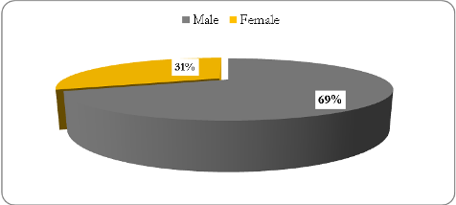

***The in- depth study sample***

A subsample was selected based on the consent of the respondents to take part in the in-depth study. Two governorates; namely Bani Suef and Qena were selected for the in-depth study. It is important to note that the decision to select Qena for the in-depth study was made as the results of the baseline survey indicated a need for further investigation. The geographic proximity of the governorate of Qena to Luxor and Sohag entailed selecting Bani Suef for the in-depth study as a representative of both Minya and Assiut.

For the in-depth study, the sample consisted of 26 male and female farmers drawn from the original baseline survey sample, and 19 male and female workers. The geographic distribution of the sample is presented below. In Bani Suef focus group discussions were conducted with the subsample of workers and farmers. In Qena female farmers and workers were interviewed individually in their homes due to difficulty to gather them in the association.

Table 3: Distribution of in-depth subsample by governorate and gender

|  |  |  |  |  |  |  |
| --- | --- | --- | --- | --- | --- | --- |
| Governorate | Farmers | | | Workers | | |
| Male | Female | **Total** | Male | Female | **Total** |
| Bani Suef | 9 | 8 | **10** | 7 | 5 | **12** |
| Qena | 11 | 5 | **16** | 3 | 4 | **7** |

### 2.3 Characteristics of baseline survey sample

This section presents the main demographic characteristics of the farmers and workers in our sample which cover the size and composition of the household, age, educational attainment and work.

### *Age*

In our sample the average age of farmers is 47.07 years whereas that of the workers is 33.09 years. Our results show that in terms of age, slightly less than one third of the farmers sample (32%) falls within of the age group 41-50 years and nearly 32.5%falls in the younger age group under 40 years (figure 4).

Figure 4: Farmers distribution by age (%)

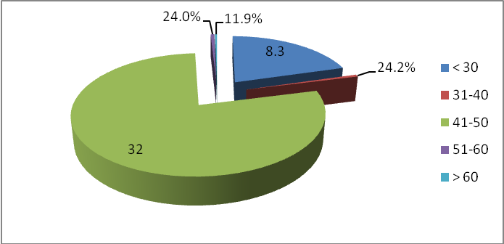

With regard to the workers, it is clear that they are younger than the farmers. Figure5 shows that 43% of the sample aged less than 30 years. The proportion of workers who falls within the age group 30-39 years constituted 28%.

Figure 5: Distribution of Workers by age (%)

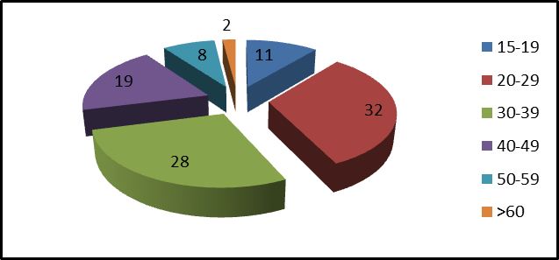

To capture child labor a number of questions were included in the questionnaire regarding the age of workers performing specific agricultural tasks. Our results show that age is a variable determining the type of activities workers carry out, as almost 60% of our respondents agreed. It is evident that child labor is widespread in these governorates. The highest percentage of children (under 18 years) (64.9%) are involved in harvesting.

When considering workers age by gender, Figure 6 reveals that almost one third of female workers is concentrated in the youngest age group (15-19) compared to only 1.4% of their male counterparts. Almost 64% of male workers fall within the age group 20- 39 years compared to 51.6% of female workers.

Figure 6: Workers Age by gender

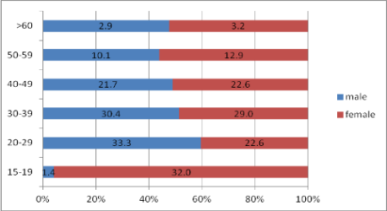

### *Education*

Figure 7 shows that 12.6% of the farmers sample had received a few years of schooling and had obtained a certificate. Higher levels of education (both intermediate and university degree) account for 44.1% of the sample. The data also show that around 35% of the farmers were illiterates, which is slightly higher than the illiteracy rate at the national level of 34.4%. The data further revealed a clear difference between women and men’s level of education. Almost all women farmers in our sample are illiterate.

Figure 7: Farmers educational level

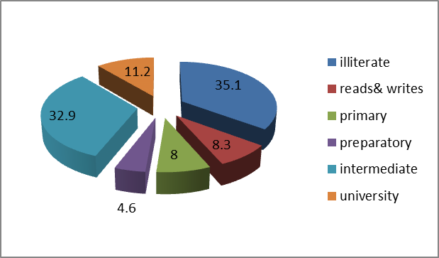

Figure 8 shows that illiteracy is widespread among workers (55%).The remaining had received some formal education. A small percentage had obtained an educational certificate; primary/preparatory (19%). It is interesting to note that 14% of respondents reported that they had obtained a diploma.

Figure 8: Workers educational level

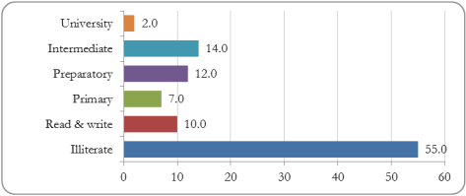

### *Size of the household & housing conditions*

Nuclear family household is the predominant type of family among farmers and workers (97% and 92% respectively). The average size of farmers’ household is 5.6 persons and the workers’ household is 5.7.The average size of household in our sample is slightly larger than the average size of rural household at the national level (5.5 persons) (CAPMAS 2006).The findings show that the vast majority of farmers (97.1%) and workers (90%) own their residential units. In the survey, respondents were also asked whether their houses were supplied with electricity, piped water and sewage facilities. Our findings show that almost all farmers’ houses (99%) have electricity, 97.1% have piped water, but only 6.3% have sewage system. No significant differences were found between farmers and workers households with regard to public utilities.

Figure 9: Farmers Housing conditions

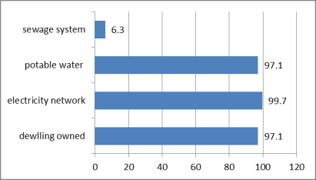

### *Land ownership*

The results of the survey show that the highest percentage of farmers (64%) owned their land compared to those who rented or only managed farms (34% and 2% respectively). The majority of farmers in our sample (60.6%) operate farms between 1-5 feddans, followed by those who operated farms of less than 1 feddan accounts for 32.3%. Farmers who own 5- 10 feddans did not exceed 3.6%. The results reported in Figure (10) show that the highest proportion of farmers who own between 1-5 feddans are found in Bani Suef (72%), followed by Qena and Luxor (68.8% and 67.2% respectively). The lowest percentage is found in Minya (32%). Our results further show that the highest proportion of farmers who own less than 1 feddan is found in Minya (67.6%) and the lowest proportion is found in Qena (18.8%).

Figure 10: Distribution of land ownership by size & governorate

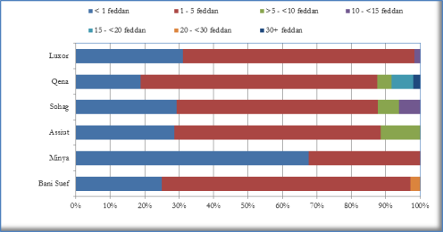

### *Welfare index*

Ownership of consumer durables is a measure that is usually used to evaluate the household standards of living. To this end, a list of commodities was composed and respondents were asked to state whether they owned each commodity or not. The list of household’s ownership of the consumer goods; dwelling characteristics; availability of public utilities; and other characteristics related to socio-economic status of the household were used to develop the welfare index. Each indicator in the index for which information is collected is assigned a weight (0-1). The resulting scores are standardized between 0.0- = very poor, to 0.75-1= very rich. Table 4 revealed that 47.5% of the workers’’ household fell within the poor category, and 37.4% fell within the very poor category. Rich households account for 12.1%.

Table 4: Workers household welfare index

|  |  |  |
| --- | --- | --- |
| Status | Count | % |
| Very poor (0.00 - ) | 37 | 37.37 |
| Poor (0.25 - ) | 47 | 47.47 |
| Rich (0.50 - ) | 12 | 12.12 |
| Very rich (0.75 - 1) | 3 | 3.03 |
| Total | 99 | 100.00 |

With regard to farmers’ household, slightly higher than half the sample fell within the poor category and 15.7% fell within the very poor category. Slightly less than a quarter of the sample fell within the rich category and 7.1% fell within the very rich category. Our findings clearly show that most small farmers are poor (Table 5).

Table 5: Farmers household welfare index

|  |  |  |
| --- | --- | --- |
|  | Count | % |
| Very poor (0.00 - ) | 55 | 15.71 |
| Poor (0.25 - ) | 187 | 53.43 |
| Rich (0.50 - ) | 83 | 23.71 |
| Very rich (0.75 - 1) | 25 | 7.14 |
| Total | 350 | 100.00 |

### *Income & expenditure*

According to survey results, farmers’ average monthly household income in our sample was LE 1323/month. The highest average monthly income from work is found in Qena followed by Luxor (LE 1071 and 932 respectively, while the lowest is found in Bani Suef (LE 787) (Figure 11).

Figure 11: Farmers’ average monthly income by governorate (%)

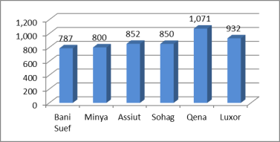

The survey results show land revenue constituted a main source of monthly income (between 100% and 75% of household income) for 57.4% of farmers’ household, which clearly indicates most households are dependent on agricultural activities (Figure12).

Figure 12: Contribution of agricultural activities to household income (%)

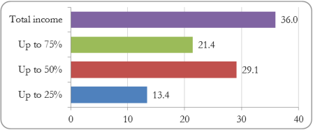

Our results revealed that workers’ household average monthly income is LE 795.5. Figure 14 show that most workers (44%) earn LE 700/ month. Those who earned up to LE 500 constituted 37%.

Figure 13: Workers Household monthly income

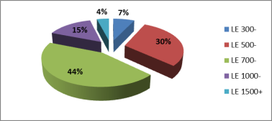

When comparing monthly wage between male and female workers in different age groups, our results reveal that in each age group male worker earn more than their female counterparts (figure 14).

Figure 14: Average monthly wage by age and gender

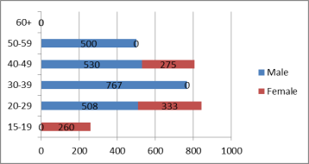

Information regarding household spending was also included in the questionnaires. The average monthly expenditure of farmers’ household is LE 1224. Almost 60% of our respondents reported that they spend up to 50% on food. On the other hand, the average monthly expenditure of workers’ household is LE 709. Similar to the farmers’ household almost 60% of the monthly spending goes to food.

### *Savings and debts*

It is widely known that low-income households are vulnerable to damaging financial shocks. One of the ways that households can create a protective cushion against income shocks is through savings, which can take a variety of forms. Saving generally refers to the extra income put aside for future need, whether in the form of money or accumulation of assets.

When asked whether they save, only 9% of the sampled farmers responded affirmatively. On the other hand, almost 39% (135 cases) of farmers reported that they are in debt. Figure (15) indicates that most debts are loans obtained from banks (63.8%).

Figure 15: Farmers type of debts

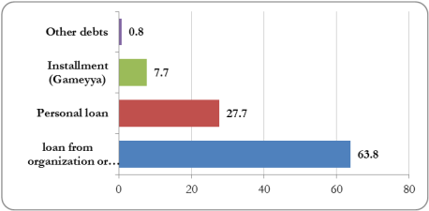

When considering workers’ situation the picture differs. Slightly less a quarter of worker respondents reported that their households are in debt. According to Figure (16) the vast majority of respondents (68%) reported that have borrowed from relatives or friends, and 28% have taken loans form a bank.

Figure 16: Workers type of debts

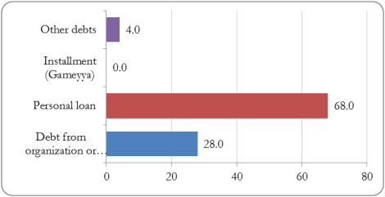

## The Institutional Capacity Assessment of FAs & PHCs

### 3.1 Objectives

The aim of the institutional assessment is to provide a better understanding of the organization and its performance, organizational development and needs. To this end, two checklists were developed one for FAs and the other for PHCs (see Appendix B).

The FAs checklist covered six components of organizational life and the characteristic criteria or indicators of performance for each component these are:

1. Governance & Management
2. Internal Systems
3. Human Resources
4. Financial Resources & Sustainability
5. Service Delivery
6. External Relations & Outreach

On the other hand, the PHCs checklist covered the following aspects:

1. Quality management system applied
2. Products
3. Transportation and Crop Handling
4. Suppliers
5. Supply and Payment Terms
6. Logistics
7. Equipment
8. Personnel

### 3.2 The FAs sample

The 17 FAs identified the TOR were selected for this investigation, in each FA board member(s) and/or senior staff member(s) were interviewed. Table 6 outlines the main characteristics of the Farmers associations in terms of their location, size of membership, age and area of work.

Table 6: Characteristics of FAs sample

|  |  |  |  |  |
| --- | --- | --- | --- | --- |
| Association | location | Age | GA Members | Main Field of Work |
| Agricultural Community Development, Mousha | Assiut | 7 | 165 | Agriculture |
| Pomegranate Growers and Exporters, El-Badari | Assiut | 5 | 56 | Agriculture |
| Agriculture Development Bani Sulaiman, El Sharq | Bani Suef | 8 | 192 | * Education * Agriculture |
| Local Community Development, Gaafar | Bani Suef | 15 | 263 | * Environment * Health/Education * Loans * Agriculture |
| Small Farmers and Families’ Development, Dandil | Bani Suef | 7 | 130 | Agriculture |
| Al Negoua' Bahari, Armant | Luxor | 9 | 120 | Agriculture |
| Agricultural Community Development, Tafnis | Luxor | 7 | 115 | Agriculture |
| Agricultural Community Development, Tood | Luxor | 9 | 120 | Agriculture |
| Community Development Association, Abu-Quorqas | Minya | 5 | 130 | Agriculture |
| Agriculture Community Development, El Bayaho | Minya | 7 | 142 | Agriculture |
| Agriculture Community Development, Minbal | Minya | 6 | 140 | Agriculture |
| Agriculture Community Development Association, Mahrousa | Qena | 7 | 160 | Agriculture |
| Dandara Association, El Marashda | Qena | 7 | 120 | Agriculture |
| El Waqf Association | Qena | 9 | 79 | Agriculture |
| Agriculture Community Development, Beit Khalaf | Sohag | 9 | 103 | Agriculture |
| Al-Sadaqa Association, Tahta | Sohag | 4 | 34 | * Agriculture * Community Development |
| Agriculture Community Development, Awlad Yahia | Sohag | 10 | 399 | * Agriculture * Community Development * Education * Loans |

In general, the table above indicates that:

* Most of the associations have been established and registered between 2000 and 2007;
* The main field of work is agriculture related (contract farming extension services, post-harvest practices, etc.);
* Still other community development activities/services provided by few associations who are mainly CDAs (e.g. Gaafar and Sadaqa);
* Women representation in the General Assembly ranges between 2% – 45%.
* There is no strict membership policy or minimum land holdings required which means absence of discrimination against women.

### 3.3 The Packing houses sample

The three PHCs were established in July 2008. The main crops handled in these PHCs are grapes, pomegranates, cantaloupe, banana, pepper, onion, green onion, garlic, beans, tomato and cucumbers. Table 7 below presents the main characteristics of PHCs under study in terms of their location, age, area, production and workers.

Table 7: Main characteristics of the PHCs

|  |  |  |  |  |  |  |  |
| --- | --- | --- | --- | --- | --- | --- | --- |
| PHC | location | Age | Area (m2) | Crops | Current Production Capacity (ton/day) | Workers (#) | |
| **M** | **F** |
| Al Sharq | Bani Suef | 3 | 2500 | Green onions  Garlic  Beans  Grapes  Pomegranates | 3.4 | 20 | 100 |
| Al-Bayaho | Minya | 3 | 2500 | Grapes  Pomegranate | 40 | 30 | 80 |
| Upper Egypt Future | Qena | 3 | 2000 | Grapes  Cantaloupe | 57 | 20 | 60 |

## 4. The In-depth Study

### Objectives

The aim of the in depth study was to collect detailed information regarding key priorities and concerns in this sector and approaching more complex issues related to power relations and control within the chain. To this end a number of in-depth interviews were carried out with representatives of main actors in the value chain. These are:

1. Three input suppliers located in Cairo were interviewed: “Shoura Chemicals”, “Alameia for Trading & Agriculture”, and “Agrimatco”.
2. A focus group discussion with four traders was conducted in Luxor governorate.
3. An interview was conducted with “The Egyptian Center for vegetables & fruits” as an exporter, located in “Obour Area”.
4. An interview was conducted with private food processer: “Paste & Juice Co.”, located in Fourth Industrial Area, Sadat city- Monofeya Governorate.

In addition, four interviews were conducted with officials from the Ministry of Agriculture in order to investigate their views regarding the Ministry’s strategies, the services provided to small farmers, challenges the Ministry encounters, and its future plans. The Participants included: Dr. Salah Yusuf: First Under-Secretary, Head of Agricultural Services and Monitoring Sector; Dr. Aquila Saleh: Food Security Information Center; Dr. Hesham Allam: Horticulture Research Center; and Dr. Asem Shaltoot: Union of Producer and Exporters of Horticulture Crops (UPEHC).To this end, 5 separate interview guides were developed to cover each type of respondents (see Appendix B).

## The Implementation Process

The baseline survey was carried out over the period between 21st October and 8th November 2010. The research team consisted of 10 enumerators and two senior researchers responsible for supervising the implementation process. The research team was divided into two groups each responsible for the fieldwork in three governorates. To speed up the implementation process the two teams worked in parallel. Prior to actual implementation of the fieldwork the research team received an extensive training on the survey instruments, which have been pre-tested and modified accordingly. The institutional capacity assessment was conducted simultaneously with the baseline survey by the consultant.

The qualitative study (in-depth interviews and focus groups) was carried during the first week of January 2011right after the presentation and discussion of the preliminary findings of the baseline survey.

### Limitations of the research study

**1. Sampling issue:** Research team faced some constraints regarding the sampling process; such as the fact that not all FAs’ members (males or females) are farmers, in addition to the difficulty to find female labors above 17 years in throughout the crop production practices.

**2. Delays**: The team experienced delays in administering the questionnaires due to the Egyptian parliamentary elections of 2010 that took place during November through December. Difficulties in setting appointments with respondents had also resulted in delays beyond the agreed upon timeline.

**3. Nonoperational FAs:** during the fieldwork the team discovered that some FAs were completely out of service, as premises were closed and research team had to conduct interviews with current or sometimes former board members or executive director at other public places.

**4. Respondents attitude:** Farmers were sometimes reluctant to cooperate with the research team because of their disappointing experiences in participation in such studies. According to them, these studies were never materialized into real interventions.

# Findings of the Baseline Investigation

The analysis in this section draws both on qualitative and quantitative data collected during the fieldwork. The findings of the baseline investigation are organized in accordance with the stages identified in the value chain map below; input supply, production, harvesting and post-harvesting and marketing.

## Mapping the Value Chain

The Value Chain Analysis (VCA) is a diagnostic tool employed to assess the performance of the value chains including the analysis of product flows, information flows, management and control of the value chain. In the current investigation, the objective of such analysis is to identify key points for intervention along the chain to improve the position of small farmers, especially female farmers, and to highlight possible policy recommendations to enhance the competitiveness of the sector and linking small farmers to export markets.

Our mapping exercise developed in two stages. The first stage involves drawing an initial map which gives the contours of the chain; the main activities carried out, the connections to the final market, with some initial indications of size and importance. The second stage, which follows the in-depth investigation, resulted in a more elaborate map (see Figure18). The diagram below identifies all activities, interactions and relationships among actors along the chain. In our map, we list the activities vertically, starting with suppliers of agriculture inputs and material at the bottom and ending with final consumers at the top.

Figure 17 shows that the stages covered in the value chain map are:

1. **Input supply:** this includes the production and distribution of material inputs such as fertilizers, seeds utilized in the primary production
2. **Farm production:** this stage concerned with primary agriculture production and ends with the sale of the produce at the farm gate.
3. **Post-harvesting/processing:** this stage involves the transformation of agriculture products into one or more finished goods (done by PHCs), and the role of FAs in processing and/ or trading the crops.
4. **Marketing**: the logistical stage concerned with the delivery of marketed commodities to their final market destination.

In our analysis we will focus both on the activities carried out in each stage and actors along the chain. Gender and gender relations will be examined systematically in each stage, so as to provide a better understanding of the different position of men and women occupy along the chain and to examine the impact of their participation in the value chain on their lives and the degree of control over their activities.

It is important to note that calculating the percentage of waste or losses along the entire value chains is a difficult and lengthy procedure that cannot be covered by research of a short-term nature. Measuring crop losses along the value chain entails weighing the crop at each stage in the chain from harvesting till consumption for each crop in each governorate. Given the short duration of the baseline investigation (October 2010– January 2011), together with the fact that the investigation covered five crops (each of which has its own cultivation and harvesting season during the year) in six governorates, such a task could not have been realistically and accurately covered. As a result, our research tools avoided addressing this aspect. However, our findings captured where waste/losses occur, as well as the different crop grades (from the farmers’ perspective). It was evident most waste occurs during: 1) harvesting and field packing as the produce left out in the sun; and 2) during transportation and handling as most farmers use inadequate packing materials and non-refrigerated transportation.

Figure : Horticulture Value Chain Diagram

**Traders / Brokers**

**Water**

**Labors**

**Machinery**

**Seeds**

**Transplants**

**Fertilizers**

**Pesticides**

**Growth Regulators**

**Farm Production**

**PHCs**

**FAs**

**Retailers**

**Exporters**

**Wholesalers**

**Processors**

Regular relationship

Irregular relationship

Two-way reciprocal relationship

Two-way interdependent relationship

**2. Input Supply**

### 2.1 Introduction

Agriculture input supply has an immense contribution to enhancing the productivity of agriculture commodities. The input demand-supply system is influenced by personal, situational, institutional and organizational factors. In Egypt, the Ministry of agriculture had traditionally been a primary supplier of agriculture inputs, through agriculture cooperatives serving as the single channel for distributing farm inputs (mainly chemical fertilizers, improved seeds, insecticides).

The mid-1970s witnessed the establishment of Principle Bank for Development and Agriculture Credit (PBDAC) with branches established in nearly all the villages of Egypt. The Bank took over the monopolistic role played previously by the agriculture cooperatives. However, in the 1990s the market share of PBDAC decreased substantially with the economic liberalization and the increased participation of the private sector in the production and distribution of farm inputs. The available statistics show that between 1990 and 1994, the role of the Bank in the distribution of fertilizers has declined gradually from complete monopolization to handling only 10%, whereas the role of private sector increased to reach 70% of domestic production in 1994.[16]

PBDAC, the agriculture cooperatives and private traders continue to participate in the distribution of fertilizers. The government determined the share of each participant. There are about 27 large scale distributers who deal with delivery of fertilizers manufacturing within the limits of the quota fixed by the government. The number of private traders is 6000, only half of them are licensed, while the other half consists of small retailers located in villages (unlicensed). Wholesalers generally receive their fertilizers from the distributors and sell to retailers.

In the same vein, the liberalization of the seed sector followed in gradual and coordinated manner. In the past the PBDAC provides credit and was responsible for storage and distribution of certified seed. However, the role of the Bank has been reduced to financial agency for the seed. Seed marketing and distribution is transferred to the cooperatives and private sector. The private sector has been dominant in production, import and distribution of vegetable and forage seed. They also have gained a major share in the supply of hybrid seed of maize, sunflower and sorghum. Moreover the private sector started to procure seed of self-pollinated crop such as wheat, rice and Faba Beans where the share b=now reached 30-40%of commercial seed market.

Currently, horticulture inputs are mainly supplied by small inputs store in the village, or by agriculture cooperatives located in rural districts. Large inputs supply companies are located in main cities providing wide range of fertilizers and seeds. These companies supply inputs to wholesalers, or through their salesmen, or providing directly to large farms producing for export.

### 2.2 Key findings

***Input suppliers***

In the baseline investigation three private sector input supply companies were selected. The selection of these companies was based on their consent to take part in the research study. The three companies are located in Cairo. The interviews were conducted with a representative from each company. In what follows a brief profile of the input supply companied selected (see Appendix C).

**Shoura Chemicals**

Shoura Chemicals was established in 1989 and located in Cairo. It is the biggest agrichemicals company in Egypt and the sole importer of more than 40 agriculture inputs and materials including pesticides, fertilizers and growth regulator. Its outreach is wide covering almost all governorates in Egypt. It is also involved the field of technology transfer, agriculture research and development.

**Alameia for Trading and Agriculture**

Founded in 1999 in Cairo, Alameia is an exporter company of all kind of fruits, beans, and fresh preserved vegetables. It also involved in importing input supplies including fertilizers, pesticides, and hygiene seeds.

**Agrimatco**

Agrimatco is an Egyptian inputs supply company, established in EL Haram, with more than 42 branches across the Middle East, North Africa, Central Europe and Central Asia. The company is specialized mostly in selling pesticides; followed by seeds and fertilizers.

The aim of the investigation is to gain a better understanding the relationship between inputs suppliers with farmers and the problems both encountered by inputs supply companies and small farmers. The investigation covered several areas related to the quality systems in place, production and employment, and transporting and marketing.

***Quality management system***

In our sample, the three companies apply quality control systems such as ISO in order to ensure the safety of the production process and product quality. It is evident that the inputs supply companies follow both the national and international standards as communicated through the regulations and laws of the Ministry of Agriculture which guarantee the inputs quality.

To assess the quality of their products, the companies reported that they measure the volume of the demand over various seasons, and/or depend on farmers’ feedback obtained during field visits.

With regard to after- sales services, our respondents advanced that their companies mainly depend on a well-trained and specialized team (fertilizers, pesticides, and seed specialists) to provide the customers, farmers and agriculture associations, with all the needed technical support.

***Product and human resources***

The products sold by the three companies under study include agriculture inputs (fertilizers, pesticides, seeds and compost), irrigation system tools and small machines. Some of these products are either imported or locally manufactured. The size of the production or volume of import differs from one company to another and directly related to market demand. Such demand is determined by the seasonality, nature of the crop and the size of cultivated area

When asked about the prices of the inputs, our respondents reported that prices are rising annually. The companies reported that various payment methods exist. In some cases the companies are paid in cash up front, and in other cases, especially with farmer customers, the payment delayed until the time of harvest.

Only few male workers are employed by inputs supply companies. Our respondents explained that labor is only needed for the duration of transporting of the products. The daily wage of the workers is 25 EGP.

When asked about the problems the companies might encounter regarding their products, our respondents cited the availability of cheap non-certified products in Upper Egypt. They further explained that effect of such problem goes beyond product imports to compromising the quality of the crops.

***Transportation & marketing***

The transportation of products is done through transportation companies. All our respondents claimed that the cost of transportation is very high due to the long distance between the production sites and the ports. Moreover, the demand on the products is limited while the supply is not necessarily elastic.

When asked about their customers, the suppliers reported that they are mainly farmers (small, medium, and large), and the governmental associations in cooperation with the agricultural cooperative.

### *Challenges & problems: respondents’ perspective*

***Input suppliers***

When asked about the main problems they encounter in their work, our respondents reported that they do not encounter any problem in terms of regulations and policies. However, they cited infrastructural problems such as roads. They also explain that despite their widespread outreach they cannot respond to the increasing demand. Thus, they suggested a bigger role for the government in responding to such demand especially among small farmers. They also advanced that there is a need for an official monitoring system for seeds quality to ensure improvement in horticulture in Upper Egypt.

***Farmers***

The results of the baseline survey show that small farmers face a number of problems related to input supplies. According to our results, high cost, unavailability and low quality of supplies were the main problems cited by farmers (48.8%, 26.8% and 27.2% respectively). When considering the inputs supply problems cited by farmers by land governorate, our results clearly show that high prices and unavailability are the main problems among all governorates (Table 8).

Table 8: Inputs supply problems by governorate

|  |  |  |  |  |  |  |
| --- | --- | --- | --- | --- | --- | --- |
| Inputs Supply | Bani Suef | Minya | Assiut | Sohag | Qena | Luxor |
| low quality | 22.8 | 16.7 | 20.0 | 32.1 | 37.3 | 31.3 |
| high prices | 40.4 | 51.7 | 40.0 | 57.7 | 45.1 | 51.6 |
| unavailability | 35.1 | 40.0 | 45.0 | 24.4 | 3.9 | 17.2 |

However, when considering these problems by land size, it became clear the high prices are the main problem for farmers with smaller holdings (Table 9).

Table 9: Inputs supply problems by size of landholding

|  |  |  |  |  |  |  |  |
| --- | --- | --- | --- | --- | --- | --- | --- |
| Inputs Supply | < 1 feddan | 1-5 feddan | >5-<10 feddan | 10-<15 feddan | 15-<20 feddan | 20-<30 feddan | 30+ feddan |
| low quality | 22.0 | 29.4 | 35.3 | 0 | 0 | 100 | 0 |
| high prices | 43.9 | 51.7 | 52.9 | 16.7 | 40.0 | 0 | 0 |
| unavailability | 26.8 | 27.3 | 35.3 | 0 | 20.0 | 0 | 0 |

The focus group discussions with female farmers in Bani Suef clearly indicate that dealing with suppliers was made easier through the FA. The services offered by the FA were not limited to ensuring the availability of inputs but also negotiating the prices on behalf of female farmers.

**Input suppliers/ farmers relationship**

The inputs suppliers reported that they support the farmers by providing all the needed inputs and material for the production process (fertilizers, pesticides, seeds, and compost) the amounts of inputs is determined according to the cultivated area that differs from one year to the other, which depends originally on the market demand. Our suppliers explained that in case of **farmers’ complain** of any product; the company takes a corrective action. As one of our respondent explain:

*“In Qena, one of the growers, (client) while using a pesticides spray got some trees burned. Once the complaint received our company agent immediately respond and solve the problem”.*

Moreover, the suppliers are keen on establishing good communication with farmers and associations, which is achieved through field visits and presentations of new products and follow-up of the products effectiveness. The suppliers also organize two annual agricultural fairs in Luxor and Minya to present and market their products.

Our in depth investigation confirmed these findings. According to male farmer participants from Qena, most agriculture inputs are not sufficiently available at the agricultural cooperative. Thus, they obtain these inputs from traders which cost them a lot. Farmers in Bani Suef cited the FA as the main supplier, where they find quality inputs at relaxed methods of payments. However, due to lack of financial resources, the association cannot always supply farmers with needed inputs.

In general, the interviews showed that farmers mistrust suppliers because they sell low quality inputs for higher prices hence; they are obliged to buy more quantities, especially of pesticides, to maintain effectiveness. In most cases, according to our respondents, suppliers are not qualified or agriculture specialists; therefore, a more active governmental control role is highly needed, as Input market lacks the management measures to control product quality and price. Farmers suggested making inputs available through the farmer association.

**3. Farms and Production**

This section presents the main findings of the farmers and workers baseline survey. The finding reported in this section draw upon both quantitative and qualitative data collected during the fieldwork.

### 3.1 Farmers

In general, small farmers concern themselves only with primary farm production: they prepare the land, plant the seeds; apply fertilizers, control pests and weeds, and harvest the crop when it is mature. Some of the farmers in our sample reported that they are involved in activities such as sorting and grading their produce. All the activities carried out by small farmers represent only one step in the value chain, without any type of activities related to vertical integration. It is evident that small farmers are excluded from many decision making issues that affect them, and have weak bargaining power. In some cases, and depending on the type of crop and its perish ability, farmers may be able to decide on how much they sell, to whom and at what price.

***Crop production***

The survey findings show that there are five main crops cultivated by farmers during the last season and perceived by farmers as the most profitable. Figure (18) displays these crops arranged by the area of land cultivated by each crop. It is clear that the most cultivated crop is Tomatoes, followed by potatoes and Pomegranate.

Figure 18: Top five crops by cultivated area



The results reported in Table (10) show that the production of the lowest cost crops; Potatoes, Onions and Green Beans are very low compared to its cost which means minimal profit. On the other hand, the production of the two crops; tomatoes and pomegranate, which cost more, is much higher than the cost per ton suggesting higher profit.

Table 10: Average production of selected crops (Tons)

|  |  |  |  |  |  |  |
| --- | --- | --- | --- | --- | --- | --- |
| **Crops** | **No. of farmers** | **Area** | **Av. Production (Tons)** | **Av. % of**  **1st degree** | **Av. % of**  **2nd degree** | **Av. % of**  **3rd degree** |
| **Tomatoes** | 84 | 150.1 | 32.6 | 65.5 | 24.2 | 17.1 |
| **Potatoes** | 81 | 77.9 | 9.5 | 87.6 | 13.5 | 10.9 |
| **Pomegranate** | 18 | 62.5 | 20 | 57.5 | 27.9 | 22.8 |
| **Onion** | 46 | 41.8 | 9.5 | 78.5 | 20.1 | 12.1 |
| **Green Beans** | 40 | 22.9 | 3.6 | 78.6 | 26.0 | 20.0 |

The above table also reveals that there is significant room for improvement in the quality of crops, especially tomatoes and pomegranates. It is anticipated that with proper extension services and training significant improvements can be made to product quality and hence farmers’ income.

When considering the number of farmers who cultivated each crop during the last season the picture differs (Figure 19). While the two first crops; tomatoes and potatoes remain at the top cultivated by slightly less than a quarter of the farmers, the pomegranate coming last and did not exceed 5.1%. The main reasons for the domination of tomatoes and potatoes as main crops are: 1) the inherited long experience in growing these crops at the regions under study, 2) for these two specific crops, and in many cases, the traders provide advance payments (or input supplies) to poor small farmers within a frame of informal contract farming, and 3) these two crops are subject to high level of price fluctuations that encourages many farmers to grow them hoping for an extremely high profit, which happens every several years.

Figure 19: Number of Farmers Cultivating the Top 5 Crops as First Crops



The table below reveals the main cost elements of agricultural processes implemented for the different crops. One can conclude from this structure the areas of weakness and the potential directions for improvement.

Table 11: Average Cost Breakdown of agriculture processes per Feddan by Crop (LE)

|  |  |  |  |  |  |
| --- | --- | --- | --- | --- | --- |
| **Type of average cost/ feddan** | **Tomato** | **Potato** | **Pomegranate** | **Onion** | **G. Beans** |
| Organic fertilization | 846.19 | 675.58 | 1,357.08 | 1,110.06 | 963.48 |
| Land preparation & cultivation | 884.59 | 1,022.92 | 1,495.47  (once during plantation) | 651.46 | 618.73 |
| Nitrogen fertilization | 837.49 | 749.29 | 809.29 | 1,086.65 | 611.11 |
| Phosphate fertilization | 484.52 | 583.20 | 432.45 | 573.11 | 953.75 |
| Potassium fertilization | 470.38 | 391.69 | 236.51 | 554.25 | 614.93 |
| Micronutrients | 378.62 | 237.47 | 589.07 | 200.64 | 306.61 |
| Pest Control | 1,024.51 | 364.24 | 1,852.11 | 704.55 | 425.37 |
| Harvesting | 853.06 | 711.28 | 1,688.46 | 609.03 | 603.02 |
| Transportation | 883.45 | 365.28 | 850.55 | 429.95 | 202.17 |

The above breakdown excludes the cost of seeds and seedlings that differs greatly between the different crops mentioned and the varieties planted, and excludes also the land rent as a cost item, as the duration of the season differs from 3 months (for green beans) and 12 months (for pomegranate, which is a permanent crop). Thus deriving a general figure for the total cost per crop per feddan is not feasible. The percentage share of cost items in agricultural processes per feddan is depicted in the Figure 20 below.

Figure 20: Share of costs items in average total crop cultivation per Feddan (%)

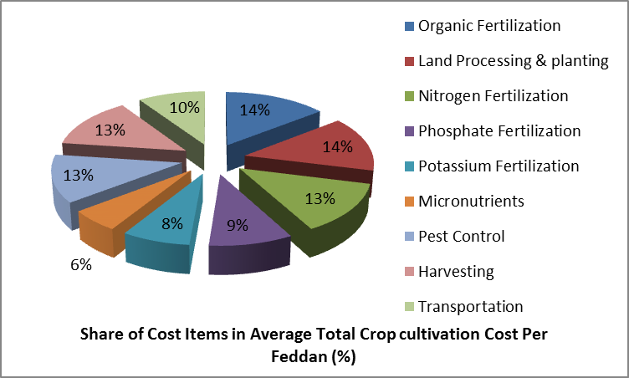

The cost structure for fertilization indicates that there is a focus on the nitrogen fertilization at the expense of Potassium, which indicates: 1) less productivity, 2) short shelf-life of the final product and post-harvest-losses, 3) low eating quality specifications, 4) negative effects on soil and environment 5) excessive unnecessary costs due to leaching from the soil. In general this reflects the need for extension services on all production aspects.

The cost of pest control seems to be high in the case of pomegranates due to excessive usage of pesticides. This explains the high level of rejections for this crop in the export markets. It is worth to note that the majority of the exported pomegranates origins from Upper Egypt, and mainly from small scale farmers in Assiut. Thus this indicated an urgent need to design and implement integrated pest management programs with focus on pomegranates.

### *Fertilization*

Nitrogen fertilization seems to be more widespread among respondents in general, followed by phosphate, potassium and micronutrients fertilization, with organic fertilization as the least widespread among respondents. This corresponds to the cost structure of the agricultural processes as explained in the previous section.

Table 12: Percentage of Farmers Using Various Fertilizers

|  |  |  |  |  |  |  |
| --- | --- | --- | --- | --- | --- | --- |
|  | Bani Suef | Minya | Assiut | Sohag | Qena | Luxor |
| Organic fertilization | 17.4 | 18 | 12.4 | 22.4 | 14.6 | 16 |
| Nitrogen fertilization | 87.7 | 85.0 | 87.5 | 73.1 | 92.2 | 84.4 |
| Phosphate fertilization | 54.4 | 62 | 80.0 | 73.1 | 92.2 | 77 |
| Potassium fertilization | 49.1 | 56.7 | 57.5 | 75.6 | 82.4 | 81.3 |
| Micronutrients | 17.5 | 58 | 52.5 | 57.7 | 31.4 | 42 |

When examining the use of different fertilizers by farmers across different crops figure (21) below, the survey revealed that the use nitrogen fertilizers is the most utilized kind of across crops (especially in the case of tomatoes), except for Green Beans, where only 65% of farmers reported using it, compared to potassium fertilization (75%) and phosphate fertilizers (70%). The above figures confirm the low awareness of respondent farmers towards the different categories of fertilizers used, and hence the reasoning for its usage at the different phonological stages. As a matter of fact, 100% of farmers use nitrogen fertilizers (with variability of amounts) as a subsidized production input that is distributed by the Agricultural Development Bank to all growers based on the land ownership document. This reflects the need for extensive extension services with emphasis on fertilization aspects.

Figure 21: Farmers’ use of fertilizers by crop (%)

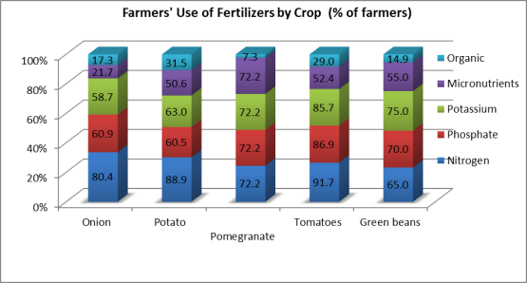

An interesting variation was discerned however when it comes to the use of fertilizers by size of landholding as concluded from Figure (22) below. All farmers with large landholdings (<20 feddans) reported using nitrogen, phosphate, potassium and micronutrients fertilization. This reflects their awareness towards the different categories of fertilizers and the balanced use of the different elements. The usage of organic fertilizers was reported more at small scale farmers, as most of them are owners of farm animals and use its manure in fertilization without giving much consideration of the economics of production.

Figure 22: Use of fertilizers by size of landholding

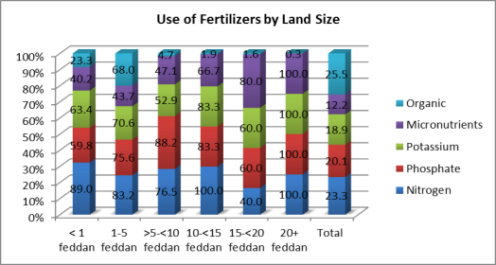

### *Irrigation*

It is widely known that higher proportion of farmers depends on the River Nile for irrigation. This situation holds true among the farmers in our study as 86% of farmers reported depending on the Nile for irrigation. Flood irrigation is predominant method of irrigation (92%), only a tiny percentage of farmers reported utilizing the drip irrigation. Drip irrigation can improve the productivity and quality of farmers’ crops. In addition, with the growing water shortage Egypt is witnessing, there is a need to move away from wasteful irrigation methods towards methods that utilize water more efficiently.

***Supervision of technical operations***

Technical agricultural operations are predominantly supported by the farmers themselves, with only 10% of the sample reporting delegating this responsibility to an agricultural engineer. Within the governorates, Bani Suef farmers seemed more prone to utilize agricultural engineers (23%) compared to Sohag or Assiut (5%).

Figure 23: Supervision of Technical operations (%)

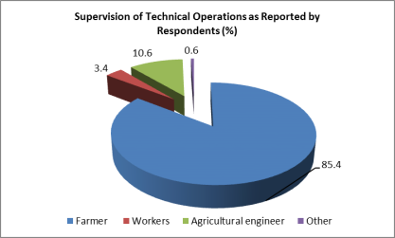

As figure (24) below shows there is also considerable variation by size of landholding. Half of the landowners with plots of 20 feddans or more utilize agricultural engineers to oversee operations. On the other end of the scale, farmers with less than one feddan are the least likely to have agricultural engineers supervising technical operations (less than 4%). This confirms the need for providing cost effective extension services to the small scale farmers that could be efficiently managed by the farmer associations.

Figure 24: Supervision of technical operations by land size

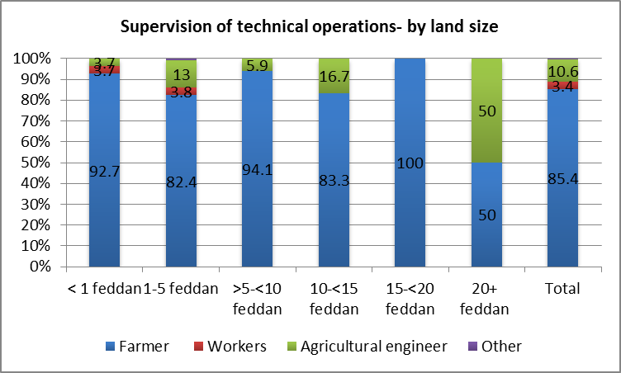

Across crops, the survey revealed that potato growing utilizes more technical supervision of engineers (20%), followed by onions and tomatoes (Figure 25 Below). On the other end of the scale, pomegranates utilize virtually no technical supervision by engineers, with a possible reasoning that pomegranate ownerships are mostly of small scale, and many of the pesticide traders and input suppliers provide recommendations to them for fertilization and pesticide usage. The final result though, is in general excessive usage of chemical fertilizers and pesticides that need to be regulated and minimized through true scientific extension services.

Figure 25: Supervision of Technical Operation – by Crop

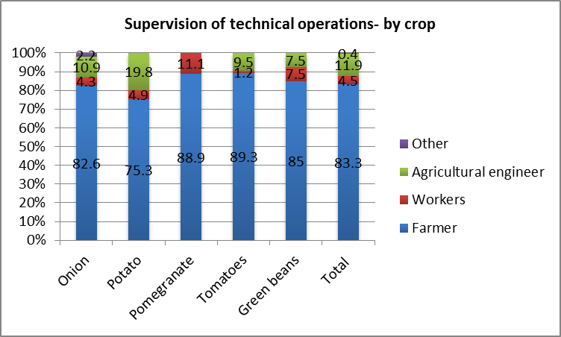

The chart below reveals that farmers in northern Upper Egyptian governorates are more likely to delegate technical supervision of farming operations to engineers. This is especially the case in Bani Suef where 23% of the farmers reported that they utilize agricultural engineers.

Figure 26: Supervision of technical operations by governorate

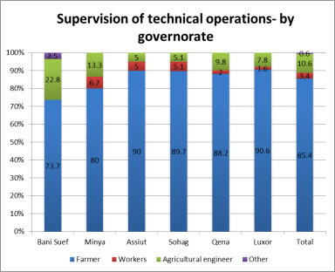

During the focus group discussions with male farmers in Qena, it was clear that there were no extension services offered to them by the extension department. In Bani Suef, the FA provided its farmer members with extension services. However, all farmers expressed the need for “technical supervision by extension experts, agricultural machinery services, establishing demo plots and training on cultivation under tunnels and greenhouses”. Our results also show that all farmers need to receive training in various areas related to production and marketing. When asked about preferred timing and location of the training, almost all respondents cited the morning periods, during the winter season (October to December). They also reported that they prefer the training to combine both theoretical and practical aspects.

***Production***

Figure (27) displays the main problems related to production faced by farmers. According to our results, the high cost, unavailability and low quality of supplies were the main problems cited (48.8%, 26.8% and 27.2% respectively). This feedback confirms the uninformed type of growers that is misused by a considerable number of input suppliers providing fraud chemicals (fertilizers and pesticides). These problems could be tackled through active involvement of the farmer’s associations by collective purchase of input supplies from trustable sources, thus assuring the quality and reducing the final cost to the small farmers.

Figure 27: Production-related problems

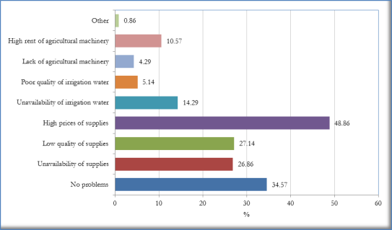

Among the Upper Egyptian governorates surveyed complaints from the unavailability of supplies were more recurrent among northern governorates (Assiut, Minya and Bani Suef). Complaint from the high price of supplies while common in all governorates were voiced more by farmers in Sohag and Minya. Qena and Sohag farmers were more concerned than those of the other governorates with the low quality of supplies. Unavailability of irrigation water was reported as a constraint facing more than one-third of the respondents in Luxor, whereas 25% of the farmers in Qena listed the high rent of agricultural machinery as a constraint they are facing.

Figure 28: Production related problems by governorate

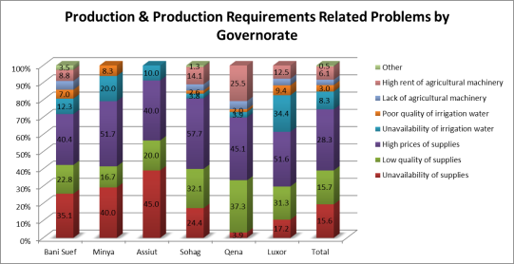

### *Use of agricultural machinery*

In the survey farmers were asked whether they use machines in the various agriculture processes. According to figure (29) in all agriculture operations except in cultivation the vast majority of farmers do not use any agriculture machines. In cultivation, almost half the farmers reported that they do. The proportion of farm owners who reported using agriculture machines was much larger than that of farm tenants (46% and 2% respectively).

Figure 29: Use of machinery in agriculture operations

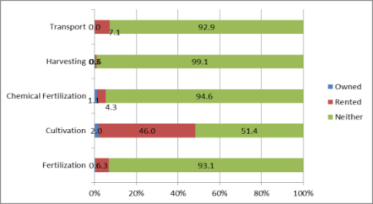

### *Employment*

According to Figure (30), high wages of agriculture workers is cited by many farmers (28.3%) as the main problem they encounter followed by shortage of agriculture labor (21.1%). Slightly higher than half the sample of farmers stated that they have no problems related to employment. This can partially explained by the fact that the majority of small farmers depend on unpaid family labor (e.g. wife and children) in all agriculture activities.

Figure 30: Employment related problems



Among those who cited high agricultural wages 65% owned 1-5 feddans, and 25.5% own less than 1 feddan. Shortage of labor was cited also by the majority of small farmers who own 1-5 feddans (61.1%). Among the surveyed governorates, high agricultural wages were more frequently mentioned as a problem by Sohag and Qena farmers (54% and 31% respectively) as the chart below shows.

Figure 31: Employment related problems by governorate

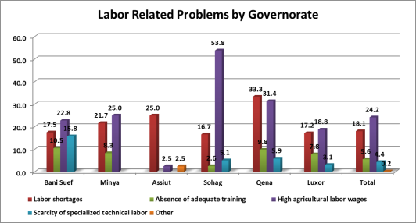

Our in-depth research results confirm these findings. Farmer participants complained from high wages of laborers and they reported that they prefer female labor because it is less expensive. On the other hand, thanks to working more hours, having no transportation cost, family labor is preferred to hired labor. As for age, preferred labor is 15 years or older for female, and 20 to 40 for male labor. With attention to remuneration, low wages because laborers to work in other professions like construction; while, to farmers, labor is a costly farming item. Pertaining to labor problems, participants agreed that low productivity, lack of training, and scarcity of specialized laborers (e.g. grape pruning) are the key labor issues that need to be addressed.

### *Harvest and post-harvest operations*

Regardless of location, crop or size of landholding, harvesting is almost wholly carried out manually. Given the lack of training provided to agricultural labor, harvesting is not done following best practices. Similarly, regardless of location, crop or size of landholding, transportation is almost completely undertaken by non-refrigerated trucks. When asked whether they face problems in harvesting and post-harvest handling, the majority of farmers answered negatively. Such response clearly indicates lack of knowledge among most farmers of the proper harvest and post-harvest techniques that should be followed. Figure (32) indicates that bad harvesting practices and the lack of refrigerated transport are the main problems cited by farmers who acknowledged the existence of such problems.

Figure 32: Harvesting & Post-harvest problems

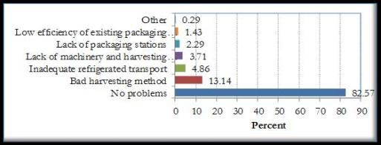

However, when considering the results by governorates (see chart below), our data shows that bad harvesting practices as a source of complaints in Qena and Luxor. Our data also show that problems related to availability of packing houses were reported by farmers in Bani Suef. This corresponds to the increased knowledge and awareness in Bani Suef towards the need for post-harvest operations, and matches also with the highest rate of utilization of extension services by agricultural engineers in the same governorates as indicated previously. Lack of machinery and harvesting equipment was reported as a problem mainly in Bani Suef and Qena.

Figure 33: Harvesting and post-harvest problems by governorate

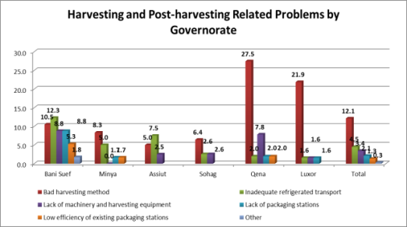

### As the chart below shows, crop grading is undertaken by less than half the farmers surveyed. The practice is more common in northern Upper Egypt compared with Southern governorates, where Sohag farmers appear to be the least likely of the farmers to conduct crop grading.

Figure 34: Crop grading by governorate

### 

Among crops, our survey results show that crop grading is less common in the case of Green Beans and onions, compared to pomegranates and potatoes. No discernible variations were detected among farmers with different sizes of landholdings.

Figure 35: Crop grading by crop

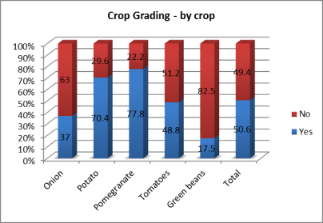

On-farm packing is another area that was researched by the study. The chart below reveals that plastic containers are more widely utilized in northern Upper Egypt than in southern governorates.

Figure 36: Packages used in harvesting by governorate

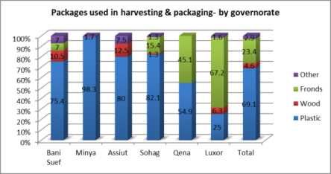

While there were no discernible variations among farmers with different size of landholdings, the study revealed significant variations by crops in this regard as the following chart shows. Despite its highly perishable nature, more than 80% of farmers reported using fronds boxes, which lead to more crop waste. It should be noted that the use of plastic containers is not in itself a sign of following good practices. Plastic containers may include plastic sacks (which are widely used but not suitable for all crops) or maybe filled in a way that damages crops.

Figure 37: Material Used in Packaging by Crop

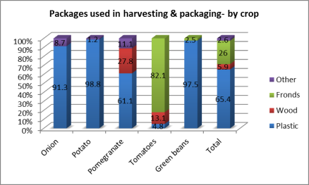

Pack houses or PHCs are used by a minority of farmers to pack their crops. Only a minority of farmers mainly in Bani Suef reported using the PHC services.

Figure 38: Place of packing by governorate

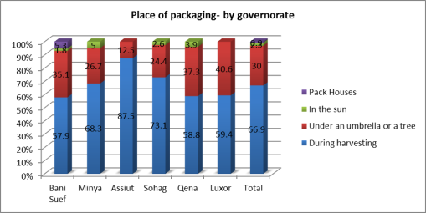

### *Access to information services*

Obtaining information regarding various aspects of agriculture operation is of great importance for farmers. Respondents were asked about the sources of information that they trust. As shown in Figure (39) two sources of information identified by the majority of farmers. These are agriculture directorate and the NGOs in the locality (60.6% and 54.9% respectively).

Figure 39: Sources of agriculture information trusted by farmers

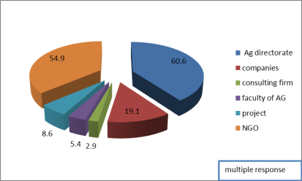

The study revealed some interesting regional variations with regards to the farmers’ utilization of information service providers. Services provided by NGOs seem to be more utilized in Luxor and Bani Sue, whereas Sohag and Minya farmers tend to rely more on information services provided by agricultural extension departments. Information services provided by seeds and pesticides companies seem to be more valued by farmers in northern Upper Egypt, albeit with a relatively low level of penetration compared to NGOS and the Department of Agriculture.

Figure 40: Sources of agriculture information trusted by governorate

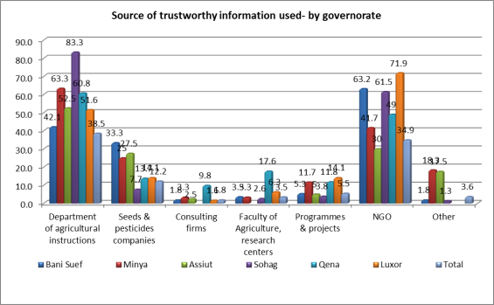

The figure below shows that large farmers benefit much more from existing information service providers than small farmers. While the latter rely primarily on the department of agricultural extension and NGOs, large farmers utilize a wide array of service providers including programmes and projects, the faculty of agriculture, research centers and seeds and pesticide companies. This suggests that not enough effort is being exerted to target small farmers.

Figure 41: Source of trustworthy information: Small vs. Large Farms

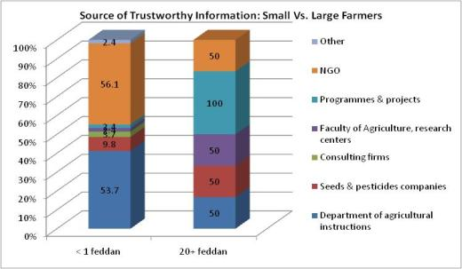

### *Financial services*

It is clear that farmers depend mainly on self-financing in all agriculture processes (Figure 42), which may result in hindering future farm expansion.

Figure 42: Sources of farm and production finance



Apart from self-financing, PBDAC is the main source of formal finance utilized by farmers, especially in Sohag and Qena. Traders’ finance seems to be relatively more widespread in Qena and Luxor. According to participants of Qena interviewed group, formal funding is available only through PBDAC, and at unaffordable interest rates. While in Bani Suef, farmers borrow from the farmer association that provides loans which range between EGP 500 – 2500. Hence, farmers suggested making funds available through the farmers’ association.

### *Farmers’ needs*

Farmers were asked about their needs to improve their work in agriculture, the findings are reported in Figure (43). It is evident that production requirements (72.9%), marketing (44%) and access to information (41%), and extension services and training (48%) are what the vast majority farmers perceive as priorities.

Figure 43: Farmers’ Needs

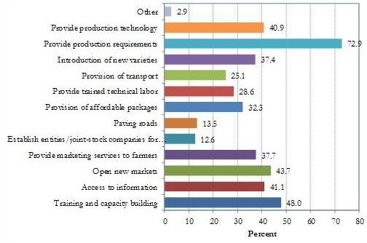

Our in-depth study indicates a wide agreement among our farmer participants on the main problems of horticulture crops cultivation which include; high cost of inputs with no guarantee of quality, high rental cost of farm machinery, high cost of harvest labor, and the scarcity of post-harvest centers. Farmers also reported that they borrow to cover the cultivation expenses. The main lenders are BPDAC, traders, and/or the FA (in the case of Bani Suef). When asked how productivity can be improved, all participants agreed that the quality seeds/seedlings and adopting modern crop production practices are the main factors.

Table (13) shows the needs expressed by farmers from different governorates. Training and access to information and capacity building seems to be more valuable for northern Upper Egyptian farmers compared to those in the south. On the other hand, Southern Upper Egyptian governorates attach more value to marketing services, affordable packaging, trained technical labor, and the provision of production requirements.

Table 13: Farmers Needs by Governorates (%)

|  |  |  |  |  |  |  |
| --- | --- | --- | --- | --- | --- | --- |
|  | Bani Suef | Minya | Assiut | Sohag | Qena | Luxor |
| Training and capacity building | 61.4 | 66.7 | 65.0 | 43.6 | 31.4 | 26.6 |
| Access to information | 52.6 | 46.7 | 67.5 | 28.2 | 33.3 | 31.3 |
| Open new markets | 54.4 | 43.3 | 45.0 | 41.0 | 39.2 | 40.6 |
| marketing services | 35.1 | 20.0 | 47.5 | 43.6 | 43.1 | 39.1 |
| Establish entities/joint-stock companies for marketing | 14.0 | 1.7 | 20.0 | 17.9 | 17.6 | 6.3 |
| Paving roads | 20.0 | 10.0 | 17.5 | 12.8 | 17.6 | 6.3 |
| affordable packages | 19.3 | 31.7 | 25.0 | 42.3 | 37.3 | 32.8 |
| trained technical labor | 21.1 | 16.7 | 22.5 | 37.2 | 47.1 | 25.0 |
| Provision of transportation | 29.8 | 21.7 | 27.5 | 26.9 | 31.4 | 15.6 |
| Introduction of new varieties | 40.4 | 26.7 | 42.5 | 50.0 | 33.3 | 29.7 |
| Production requirements | 64.9 | 61.7 | 77.5 | 79.5 | 74.5 | 78.1 |
| Production technology | 40.4 | 25.0 | 47.5 | 56.4 | 45.1 | 29.7 |
| Other | 8.8 | 8.3 |  |  |  |  |

### 3.2 Workers & work conditions

In all governorates seasonal workers predominate (49%), who have low levels of experience and technical specialization, lack of training, and receive low wages. This is because most famers will not invest in training seasonal workers.

Figure 44: Distribution of workers by type of work

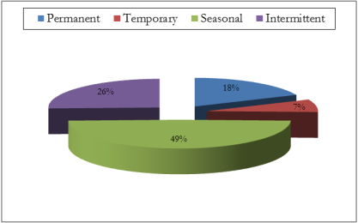

When considering the gender of the workers. Figure (45) shows that in all governorates the vast majority of workers are males. The highest proportion of female workers is found in Bani Suef and Minya (30% and 25.5% respectively).

Our in-depth study revealed lack of satisfaction among workers with regard to their wages and work conditions. In Qena, for example, daily wage reaches EGP 30 for men and between EGP 20-25 for female laborers, while in Bani Suef, daily wage amounts to EGP 40. Workers explain that their wages do not cover transportation; however, in some cases farm owners provide transportation. Workers felt that they have to “find other income generating activities such as rent small agricultural plots, breed cattle, and borrowing”. Financial constraints become even tighter for those who own no land as they lack the required collateral to borrow. However, in Bani Suef, the FA facilitates borrowing for workers especially for the women. Other workers explained that they seasonal laborers work in the construction when out of agricultural working season.

Figure 45: Distribution of Workers by Governorates and gender

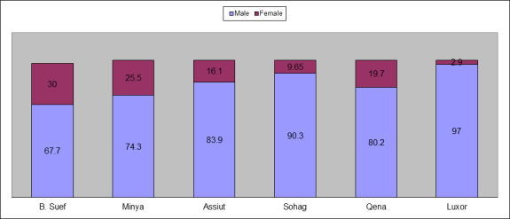

The data presented in Figure (46) clearly show that type of activity greatly affect the average number of working days. Harvesting and crop transfer consume more days than the other farm activities such as fertilization and cultivation. The findings also indicate that small farmers depend on family labor in almost all activities. As mentioned earlier, there is gender division of labor in agricultural work where higher proportion of female workers is found such crop transfer after harvesting.

Figure 46: Average Number of Working Days by Activity, Type of Labor and gender

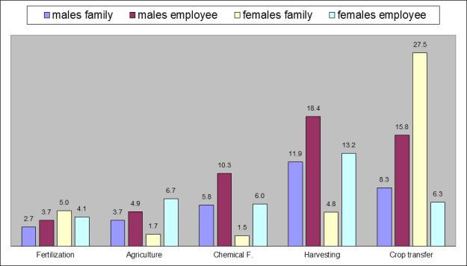

Investigating the relationship between wages and type of activities carried out, our findings did not show significant differences. However, differences do appear when considering type of labor i.e. family workers or employees and when considering gender.

Figure 47: Average wage by type of activity and gender

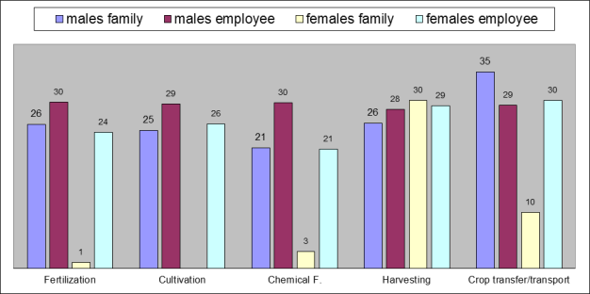

### Work related problems

Complaints regarding work conditions were widespread among agriculture workers. According to Figure (48) low wages was reported by the majority of workers (72%) as the main problem. Lack of wok opportunities and the distance to farms were cited by workers as work related problems.

Figure 48: Work related problems

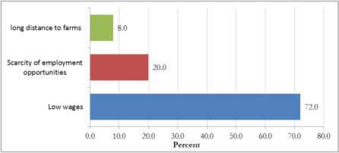

Difficult work conditions cited more by seasonal workers as they have to work in more than one farm (73%). On average the seasonal worker works on 5 farms. Moreover, the average number of monthly working days for seasonal employees is 18.33 days and their average daily wage L.E. 25.57.

Respondents were asked about the main determinants of agriculture workers’ wage, their responses are reported in Figure (49). It is clear that the type of agricultural activity is the key determinant of the wage followed by the age of the worker and the acquisition of technical skills.

Figure 49: Determinants of wage levels

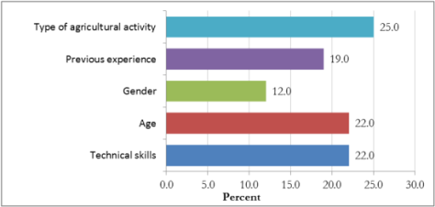

Workers were also asked whether they had received any training or attended any capacity building programs. Our findings show that only 6% of the workers in our sample reported that they have received technical training, and 8% reported that they have attended agriculture seminar and /or lecture.

The results of the in-depth study confirm these findings. Both In Qena and Bani Suef, workers reported that training for laborers is nonexistent. They also clarified that training services are not provided by the extension department or any other governmental body. However, respondents from Bani Suef advanced that Gaafar FA do provide training only for its farmer members. Respondents further specified the types of training they need including greenhouse cultivation, grape pruning, transplanting, citrus and peach production, as they are not qualified to work in the production of newly cultivated nontraditional crops.

With regard to the relationship between laborers and farm owners, our worker respondents described such relationship as “good”. As for working conditions, most laborers complained about hard manual labor and coping with the fluctuation of the weather. Although, they have no complaints regarding the working hours are fair, they advanced that their wages are not sufficient to meet the needs of their households.

It is interesting to note that male workers did not include female workers in their discussion of problems the encounter. This can be explained by the influence of the prevailing traditional perception of women’s role; as our respondents felt that women have specific roles in the production process (harvesting and post-harvesting handling) and should work with specific crops such as tomato and cotton.

### 3.3 Gender & intra-household relations

***Introduction***

There are two channels through which rural households are directly connected to horticulture value chains; through product markets or through labor market (agriculture employment). Investigating intra-household issues will highlight gender differences between men and women’s participation in value chain either as part of a production (as farmers) or as part of agriculture employment (as laborer). Gender differences may affect the allocation of productive resources (land, labor, and capital) within the household and control over incomes generated from production and employment.

To gain a better understanding of the women’s position in the value chain, our analysis will examine gender division of labor both in productive and domestic spheres. It is widely known that gender division of labor is situated within a complex set of rights and obligations within the family. With regard to female farmers, evidence shows that they have limited access to resources considered critical to farming; namely land, labor and capital. In addition, the widespread discrimination against women farmers in extension services and agricultural innovation further curtails women’s abilities to increase or improves their agriculture production.

With regard to female agriculture laborers, available studies showed that women are generally found to be disadvantaged. Cultural, social and religious norms often prevent women in rural areas of developing countries from taking advantage of work opportunities outside the home and/ or the family-farm. Moreover, even if women are able to participate in rural labor markets, they might be disadvantaged because of gender discrimination in wages and work conditions. Gender discrimination in labor markets most importantly comes from wage differences between male and female workers but also from differences between men and women in job security, working conditions, type of contracts, etc. (Joeks, 1999).

Within this framework, several gender-related issues will be addressed in this section including women’s access to resources (land, labor and capital) and their participation in decision making processes, female workers type of employment, wages and work conditions. Our analysis presented in this section draw mainly on both quantitative and qualitative data collected during the fieldwork.

***Characteristics of female sample***

The section begins a brief description of the main demographic characteristics of female farmers and workers as displayed in Table (14). Section (a) gives information on age. Women farmers were mainly concentrated in the age groups 30-39 and 40-49 (54.8%), whereas the majority of female workers (61.3%) are found in the younger age groups 15-19 and 20-29. Section (b) provides information on women’s educational level. The vast majority of female farmers (85.2%) were illiterates compared to 54.8% of female workers. Those who reported that they had obtained a primary certificate did not exceed 4.7% among farmers.

Among workers 19.4% reported that they had obtained school certificate, and 6.6% advanced that they had a diploma. Section (c) gives information on marital status 55.5% of female farmers are widows and heads of their households. With regard to female workers the majority are married (51.6%) and 54.8% are either divorced or widowed. It interesting to note that relatively large proportion of the workers (38.7%) is single.

Table 14 : Basic Demographic Characteristics of Female Farmers &Workers

|  |  |  |  |  |  |  |  |  |  |  |  |  |  |  |  |  |  |  |  |  |  |  |  |  |  |  |  |  |  |  |  |
| --- | --- | --- | --- | --- | --- | --- | --- | --- | --- | --- | --- | --- | --- | --- | --- | --- | --- | --- | --- | --- | --- | --- | --- | --- | --- | --- | --- | --- | --- | --- | --- |
| **(a) Age** | **15-19** | | | | **20-29** | | | | **30-39** | | | | **40-49** | | | | **50-59** | | | | | | **60+** | | | | | | **Total** | | |
| **#** | **%** | | | # | % | | | # | % | | | # | % | | | # | | | % | | | # | | | % | | | # | | % |
| **Farmer** | 0 |  | | | 0 |  | | | 5 | 18.5 | | | 8 | 29.5 | | | 11 | | | 40.7 | | | 3 | | | 11.1 | | | 27 | | 100 |
| **Worker** | 10 | 32.3 | | | 9 | 29.0 | | | 7 | 22.5 | | | 4 | 12.9 | | | 1 | | | 3.2 | | | 0 | | |  | | | 31 | |  |
| **(b) Education** | | **Illiterate** | | | | **Reads& write** | | | | **Primary** | | | | | **Preparatory** | | | | | | **Intermediate & University** | | | | | | **Total** | | | | |
| **#** | | **%** | | # | % | | | # | % | | | | # | | | % | | | # | | | | % | | # | | | % | |
| **Farmer** | | 23 | | 85.2 | | 2 | 7.4 | | | 2 | 7.4 | | | | 0 | | |  | | | 0 | | | |  | | 27 | | | 100 | |
| **Worker** | | 17 | | 54.8 | | 6 | 19.4 | | | 3 | 9.7 | | | | 3 | | | 9.7 | | | 2 | | | | 6.4 | | 31 | | | 100 | |
| **( c) Marital status** | | **Single** | | | | **Married** | | | | **Widowed** | | | | | | **Divorced** | | | | | | **Total** | | | | | |
| # | % | | | # | | % | | # | | % | | | | # | | | % | | | # | | % | | | |
| **Farmer** | | 1 | 3.7 | | | 11 | | 40.7 | | 15 | | 55.5 | | | | 0 | | |  | | | 27 | | 100 | | | |
| **Worker** | | 12 | 38.7 | | | 16 | | 51.6 | | 2 | | 6.5 | | | | 1 | | | 3.2 | | | 31 | | 100 | | | |

***Farmer women’s roles and responsibilities***

Our results show that women farmers shoulder the responsibility of their farms as well as their domestic work. When asked whether their husbands help them in their farm work, 56% of our respondents reported that husbands are involved in all agriculture activities. Despite their double responsibilities and burden when asked whether their work in the farm affect their domestic work, all women answered negatively.

In their farms, women are engaged in various activities. Two thirds of women farmers reported that they are engaged in harvesting and post-harvest activities. One third advanced that they work in production process (cultivation). However, none of the female farmers reported working neither on preparation of land nor in pre-harvest operations. Such finding indicates that there is gender division of labor in agriculture activities which need more in depth investigation.

However, our in depth investigation further revealed a rigid gender segregation in agriculture processes and also shed light on women’s limited access to resources including land and income. Our female respondents both in Qena and Bani Suef explained that their ownership of land does not automatically grant them the right to make decisions related to the production. This can be explained by the wider social and cultural views regarding traditional gender roles and the strong attitudes towards preventing land fragmentation.

The results of the in-depth study from Qena and Bani Suef revealed differences in female farmers’ role in production. In Qena, women interviewees reported that they have absolutely no control over the land they own despite their major labor input to the production process. They also have little say over the proceeds of what sold or any decision making. During the fieldwork in Qena women had to obtain a permission from their husbands or other male figures in the family to be interviewed. In some cases the husband (or the son in the case of widowed female) was present during the interview. In justifying the situation most women advanced that men “know better about the land”, or that they “have to consult with them when it comes to the farm”.

In Bani Suef, on the other hand, being members in FA, female farmers exhibited higher degree in independence. Unlike their Qena’s female famer counterparts, they reported that they are individually involved in signing production contracts and deal with traders through the FA. They also claim that they take a bigger part in decision making and have some control over their farms proceeds. It is clear that the role the FA led to greater empowerment for women small farmers.

However, when considering gender division of labor in production stage of the horticulture value chain, no differences were depicted between the groups of small farmers in the two governorates. Our findings are in line with the available literature on female farmers in developing countries which revealed that women are concentrated in specific agriculture activities. All women interviewed believed that there are certain types of activities that women can carry out especially those related to harvesting and moving the produce to the packing house or FA. On the other hand, all the other technical aspects of the production are perceived as male farmers’ responsibility. One can conclude that due to the exclusion of women from these processes, they are likely to benefit less form their production. This can be better understood if we take into account the gendered power relations. Women normally occupy a subordinate position relative to men within power relations, which can be replicated within the functioning of the value chains. In this case governance is linked to women's concentration in particular types of activities within the value chain (Joekes 1999).

***Female workers’ roles & responsibilities***

When considering the roles and responsibilities of female workers, our results showed similarity between them and their farmer counterparts. Female workers solely assumed the domestic responsibilities as well as their work in agriculture outside their household.

The vast majority of women workers (88.2%) reported that they can manage working outside and inside the household. However, when asked whether their work affect their health 47.1% of female workers answered affirmatively.

As we mentioned earlier, gender discrimination in rural labor market comes mainly from type of employment, wage differences and work conditions. The results of our baseline survey [17] show that the vast majority of female workers as seasonal workers (62%) have no technical skills (97%) and had never received any technical training (98%). Slightly higher than a quarter of the female laborer work in four to five farms.

When considering the wage they receive, the majority of respondents (70%) reported that they receive a daily wage between 20 to 30 EGP. As mentioned earlier there is gender wage gap in all the activities performed by women, on average women workers received around 90% of men’s wage. It is interesting to note that all female respondents justified the wage gap between male and female workers by the nature of tasks that men perform which require specific skills that they lack.

Female workers are also concentrated in specific agriculture occupations. Like their farmers counterparts they are mainly engaged in the harvesting processes. The intensity of women’s labor increases in processing activities such as peeling cutting sorting. Men on the other hand are more involved in activities related to operating and maintaining machinery and other agriculture processes.

The results of the focus group discussion with female workers in Bani Suef shed light on the role played by FA (Gaafar) in supporting them. The FA had offered these women trainings on communication skills, sorting and packing green beans, and also organizes monthly seminars to raise their awareness on issues such as health, raining children, hygiene etc. However, almost all women interviewed felt that they need training on various agriculture processes and activities. With regard to the time and location of future trainings, all women reported that they prefer the training to be held in summer season, during the morning periods, and in FA.

***Work- related problems***

The results of the in-depth study confirmed the survey results with regard to work related problems that women encounter. The main problem for the majority of female workers (82.4%) was low wages. During the focus group discussion women complained about the low wage they receive which does not match the long working hours, one of the women further explained:

“Sometimes I work in harvesting which is not appropriate for a woman my age [*only young female work in this activity*] to earn more money. I have a family to provide for”

The other problem that the female workers cited was the seasonality of the work, which means that they become unemployed for many months, which negatively affect their living conditions. Some women suggested learning other skills such as sewing to help them earn an income during these periods.

To investigate whether there are gender specific problems in agriculture work, female workers were asked about the problems they encounter in their work. A quarter of respondents cited difficult work conditions including long working hours, delay in work and unspecified time for work as the main problems they encounter. Some respondents (12%) mentioned problems related to their domestic responsibilities, especially those with young children, as they have to look after them during their work.

Figure 50: Problems encountered by female workers

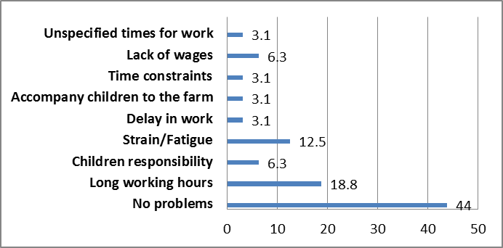

Women workers also reported that they suffer from health problems. Figure (51) indicates that bone ache is the most prevalent health complaint among female workers (35.7%). It is worth noting that female workers from Qena suffered from all health problems cited. That is because the majority of women workers who reported having health problems were from Qena (11 cases out of 14 cases).

Figure 51: Female workers health problems by governorate

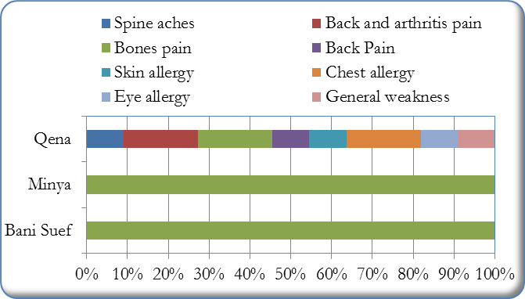

When asked how their working condition can be improved, responses vary. The majority of female workers (41.9%) suggested increase in their wages. Other respondents proposed providing better work opportunities for women in agriculture (22.6%) or in non-agriculture work (3.2%).

Figure 52: How female workers situation can be improved

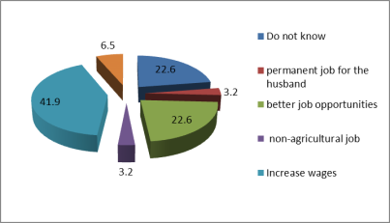

During the interviews, many female workers expressed their willingness and need to receive training on aspects related to post-harvesting training and production.

### *Domestic decision-making*

One important indicator of women’s empowerment is the degree of their participation in the domestic decision-making processes. This section examines the patterns of decision-making regarding various household matters including: household expenditure, children’s education, marriage, and work.

In the survey, respondents were given a list of the various decisions related to domestic matters, each with four possible answers depending on whether the decision was made by the husband, the wife, jointly, or by others (grandparents or children). Dominance in decision-making is used to determine where control lies between husbands and wives in the household. Making the decision jointly (both husband and wife) indicates a degree of equality between spouses.

In general, our survey results revealed that husbands are the main decision-makers in the household in all domestic matters. However, literature on household budgeting in Egypt indicates that there are specific domestic matters that women are the main decision makers such as all decisions related to daily household expenses (e.g. Hoodfar, 1997)[18]. Figure (53) shows that husbands dominate decision making in all domestic matters, the wives, on the other hand, have some say in specific matter such as buying her needs (26.9%) and daily expenses (19.1%). All decisions related to children are taken jointly, such as children’s education (31.7%), children’s marriage (40%), and children’s work (30.3%).

Figure 53: Decision making in farmers households

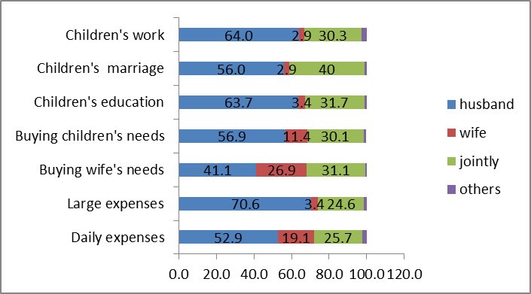

When considering female workers degree of participation in domestic decision making the picture differs. Figure (54) indicates that the degree of female workers’ participation indecision making is slightly higher than that of their farmer counterparts. The results show that women have more say in issues related to daily expenses (22%), buying her needs (26%) and her children’s needs (19%). Like farmers households the decisions related to children are either made by husband alone or jointly by husband and wife.

Figure 54: Decision making in workers households

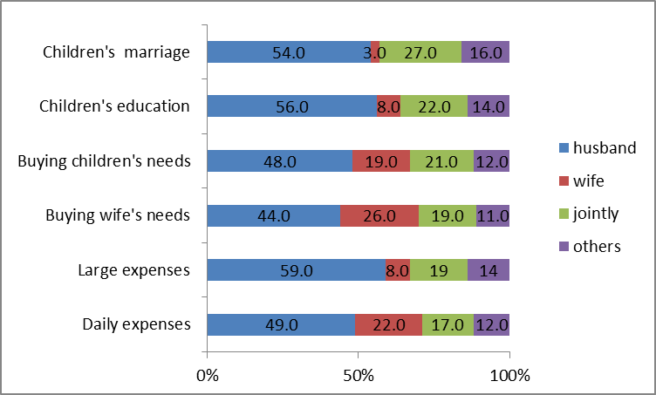

It is interesting to note that the results of the in-depth study regarding women participation in decision making confirm the survey results. Both women farmers and workers agreed that men have the final say on domestic matters. Women’s decision making is limited to areas of daily shopping and children’s need.

## Institutional Capacity Assessment

This section presents the results of the institutional capacity assessment carried out for the 17 FAs and the three PHCs. As mentioned earlier the main objective of this assessment is to gain a better understanding of the current capacity and gaps of these institutions. In the case of FAs the assessment would help in identifying the most suitable FA to partner with the project. In the case of the PHCs the assessment will help in the need to improve the facilities and work procedures. Each assessment will begin with a brief review of the literature followed by the key discussion of the main findings.

### 4.1 Farmers associations

In 2003, under the USAID-funded grant, CARE began with the Ministry of agriculture began to organize and register voluntary member based service- oriented Farmers associations in Upper Egypt. These FAs are different from state-managed Agriculture Cooperatives. The aim was to allow small land-owning farmers into an FA to help them to work as a group with buyers and exporters under forward marketing agreement.

These associations were an attempt to overcome the problem of land fragmentation has been the introduction of Farmers Associations (FAs). The USAID project "Agricultural Exports and Rural Income, AERI" (2004-2007) helped in establishing and developing 105 community-based service associations (NGOs) in Upper Egypt. A recent assessment of FAS revealed that while FAs vary in their development, they all provide or are intending to provide following services to their members and community[19]:

* agricultural extension services
* contract farming and marketing
* providing agricultural supplies and machinery
* conducting field days and workshops on seeds and supply inputs
* providing training services
* microfinance through small loans
* exporting
* health, educational and social services

E-Trace conducted a preliminary assessment of FAs in Upper Egypt based on:

* Degree of professionalism, and capacity to serve larger members base
* Enthusiasm
* Effectiveness of activities conducted
* Level of achievements in terms of their track record
* Willingness to effectively cooperate with future projects and initiatives

One of the main findings of the assessment of FAs is that they did not evolve out of a collective conscious effort on the part of the small farmers[20]. Rather their artificial development caused them to be idle and devoid of motivation to service their members. This in fact reflects a deeper cultural challenge whereby small farmers seem reluctant to engage in collective farming or marketing. This in turn hinders the success of associations as well as their integration into the supply chain. Of the 150 FAs less than 20 were found to be active by E-trace. These in general suffer from several institutional and management weaknesses that need to be addressed in order for FAs to play a significant role in improving the conditions of small farmers[21].

The farmers associations need technical assistance and extensive capacity building programs to allow for professional management of the following services:

* Professional production extension services including the selection of suitable varieties, provision of advisory services on planting and harvesting times, irrigation, fertilization and integrated pest management; in addition to good production, harvest and post-harvest practices.
* Promotion of group farming and the provision of contract farming services connecting producers with local and export markets.
* Fund-raising activities and communication with donors and development initiatives to leverage resources.
* Promotion of organic agriculture systems among small farmers’ groups[22].

### *Key findings:* general assessment

The findings are organized in accordance with the broad areas covered in research instrument including governance, operation and management system, human resource management, service delivery, and external relations. In general, our assessment shows that:

* Most of the associations fall under the “Developing” stage of development. Board members do not play a leadership role.
* Outreach to community members improving, but primarily on ad hoc basis.
* Most decisions taken by Board and Executive. Leadership still seen primarily as controlling people to do right through a system of rewards and punishments.
* Informal ways exist for getting things done but they are not yet formalized by documentation.
* For those with staff members, no assessment of performance conducted and therefore no planning done and carried out to change or improve the performance of individuals.
* Basic financial recording systems and informal accounting manuals in place. Independent audits or external financial reviews are rarely performed.
* Associations are known in their own communities, but do little to promote their activities with the general public. Little communication among associations.

### *Governance*

* Most of the associations have vision and mission statements that have been developed with external support (mainly CARE);
* Except for the four members identified by law 84 (Chairperson, Vice Chairperson, Treasurer, and Secretary), no clear written roles for board members for almost all associations;
* General perception of Board members role is to provide leadership and direction to the Associations while supervising the implementation of panned activities;
* Some associations have been founded by a (few) charismatic individual(s) with a strong commitment to a cause or purpose and a definite set of ideas about how to serve that cause;
* In the most of the associations, women role – if any – is limited to woman/family related activities or some admin work;
* No vision or plans for board members capacity building, rather members take advantage of the training opportunities that are usually available through funded projects;
* Board decisions are usually circulated to concerned bodies; i.e. MSS or beneficiaries in case of new projects;
* No participation mechanisms are there. Only beneficiaries invited to consult on new contracts with exporters;
* However, at few associations, senior staff members invited to board meetings to discuss on specific technical issues.
* Staff independence from the board was clear at limited number of associations,

### *Operations and management systems*

* 50% of the associations have strategic plans, and most of them received training on strategic planning;
* To address women needs, some associations included activities like animal breeding and environmental awareness in their strategic plans;
* Strategic plans were reflected in the annual plans in most cases;
* Some associations (35%) have policies and procedures manuals; developed mainly with the assistance of CARE or the NGO Center;
* As for the other associations, only internal regulations are in place;
* Almost no policies taking into consideration women needs were found,
* The prevailing model as a participatory approach is to invite GA members to discuss on new contracts.

***Human resources management***

* In the majority of the associations there no staff members;
* No job descriptions with clear roles and responsibly found at the remaining associations who have staff members;
* Female staff members represent 15 to 50% of the workforce in most of the associations having staff members;
* Posting job ads at public places is the common way to maintain transparency and equal opportunity in staffing;
* Priority was given to women for handling income generating activities for family, administering loans, secretary, and working at PHCs.
* Staff participation is there when in need to decide on technical or program related matters,
* Room for women participation is limited due to their weak presence in the board member and within the executive staff;
* There are no plans for staff development. Rather staff trained (including female staff members) according to emerging needs (PHCs), or through opportunities donors provide;
* Almost no mechanisms for staff performance evaluation;

### *Service delivery*

* Conducting needs assessments prior to interventions is limited to CDA type of investigated associations;
* Unlike FAs, only CDAs maintain beneficiaries participation (including women) in project planning and implementation;
* Only few associations achieved sustainability for their activities; examples include agricultural and non-agricultural paid services, and potatoes contract farming;
* Addressing women needs through animal breeding, handicraft training, loans for FHHs, & family planning found at some associations;

### *Financial resources management*

* Financial procedures are there and according to law;
* Annual external audit report was in place at only few associations;
* Usually, treasurers handle financial procedures as there are no financial departments/staff members at most of the associations;
* Most of the associations received in-grant support in the form of assets from agencies like American Embassy CARE, USAID, SFD, UNICEF, UNOPS;
* No resource development plans are in place; however, the majority of associations rely on membership development, donations, income generating projects, contract farming, proposal writing, and renting greenhouses and tractors as strategies to cover operational costs;

### *External relations & outreach*

* MSS, MALR, private sector, Agriculture Directorate, Irrigation Department, NRC, ARC, FAs and donors are the main partners the associations deal with;
* Regularity of communication with stakeholders differ from seasonal to annual basis according to the nature of partnerships;
* Collaboration among farmers associations ranges from coordination to full partnership;
* Associations tend not to communicate the impact of programs and activities; rather they market their services among potential beneficiaries;
* Few associations engaged in advocacy activities which included raising the price of sugar cane crop and the dissemination of environmental agriculture;

### *Relationship with FAs: Farmers ‘perspective*

In baseline survey, small farmers were asked about their views regarding the FAs, their membership and the services they receive. Our findings show that the vast majority of the farmers in our sample (75%) have been members in the FAs for 3 years. the majority of the farmers (71%) reported their membership in the association was beneficial to them in terms of the services they received. No significant differences were depicted in the length of farmers’ membership among the governorate under study.

To assess the impact of their membership in the association on their farms, respondents were asked whether their membership has affected their profits. In general, as figure (55) shows, half of farmers reported that they experienced an increase in their profit, slightly less than half reported that they experienced no change, and only 1% reported that their profit decrease.

However, when assessing the impact of membership in the association by land size responses vary. Our findings indicate a strong relationship between land size and increase of profit. The farmers with larger size of land (< 10 feddans) experienced increase of their profit.

Figure 55: impact of farmer’s membership in FAs on their profit by land size

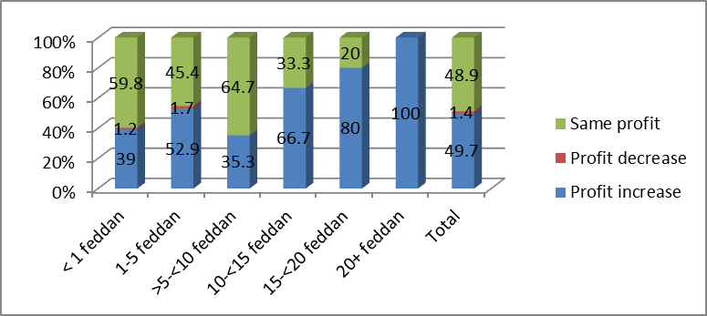

Similar differences were captured when investigating the impact of FA membership across the governorates under study. It is evident that increase in profit was experienced by farmers in active FAs. Our in-depth investigation in Bani Suef and Qena showed that farmers benefited because these associations were very active in serving their members especially Gaafar in Bani Suef.

Figure 56: impact of farmer’s membership in FAs on their profit by governorates

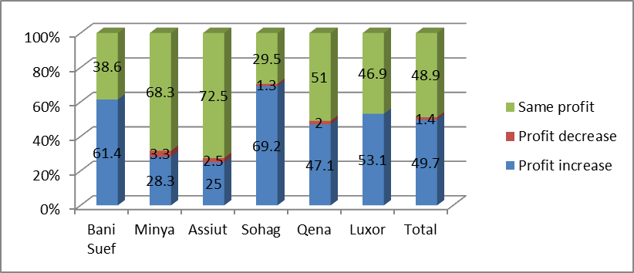

Respondents were also asked about the services they received from their associations. Figure (57) indicates that technical support ranked first 72%, followed by marketing information/ services 58.2%, and finally information regarding horticulture (53.3%). It is worth noting that not all FAs visited provide such services.

Figure 57: services provided for Farmers

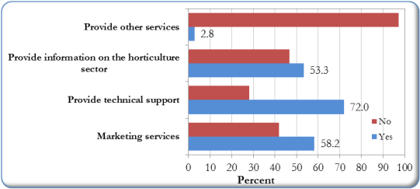

Respondent were also asked to assess the services they received from the FAs. Slightly more than half the sample of farmers reported that they services were good. 26% of the farmers described the services as fair while 22% claimed that it is bad. Differences among governorates were evident. It seems that the more the FA active in serving its members the higher the degree of satisfaction among farmers.

Figure 58: Farmers assessment of FA services by Governorate

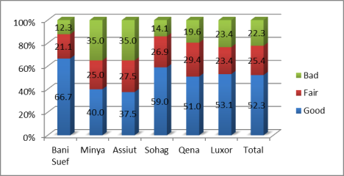

When considering the size of land, our results also revealed slight differences in farmers’ assessment of the services provided by the FA. Farmers with bigger farms exhibit a higher degree of satisfaction with the services compared to those with small-holdings. However, one can safely say that in general there is relatively high degree of satisfaction among all farmers (as shown below).

Figure 59: Farmers assessment of FA services by size of landholding

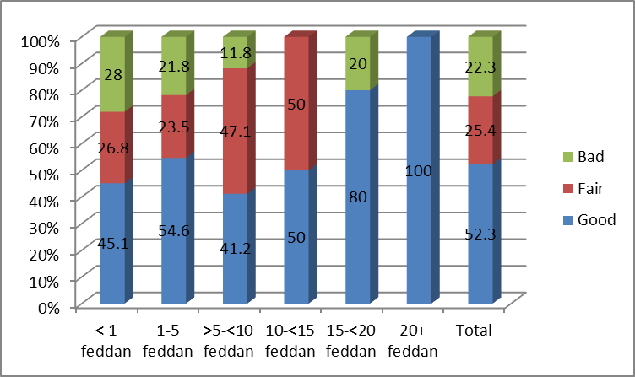

Our in-depth study in Gaafar in Bani Suef shows the importance of FA for women. Most women interviewed whether small farmers and workers emphasized the role of the FAs in their work. Some farmers mentioned that they provide buyers and help them in signing contracts; FA provides them also with inputs including fertilizers and seeds. Female workers reported that the FA employs them in sorting and grading and find them work opportunities in farms in the locality. However, most women workers felt that seasonal work was not enough because they have long periods with no work which negatively affect their living standards.

On the other hand, when male farmers were asked about their relationship with the farmer association, most participants from Qena reported that “The first unsuccessful contract farming of beans has negatively affected the relationship between farmer members and their association”. Moreover, they receive almost no services from the association. Unlike in Qena, Farmer members of FA in Bani Suef (Gaafar) are satisfied with services they receive. These include providing inputs, cleansing small canals, sub-soiling, soil analysis, and technical support. However, in addition to a more effective marketing role, they still need post-harvest services, and further technical support on all agricultural practices. The farmer association, according to participants, differs from the governmental cooperative one in that it extends its services to landless farmers.

In their assessment of the problems and shortcomings of their FAs, it is interesting to note that unavailability of services and not matching farmers’ needs were the main problems cited by our respondents (61.4%).

Figure 60: Shortcomings of the FAs

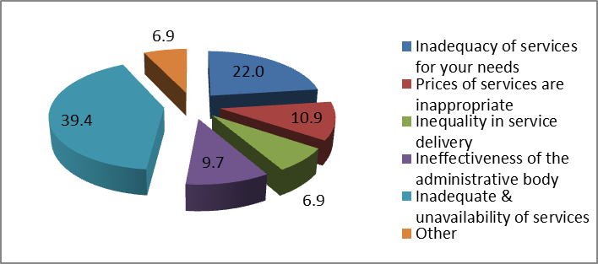

Respondents were also asked whether they will support the transformation of their FAs into private companies owned by its members. In general, the majority of farmers answered affirmatively (61.1%). Figure (61) revealed little differences among farmers when considering the size of their farms

Figure 61: Farmers’ opinion regarding the transformation of FA by land size

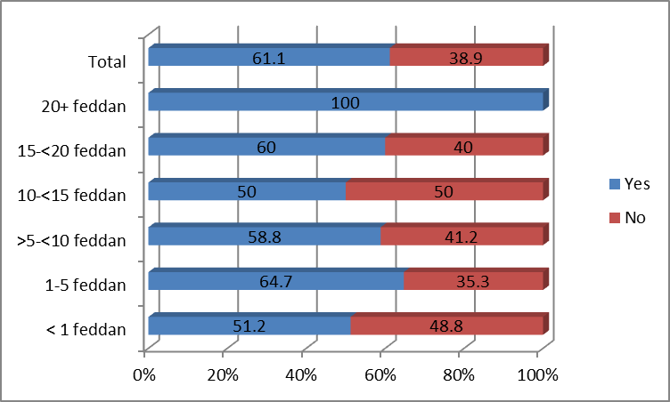

However, when considering farmers’ opinion by governorate, responses vary. The highest proportion of farmers who answered affirmatively are concentrated in Luxor and Sohag (71.9% and 70.5% respectively), whereas the lowest proportion are found in Bani Suef and Assiut (52.6% and 52.5% respectively).

Figure 62: Farmers’ opinion regarding the transformation of FA by governorate

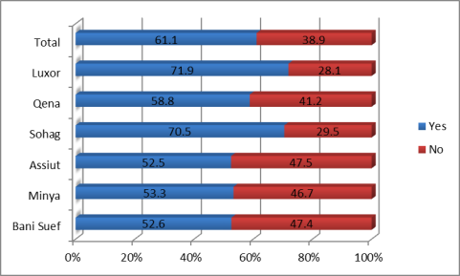

### *Challenges & constraints: FAs perspective*

The assessment also focused on the challenges that FAs encounter and hinder their work. Some theses problem related to farmers and farms in general such as lack of access for small farmers to funding; and Insufficiency of post-harvest centers in Upper Egypt; Canceling crop rotation; and the diminishing role of Agricultural Directorates in providing extension services. Other constraints and problems are directly related to the work of the FAs such as:

* The relative concentration of government support on the exporters’ side rather than on the farmers’ side;
* The constraints posed by the legal status of Associations and their ability to function in an entrepreneurial manner that serves the farmers;
* The weak transportation infrastructure (e.g. lateral and access roads)
* Lack of training and capacity building after CARE
* Lack of funds to help in providing the needed services

### *Proposed associations*

Based on the preceding discussion, the following criteria were used to select the best farmers associations for future collaboration:

* Geographic distribution.
* Potential Competitiveness of Value Chain.
* Institutional Capacity of FAs

Our assessment revealed that the following FAs constitute the best option for the project:

* + **Associations having PHCs**
    - Bani Soleiman El-Sharq
    - Agricultural Community Development Association, “Al-Bayaho”
    - Upper Egypt Future for Agricultural Community Development , “Dandara”
  + **Associations with sound institutional capacities**
    - Agricultural Community Development Association, “Awlad Yehia”
    - Community Development Association, “Gaafar”
  + **A potential association with reasonable institutional capacities**
    - Association for the Development of Farmers Community in El Tood
    1. **Assessment of the PHCs**

***Post-Harvest Centers (PHCs) in Egypt: an overview***

The post-harvest centers in Upper Egypt was provided as in kind grant by USAID/ CARE project. There are more than 20 post-harvest facilities privately owned in Upper Egypt as well as a number of cold stores distributed in the region. This sector is witnessing significant development including efforts in constructing new roads such as the Cairo – Assiut, and the Western Desert Road. Moreover, a newly established perishable terminal at Luxor Airport went into operation in 2008 serving direct exports from Luxor to Europe using low cost spaces of charter flights. These, among other efforts, will serve to significantly reduce the logistics and transport costs; thus enhancing the integration of Upper Egypt supply chain into both domestic and export markets. These developments present a window of opportunity that should be complemented by the programme in order for benefits to accrue to small farmers[23].

For the current assessment, the three PHCs owned by FAs constituted our sample. These PHCs were established by the USAID project "Agricultural Exports and Rural Income, AERI" (2004-2007) in Bani Suef, Minya and Qena Governorates. The commissioning and start-up activities for these centers were finalized by mid-2009, except for the Qena PHC which is suffering from water supply problems and as such has not yet started operations[24].

A situation analysis survey of the three PHCs in Bani Suef, Minya and Qena was conducted by E-trace. The aim of the study was to identify technical, institutional, financial, and labor aspects of these post-harvest centers. The results of the survey revealed that “these associations have a strong potential for providing competent services, but with the need for substantial assistance to reach sustainability. Although initial assistance has been provided, these associations still have technical and managerial gaps that have to be reduced in order to enter into a mature business phase. The three associations now owning new post-harvest centers also lack sufficient technical knowledge and managerial skills needed for effective operation of these facilities”[25]. Among the main needs of the post-harvest centers as highlighted in the survey:

* Capacity building of the responsible staff in administration and management skills
* Improve linkages with operators and exporters;
* Technical assistance in quality and food safety to reach compliance with quality and food safety international standards (BRC, ISO 22000, HACCP, etc.).

***Description of PHCs***

In general, the three facilities have more or less the same design, equipment and production capacity (40 tons/day). Each PHC is built on 2500 m2 and consists of the following:

* Loading and receiving platforms
* Multi-purpose semi-automatic production lines
* Pre-cooling unit with capacity of 40 tons/day
* Cold stores with capacity of 100 tons
* Administration offices with an area of about 200 m2
* IT and office equipment
* Warehouses for packing material and spare parts
* Changing rooms and toilets
* Electrical generator in a separate room
  + - * 1. **The Bani Suef PHC**

The packing house was established in 2008. The center is affiliated to As *Sharq* Association for Development and Production; based in East Bani Solaiman, Bani Suef. It occupies an area of over 2500 m2 (50m x 50m x 6m dimensions).

The main products in this packing house are green onions, garlic, beans, grapes, pomegranates, at a production capacity of 100 tons per month. (Maximum production capacity reached so far). The total employment is 120 workers, the majority of whom are female workers (100 workers). Female workers are employed as temporary workers; they carry out technical work (such as sorting and packing) while males perform physical work.

* 1. **The Minya PHC**

**Al-Bayaho Association for the Development of Agricultural Community**; is the packing house established in 2008. It is located in western desert road- 6.5kilometers away from Samalout Traffic Department- Mubarak Al-Azima village- Minya. It occupies an area of 2500 m2 (50m x 50m x 6m dimensions).

The main horticulture products handled in this pack house are grapes and pomegranate at a production capacity of 40 tons a day (maximum production capacity so far).

With regard to employment, the packing house employs 110 workers, here again the vast majority of whom are female workers (72%) hired as temporary workers. Females carry out post- harvesting handling such as sorting and packing, while males perform physical work.

* 1. **The Qena PHC**

The **Upper Egyptian Future Association for the Development of Agricultural Community** is the packing house in Qena was established 2008. It is located in Nag Hammadi-Qena western road near Kom Ombo pumping station Al-Marashda, Qena. Its total area is 2000 m2 (50m x 40m x 6m dimensions).

The main products handled in this packing house are grapes and Cantaloupe at a production capacity of 57 tons a day (maximum production capacity so far).The packing house employs 80 workers, the majority of whom are females (75%). Female workers are mainly engaged in post-harvest handling (sorting, grading and packing) while males perform physical work.

It is important to note that the three PHCs extend their services to suppliers from neighboring governorates as well as the main collection centers in the value chain in Upper Egypt.

***Key findings***

***Quality Management System***

Our investigation reveals that the three PHCs have no quality management systems in place, thus they do not deal with any supplier applying such systems.

1. Lack of quality policy in the PHCs:
   * The PHC should have a clearly defined and documented policy statement;
   * The policy should state PHC’s obligations to produce safe and legal products;
   * The policy should be comprehensible by all supervisor staff, key personnel, and implemented accordingly.
   * The policy should be communicated throughout the PHC, and be reviewed regularly.
2. Lack of quality manual in all PHCs. The PHCs should have a Quality Manual which include the following:
   * PHC commitment to quality and safely which covers the requirements of food safety standard.
   * An outline of working methods and practices, or references to where such an outline is found.
3. Absence of Organizational Structure, Responsibility and Management Authority
   * The PHCs should have an organizational structure which comprises job description, role and responsibilities including occupation hierarchical relationships. The activities that affect product safety, legality and quality should be clearly defined and documented.
4. Lack of Management Commitment. The PHC’s top management should be:
   * Fully committed to the development, implementation and improvement of the food safety Management System.
   * Ensure that the quality and safety measures are established and maintained.
5. Absence of Customer Focus procedure.
   * The PHC’s top management should ensure that the processes that determine their customer’s needs and expectations are in place.
   * Performance indicators should be established in relation to customers’ satisfaction and that these indicators should be communicated to appropriate staff.
6. Lack of Management Review procedure.
   * The PHC’s top management should review the effectiveness of the Food Safety Management Systems at planned intervals. The review should ensure a critical evaluation of the Systems’ suitability, adequacy and effectiveness, and identify the need for change.

***Products***

The PHCs work on products that meet customer requirements; however, they lack technical personnel who can do quality control on the products.

**Current products**

* 1. In **Qena:** Upper Egyptian Future Association for the Development of Agricultural Community”, the main products are Grapes and Cantaloupe. These are available during the periods from May to July and from December to February.
  2. In **Minya:** Al-Bayaho Association for the Development of Agricultural Community**”,** the main products are Grapes and Pomegranates. These are available during the periods: from May to July and from September to November
  3. In **Bani Suef:** Al Sharq Association for Development and Production, the main products are Green onion, Garlic, Beans, Grapes and Pomegranates. These are available from October to July of the following year.

Table 15 Current Product by Governorate & Season

|  |  |  |  |  |  |  |  |  |  |  |  |  |  |  |  |  |  |  |  |  |  |  |  |  |
| --- | --- | --- | --- | --- | --- | --- | --- | --- | --- | --- | --- | --- | --- | --- | --- | --- | --- | --- | --- | --- | --- | --- | --- | --- |
| Month  Crop | Jan | | Feb | | Mar | | Apr | | May | | Jun | | Jul | | Aug | | Sep | | Oct | | Nov | | Dec | |
| **Qena** | Grapes |  |  |  |  |  |  |  |  |  | | |  |  |  |  |  |  |  |  |  |  |  |  |  |
| Cantaloupe |  | | | |  |  |  |  |  |  |  |  |  |  |  |  |  |  |  |  |  | | | |
| **Minya** | Grapes |  |  |  |  |  |  |  |  |  |  | | | |  |  |  |  |  | | | |  |  |  |
| Pomegranates |  |  |  |  |  |  |  |  |  |  |  |  |  |  |  | | | | | | | |  |  |
| **Bani Suef** | Grapes |  |  |  |  |  |  |  |  |  |  | | | |  |  |  |  |  | | | |  |  |  |
| Pomegranates |  |  |  |  |  |  |  |  |  |  |  |  |  |  |  | | | | | | | |  |  |
| Green onion |  | |  |  |  |  |  |  |  |  |  |  |  |  |  |  |  |  |  |  |  | | | |
| Garlic |  |  |  |  | | | | | |  |  |  |  |  |  |  |  |  |  |  |  |  |  |  |
| Beans |  | | | |  |  |  |  |  |  |  |  |  |  |  |  |  |  |  |  |  | | | |

* In Upper Egypt products meet the quality specifications and face growing demand because they are available in appropriate marketing periods of time. However, to increase their marketing opportunities there is a dire need for a professional marketing staff.
* There are no Procedures in place to ensure that product packaging conforms to specification. It is also evident that packaging does not comply with relevant food safety legislation and suitability for use.
* **Product Inspection and Analysis:** There is no monitoring of all incoming raw materials to ensure their compliance with the specifications based on risk assessment. Moreover, inspection method, procedures and frequency neither specified nor documented. Suppliers of raw materials are not required to provide evidence of guarantees, certifications/declarations of analysis or certificates of conformity.
* **Product Release:** There is no system to ensure that the product is released by authorized personnel.
* **Control of Non-Conforming Product:** The PHCs lack designated places to isolate non-conforming products. Moreover, the PHCs lack clear procedures for the control of non-conforming materials including rejection, or regarding for an alternative use.

***PHCs complaints***

The three PHCs reported the following as the main problems they face:

1. Water shortage in the station
2. Lack of technical and administrative staff in the station.
3. Lack of measuring and monitoring equipment.

***Transportation and handling***

Appropriate vehicles**:** The vehicles used by the PHCs are not appropriate; because they are not well equipped to transport perishable produce given the long distance they travel.

Roads**:** During the fieldwork problems related to roads was depicted in one PHC; namely **Upper Egyptian Future Association for the Development of Agricultural Community** in Qena, as the road from Al-Marashda to Nag Hammadi - Qena western road is bumpy.

**Supportive facilities such as:**

1. Shipping companies
2. Ports and airports

Luxor – Safaga, Cairo Airport as well as ports of Alexandria, Damietta and Port Said.

1. Incentives:

Quality of crops: Crops characteristics such as color, weight, size and TSS are very good

1. Time of production: Crops available in the beginning of the export season.

***Relationship with farmers***

Currently, the PHCs deal with individual farmers in the same locality as well as the farmers in the region surrounding each association. The farmers (suppliers) are selected based on the required quantities and quality of their produce, and the ability to deliver on time.

When asked whether there is any difference in dealing with male and female farmers, our respondents answered affirmatively. All respondents advanced they prefer to deal with female farmers because they deliver a better quality produce than their men counterparts.

***Contracting and payment***

In the pre-contracting process, the method of payment and quantities to be supplied are agreed upon; therefore, the supplying process takes place smoothly and easily. The PHCs need professional technical, administrative and marketing staff as well as technical support for farmers. The PHCs also need invoices from suppliers as well as analyses of pesticides residues and other applied control programs.

***PHCs infrastructure***

1. Production steps: The PHCs are equipped with production lines which are appropriate for the production of some crops like grapes, Green beans, pomegranates, but they are in need of amendments and additional parts to produce other crops like cantaloupe, green onions ... etc.

2. Operation steps: The PHCs are designed in a way that ensures that no contamination can occur in the operating process. The PHCs may need more arrangement of production steps inside them to reduce contamination risks and workers need continuous training.

3. Walls and ceilings are well designed, but the stations should design and implement a cleaning and maintenance program.

4. Drainage system: The current drainage system needs periodical maintenance and cleaning; wider-diameter pipes should be used instead.

5. Doors windows: Ventilation wired windows are available. Some windows should be protected against breakage and damaged wires in the windows should be continuously replaced. Some doors and windows need maintenance to be tightly sealed.

6. Operating and storage spaces: Appropriate operation and storage spaces are available.

1. Pests and insects control: The PHCs need a documented pest control system and should contract with specialist companies and train its workers on pest control. PHCs boundaries should also be built around each PHC to facilitate the implementation of pest control programs.
2. Lighting: The PHC has lighting. The glass of the lamps is under control but there is no record to follow-up anything related to bulbs.
3. Water: There are water sources in the PHCs except for Upper Egyptian Future Association for the Development of Agricultural Community which suffers a water shortage. The three PHCs lack analyses required to prove that water is suitable for drinking.
4. Staff facilities: There are special separate places for men and women workers to change their clothes but these places are used for other purposes. There are places for workers to have their lunch but there is no special refrigerator to store the food that workers bring with them.
5. Toilets: There are toilets and appropriate places to wash hands (for men and women), but they should be cleaned properly.
6. Cold store: The stations have a pre cooling and cold store unit. The PHCs should establish another pre cooling unit to increase the production capacity, especially at the peak of the exporting season.
7. Cleaning and maintenance system: The PHCs are cleaned but do not have documented cleaning and maintenance system on a regular and appropriate manner.
8. Waste control: There is no documented waste control system.

***Human resources***

Number of employees**:**

1. Upper Egyptian Future Association for the Development of Agricultural Community: 80 workers (20 males and 60 females)
2. Al-Bayaho Association for the Development of Agricultural Community: 110 workers (30 males and 80 females)
3. As Sharq Association for Development and Production: 120 workers (20 males and 100 females)

***Work conditions***

With regard to **working hours;** 8-hours is the working day system in both Al-Bayaho Association for the Development of Agricultural Community and As Sharq Association for Development and Production. The workers in Upper Egyptian Future Association for the Development of Agricultural Community work for six-hour a day. There is a wage gap between male and female workers; women are paid EGP 20- 25 whereas men are paid EGP 20-30. In terms of qualifications, most workers had obtained a technical diploma.

All workers received on job training on sorting, packaging, post-harvest. Our results revealed that workers need post-harvest training on various crops, hygiene, public health, first aid and industrial safety.

***The assessment of PHCs: workers’ perspective***

Three interviews were conducted with a male and two female workers. The female workers were younger for the male worker (17 years and 27 years respectively). As mentioned above, female workers were involved in sorting and packing activities. The male worker was a night watchman of the PHC. Female workers reported that they have received training on sorting and packing before they join the PHC by older co-workers. In the Future Association at Qena the female worker earns EGP 25 / day, whereas the female worker in Sharq Association of Bani Suef earns EGP 15 / day. The night watchman work in Al-Bayaho Association and earns EGP 500/ month.

***Key problems facing workers***

1. Water shortage in the PHC (Future Association at Qena)
2. Lack of means of transport (Al-Bayaho Association)
3. No available residence for agronomists (Al-Bayaho Association)

***Workers needs to Improve work conditions***

1. Special training to maintain work opportunities (Future Association at Qena)
2. Signing employment contracts with the station (Future Association at Qena)
3. Holding annual medical check-ups (Future Association at Qena)
4. Providing appropriate means of transport for workers (Al-Bayaho Association)
5. Providing appropriate residence and accommodations for workers (Al-Bayaho Association)
6. Providing another source of higher-quality water (As Sharq Association of Bani Suef)
7. Providing a refrigerator for employees (As Sharq Association of Bani Suef)

In addition to the above, women workers cited:

1. Work in the PHCs should continue for a longer period of time in the year.
2. Building boundaries around the PHC to help protect the security of the station.

***Evaluation of the PHCs against the BRC Standard***

1. **Senior management committed to developing the packing houses**

* Senior management of packing houses should show the commitment to implementing requirements of the global standard for food safety through providing adequate resources, effective communication and review systems and procedures taken to achieve continuous improvement and fully define, implement and document improvement opportunities.
* The senior management of the packing houses should provide trained personnel and financial resources required to implement the food safety and quality management system.
* The packing houses need communication channels or reports for management to monitor how far competent departments are committed to the system.
* There is no food safety and quality policy in the packing house.
* The senior management of the packing house should ensure there is a process to defining handling any safety or legal issue at a strategic level.
* The senior management of the packing houses is responsible for reviewing the management process which should take place in planned and appropriate periods, at least annually, to ensure a critical assessment of the food safety plan as well as adequacy, efficiency and effectiveness of the HACCP system.

The management's review process should assess:

1. Internal reviews and second and third parties' reviews
2. Previous administrative review documents, work plans and time frames.
3. Performance indicators and customer complaints and feedback
4. Incidents, corrective procedures, unidentified results and out-of-standard materials
5. Performance and deviation of process from defined standards
6. Reviewing existing system against HACCP
7. Developments in the scientific information relating to products in the domain
8. Importer's requirements.
9. **HACCP food safety plan**

* Packing houses should establish HACCP plans and create and train a food safety team, and appoint a qualified team leader.
* The food safety team should define products and processes upon which HACCP system would be applied, fully describe the product, raw materials and flow chart for each product, define and how to control chemical, biological and physical risks, control methods, critical control points, critical limits and corrective actions whenever a problem occurs, establish review and verification procedures based on HACCP plan and used records and determine how HACCP plan review is carried out.
* Pack houses do not have food safety and quality systems. Senior management in packing houses should establish a food safety and quality policy and communicate it to workers in the packing house.
* Packing houses should establish a food safety and quality directory to describe how to meet requirements of the global standard for food safety. These requirements should be fully implemented and reviewed in planned and appropriate periods and should be improved, if necessary.
* Packing houses should establish an organizational structure for the packing houses and make a job description to define responsibilities and authorities.
* Packing houses should have procedures for reviewing contracts and focusing on the customer to determine customer demands and expectations.
* When packing houses establish a food safety and quality system and after implementing and documenting this system, the packing houses should conduct an internal review to ensure that they meet food safety and quality systems.
* Packing houses should establish and implement procurement procedures to ensure that procurement comply with legal standards and food quality and safety system.
* Packing houses should work and provide specifications for raw materials and end products as well as provide customer specifications and Egyptian standards and keep these specifications in a good manner and update them when necessary.
* Packing houses should establish an appropriate tracking and recalling system.
* Packing houses should establish an effective and documented system to detect record and manage product-related complaints.

1. **Site Standards (PHC)**

The location and specifications of the packing houses are good but they should take into account the following points:

* Arrange external areas properly.
* Disposal requires proper control through covering cesspits with thick wire.
* There is crowdedness in the access to the packing houses. Although there are special entry gates for workers and visitors, no one use them.
* Establishing procedures to maintain security in the site and to ensure that only authorized staff is given access to storage and production areas through specific entry points. Areas should be evaluated based on their risk. Restricted or sensitive areas should be defined and clearly marked, controlled and monitored.
* Risk assessment-based procedures should be taken to make sure that there is a secure storage process for all materials, including components, packing, chemicals and equipment.
* Establishing procedures to ensure that end product is under safe storage and transport conditions.
* Establishing appropriate procedures to control product contamination risk and to comply with all relevant laws.
* Establishing effective physical barriers or guide procedures in place to minimize raw materials and end product contamination.
* Based on risk assessment, production and production lines and equipment are cleaned in separate areas or during certain periods of time away from the production development process.
* Aiding in cleaning and inspecting areas and equipment should take place through avoiding obstacles and through providing sufficient space if available.
* Taking proper precautions to prevent infestation of pests. Levels of pavement and doors in these areas should be properly closed or sealed.
* Based on assessment risks, a proper monitoring process should be in place for chemical and microbiological quality of water. This should never pose any risk to product safety or quality and should comply with relevant legal regulations.
* Provide certificates of commitment or any other evidence of packing materials equipment directly connected with the products to ensure they are suitable for use.
* Preparing a risk assessment-based maintenance program and ensuring that the product safety and legality are not under risk during cleaning and maintenance processes.
* Establishing equipment inspection programs at fixed intervals. Inspection results should be documented and an appropriate action should be taken.
* Providing appropriate greases and lubricants for packing houses if necessary.
* Providing designated smoking areas and smoking instructions.
* Providing a refrigerator to store food for workers and appropriately properly keeping the catering and waste management areas.
* Providing hygiene and public health policy.
* Making chemical risk analysis.
* Providing a documented policy for controlling sharp metal instruments.
* Equipment and machinery should be stored in appropriate places to control them and prevent product contamination.
* Appropriate precautions should be taken to prevent product contamination during packing.
* Documented procedures should be taken to detail the action to be carried out in case of broken glass, brittle or hard plastic, which may include glass packing or any other similar materials. They should include the following:

1. Quarantining possibly affected products and production areas
2. Cleaning production area
3. Inspecting production area and allowing continued production
4. Changing work clothes and inspecting shoes
5. Naming personnel designated to implement the staid points
6. Recording the breaking incident.

* Wood pallets used in packing houses should be fumigated; fumigation documents should be maintained.
* A documented cleaning and disinfection procedure should be established; cleaning personnel should e trained on this procedure; appropriate cleaning tools and relative documents showing this should be provided.
* A documented waste removal system should be established; sufficient waste baskets should be established.
* A pest control system should be established and implemented; personnel should be trained on this system; pest control instruments should be provided in the packing house; monitoring records and control plants should be established.
* Procedures should be in developed to maintain product safety and quality during storage, loading and transport based on risk assessment; these procedures should be implemented accordingly. This should include the following:

1. Adjusting temperature
2. Clean storage areas and vehicles
3. Storing materials away from the floor and walls
4. Ensuring that vehicles, such as large trucks, are designed to be healthy for
5. Use for food; procedures should be place to prevent any cross contamination from previous.
6. Inspecting the vehicle before loading and unloading
7. Loading and unloading vehicles through covered lines
8. Maintaining product safety and preventing damage.
9. **Product control**

* There should be documented procedures in place to ensure that product temperature requirements are met. This should include devices to record temperature that may be used in ensuring that the time / temperature conditions or systems to verify and record at specific and repeated times the correct operation of the cooling equipment.
* Product receipt / identity documents should facilitate the correct recycling of the stored goods and ensure that materials are used in the correct order, within their specified shelf life and that they undergo certain tests to determine this shelf life.
* Performing a risk assessment to define causes of pollution and establishing documented procedures and policies to deal with raw materials and end products to ensure that cross contamination has been avoided.
* Establishing procedures and providing specifications and personnel to perform inspection and analysis to prove safety, legality and quality of product and recording this in relative records.
* Establishing procedures in the packing house to confirm confidence in the lab such as:

1. Using accredited test methods if available accredited documented inspection
2. Ensuring that personnel are qualified and / or trained and properly qualified to perform the required analysis.
3. Using a system that verifies accuracy of test results such as proficiency testing
4. Using proper and well-preserved equipment.

* Establishing and applying a procedure that handles the out-of-standard product and a corrective action to handle non-conforming product.

• Establishing a procedure for dispatching conforming product.

1. **Process control**

Identifying measurement equipment used in monitoring critical control points, safety and legality of product. These defined measurement equipment should be calibrated in accordance with an accredited national or international standard.

1. **Individuals**

* The packing house should lay out accredited and proper programs that include appropriate training needs for relevant personnel. This should include at least:

1. Defining necessary competencies for certain roles
2. Providing training or other work to ensure that personnel have the necessary competencies
3. Review the implementation of the effectiveness of training and competence of trainer
4. Taking into account using appropriate language training for trainees in the training.

* Available records for all training processes should include at least:

1. The name of the trainee and attendance confirmation
2. Date and period of training
3. Level or contents of the session as required
4. Trainer.

* Making a map of the site to determine personnel entry points, travel routes and facilities
* Getting contractors and visitors, including drivers, acquainted with all procedures of entering buildings and procedures and requirements in the areas they are allowed to visit with special reference to possible product contamination risks.
* There should be a document in place to define the following:

1. Watches shall not be worn. Jewelry shall not be worn, with the exception of a plain wedding ring, a wedding wristband and sleeper earrings (continuous loop). Rings and studs in exposed parts of the body, such as noses, tongues and eyebrows, shall not be worn.
2. Fingernails shall be kept short, clean and unvarnished. False fingernails shall not be permitted. Where visitors cannot comply, suitable control procedures shall be in place, e.g. non-handling of product, use of gloves.
3. Excessive perfume or aftershave shall not be worn. All cuts and grazes on exposed skin shall be covered by an appropriately colored plaster different from the product color (preferably blue) and containing a metal detectable strip. Where appropriate, in addition to the plaster, a finger stall shall be worn.

* There should be a procedure for the notification by temporary employees, of any relevant infections, disease or condition with which they may have been in contact or be suffering from.
* Visitors and contractors shall be required to complete a health questionnaire prior to entering the raw material, preparation, processing, and packing and storage areas.
* There shall be written and communicated procedures for employees, including temporary employees, contractors and visitors, on action to be taken in the case of infectious disease from which they may be suffering or have been in contact. Particular consideration should be given where product safety may be compromised.
* Based on risk assessment, the company shall document and communicate to all employees, contractors or visitors the rules regarding the wearing and changing of protective clothing in specified work areas, e.g. high-risk and low-risk areas. This shall also include policies for wearing of protective clothing away from the production environment, e.g. removal before entering toilets, use of canteen and smoking areas.
* Protective clothing shall be available
* Protective clothing shall be provided in sufficient numbers for each employee
* These protective clothes should be of suitable design to prevent contamination of the product (as a minimum contain no external pockets or sewn on buttons).
* Laundering of protective clothing shall take place in-house using defined and verified criteria to validate the effectiveness of the laundering process, or by an approved contracted and audited laundry. There are no detailed procedures to ensure the effectiveness of the laundering process.
* All scalp hair shall be fully contained to prevent product contamination.

The preliminary assessment conducted by the programme recommended the following interventions[26]:

* Concentrated vocational training to comply with demand for quality, food safety and traceability.
* Capacity building for more efficient production, as well as higher quality standards.
* Extension services in the pre-harvest and harvest period would significantly contribute to maintenance of quality, enabling delivery of higher value produce.
* In Qena availability of potable water needs to be addressed promptly.
* Washrooms, taps and soap dispensers to fulfill requirements.
* Management and documentation systems are is clearly missing and needs to be established.
* PHCs need to have a vision, mission, smart objectives and strategy.
* Improving marketing capabilities to design and implement marketing plans.
* Advocacy to change the cost of electricity charged by electrical companies.
* Establishing an accounting and financial system according to international standards.
* Train the staff in financial management.
* Full compliance with occupational safety and health measures in the workplace.
* Minimizing child labor within the selected PHCs.
* Integrating decent work measures within the selected PHCs.
* Providing a comprehensive training package including the following:
  + Modules of the gender equity seal.
  + Tailored training on basic women and girls’ rights in PHCs and FAs.
  + Women hygiene.
  + Management training on how to deal with harassment in the work place.
  + Educational needs of the women workers.
* Providing the PHCs and FA with tools to support them to operate in a Gender Equality Rights context to be supported to meet international standards in the supply chain.
* Establish women committees in the PHCs and FAs to whom workers may report to in case of any violations of any of their rights.
* Ensure the development of a gender sensitive labor code inside each of the PHCs.
* Supporting the development of health and child care unit to serve each PHC (seek support of Ministry of Health and Ministry of Social Solidarity).

## 5. Marketing & Market Channels

This section covers the final stage in the value chain prior to reaching the final consumers; the marketing stage. In this section we will cover the various actors engaged in the marketing of the produce. It is clear that there are many marketing channels open for the small farmers to sell the crop. The section begins with famers’ assessment of these marketing channels, and then discussion of the role of actors operating in this stage will follow. Special attention will be paid to the relationship between small farmers and each actor.

### 5.1 Market channels: Farmers’ perspective

The majority of famers (90.3%) sell their crops either to traders or wholesalers. Only a tiny percentage of farmers reported selling to exporters which means that they cannot obtain higher prices for their produce (Figure 63). When asked why they prefer traders at the farm, most respondents reported getting fair prices and save time and labor (68% and 61.6% respectively). When considering the preferred marketing channel by land size, our results revealed no significant differences among traders. Small farmers (1-5 Feddans) deal with all the market channels available to them.

Figure 63: Preferred Marketing Channels for Farmers (%)

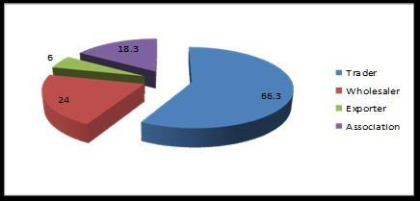

However, when asked about the reasons behind their preference of a particular marketing channel, the vast majority of farmers, besides the land size or the geographic location, cited getting the best price and save time and labor.

***Marketing-related problems***

Most small growers reported that they have no problems when asked about marketing which indicates lacking the necessary information about the various and more profitable marketing channels. The farmers who reported facing problems, cited absence of marketing services, lack of access to information and long distance to markets which increase transportation cost (27.4%, 21.4% and 17.7% respectively).

Figure 64: Marketing related problems

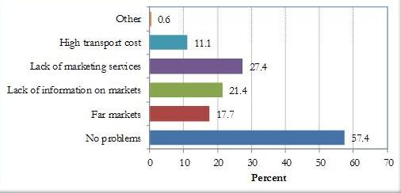

***Gender & marketing***

A major challenge in market development is to ensure stable distribution of gains. Women historically been excluded from gaining higher shares in value chain. Our analysis shows that women are disadvantaged in the value chain as one two thirds of women farmers cited lack of access to market information and absence of market services as their main problems. One approach for adding value to products and to ensure that women benefit financially involves assisting them to become crop specialist while maintaining a clear market orientation. Women may need to improve their production skills, and they may need training on farm management skills, to produce for export market is far more demanding than to produce for local markets; it takes years to develop needed skills. Another value adding strategy involves helping farmers to move into processing and marketing to add value to the product. This strategy also provides opportunities for landless women to enter value by offering processing and marketing services to local farmers.

### 5.2 Traders

The relationship between farmers and traders can be described as old and strong tie built on mutual trust and respect. As we mentioned earlier traders represent the most preferred marketing channel for small farmers. For the farmers traders are the most trusted, easy to reach and offer fair prices. In Egypt, the relationship between the small farmer and the traders does not end at selling the produce. Traders also help farmers when they encounter any financial crisis.

During the cultivation process, the trader may provide the farmer with agricultural inputs such as seeds, fertilizers, pesticides, and labors. In some cases, the trader covers all production costs and repaid by the farmers by harvesting. Farmers, on the other hand, sell the cultivated crop to the specific trader he deals with.

***Types of traders***

There are different types of traders with specific connection to the farmer. 1) The **“farm- gate trader**” usually the small trader who has strong ties with the farmer and deals directly with him in purchasing the crop; 2) the **intermediary (agent)** who is located in the small markets in the center of the governorates. He usually finances the crop and collects the crop from a number of small traders. 3) The large trader who control the market i.e. determines the prices of produce, usually operates in big markets (e.g. Al-Obour marker) located in metropolitan areas such as Cairo and Alexandria. They are the main distributers for the retailers, suppliers, and food processing factories; 4) the small exporter who buys the products from a wholesale market and exports the crop to the Arab and/or African countries.

***Gender of traders***

Gender segregation appears in the trading level. Women are only found among small retailers. When asked about the absence of women among traders, our respondent explained that the nature of the trading work requires a lot of travelling and long working hours which does not suit women and might negatively affect her domestic responsibilities.

**Problems & challenges**

When asked about the problems they encounter in their work, the traders cited the fragmentation of cultivated land among small farmers which proved to be tiring and costly to collect the crop.

For many traders paying in advance for the crop pauses a problem; as they might end up with a small quantity of the product which will not be exported. In other cases, any damage happens to the crop due to natural circumstances, the traders will have to wait for the following season to collect the crop, which indeed disrupts his investments. Finally, some traders mentioned infrastructural problems such as lack of packing houses, big refrigerator for storage, and high costs incurred in the transportation of produce by air, while using the land transports (Upper Egypt-Cairo) might affect the fresh products.

***Farmer/ trader relationship***

It is interesting to note that the trader plays an important role for the farmer as source of market information. The results of the baseline survey revealed that the vast majority of farmers (82%) cited traders as the favorable of market information. According to Figure (65), agriculture associations play a limited role in providing farmers with needed information (26.3%).

Figure 65: Source of Market Information

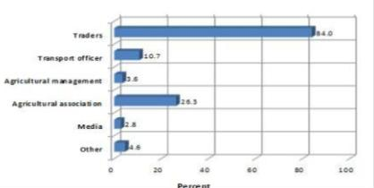

When considering the most trusted sources of information by governorate, the results presented in Figure (66) reveal a significant relationship between geographic location and the type of the information source. It is clear that in the Southern governorates traders played an important role in governance of the value chain as they are the main source of information for farmers. It is evident that the importance of the traders slightly decreased as we move north, where FAs seemed to play a greater role.

Figure 66: Market & prices source of information- by governorate

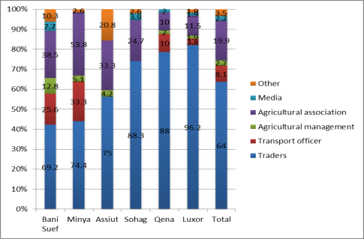

Our results further show that regardless of the land size, the trader play a leading role in the governance of the value chain through controlling information on markets and prices.

The results of the focus group discussions with male farmers in Qena confirm these findings. Almost all farmers reported that for those traders are the main source of market information and borrow money, and also play the input suppliers. The picture differs in Bani Suef where the FA (Gaafar) plays an important role in the production of the farmers. Most male farmers explained that they get information both from traders and FA. On the other hand female farmers advanced that the FA is the main source of market information for them.

### 5.3 Exporters

It is evident, as revealed in the literature, that the value of horticultural crop swill soon rival the value of traditional export crops; presently, the total value of horticultural crops represents 36% of total crop value. For example, the value of fruit and vegetables on the international market increased steadily, fromUS$9.2 billion in 1992 to US$15.5 billion in 2001, an increase of 6.8% per annum. In addition, the volume increased by only 4.8% per annum, from 813 million tons in 1992 to1.2 billion tons in 2001, which means that the unit price increased more rapidly than production. Export of fresh and processed horticultural products in Egypt have soared from $86 million in 2000 to more than $ 2.5 billion in 2009, but improved quality, traceability, and affordability of raw crops are needed for Egypt to sustain this incredible growth[27].

The data shown in Figure (67) below represents the total export volumes (in Tons) of the five main crops covered in the study. Obviously, potatoes and fresh onion are the largest horticultural export crops (following citrus crops that were not included in the study); Pomegranate is a promising export crop, however, it seems that expanding this crop production remains unexploited.

Figure 67: the Five Main Crops Export Volume in 2009

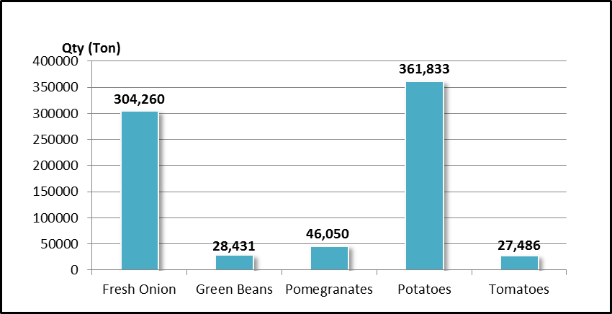

The table below presents the recent figure of the main importer countries of the five main crops export volume.

Table 16: Main Crops Export Volume in 2009(tons)

|  |  |  |  |  |  |
| --- | --- | --- | --- | --- | --- |
| **Crop**  **Countries** | **Fresh Onion** | **Green Beans** | **Pomegranates** | **Potatoes** | **Tomatoes** |
| **Belgium** |  | 3614.3906 |  |  |  |
| **England** |  | 5917.5295 |  |  | 652.955 |
| **Germany** |  | 2446.3263 |  | 46925.19 |  |
| **Greece** |  |  |  | 70373.005 |  |
| **Italy** |  | 7025.252 |  | 39846.05 |  |
| **Jordan** | 13457.195 |  |  |  |  |
| **Kuwait** | 27557.664 |  | 3916.01 |  |  |
| **Lebanon** |  |  |  | 47656.35 |  |
| **Netherlands** |  | 2365.4365 |  |  | 2116.2772 |
| **Russia** | 19332.1655 |  | 15069.2201 | 78805.385 |  |
| **Saudi Arabia** | 157893.087 |  | 6114.937 |  | 4491.0946 |
| **Syria** | 23368.745 |  | 7498.619 |  | 17896.155 |
| **Tunisia** |  |  |  |  | 960.9 |
| **Ukraine** |  |  | 2212.413 |  |  |

**Source: Union of Producers and Exporters of Horticultural Crops (UPEHC)**

**The Egyptian Center for vegetables & fruits**

Established in 2000, in el Obour Area, and certified by ISO 9001, Euro gap, and HACCEP & BRC. The Egyptian Center for vegetables & fruits is a leading company in exporting dates and oranges. The center has its own farms, factories and a number packing houses for citrus. It also exports various kinds of fruits, vegetables, herbs and spices. The Center serves as a supplier for many big companies and chain stores such as NTUC, METRO, and CARREFOUR (Far East).The center’s main clients are mainly medium and lager farmers coming from different parts in Egypt, especially Upper Egypt governorates such as Qena, Luxor, Minya, Bani Suef, and Assiut.

The interview was conducted with a representative from the exporting company. When asked about the labor employed by the company, our respondents explained that despite the fact that no differences in the quality of the products produced by female or male workers, the wages of male workers are much higher than that of their female counterparts (10-20% less than male worker wage). Currently, the total number of workers is 100 out whom 60% are females. Female workers are concentrated in the packing activities. The monthly average wage of the worker range between in 600 to 800 EGP. Capacity building and on-job training is reserved to the administrative employees.

As for **marketing and outputs prices**, our respondent advanced that it is determined by the clients. Moreover, as the respondent explained, changes in price indicator is unpredictable; “for example the average price for some products over the last 3 years was as follows; for Green beans (1600-1200 EGP/ Ton), Onion (1400 EGP/ton), and garlic (2000-4000 EGP/ton)”.

Regarding the main challenges that affect **food quality and safety,** especially in Upper Egypt, our respondent cited bad harvesting and post-harvesting systems due to lack of technology usage. In addition to lack of the quality standards and control systems in Upper-Egypt applied in Upper Egypt either among farmers such as Global Gap, or PHCs such as ISO 22000 and BRC standards.

**Horticulture investment in Upper Egypt**, Our exporter explained that although Upper Egypt governorates are known for their large variety and availability of horticulture crops, there are many pressing problems that hinder production for export. These problems related to the insufficient infrastructure, lack of communication with the associations, and the lack of commitment from their part. It is interesting to note that farmers, during the in depth interviews, described their relationship with exporters as problematic. Some of the farmers had problems with exporters, as they wouldn’t take the crop which cost them a lot.

The exporter interviewed put forward some suggestions to overcome the difficulties mentioned:

* Establishing experienced entities in marketing in general and exporting in particular in Upper Egypt,
* Giving the needed attention to infrastructural issues including refrigerated transportation (trains in addition to vehicles)
* Providing trainings to farmers on the agriculture good practices, quality standards, and the pesticides remains analysis.
  1. . Food processors

Available literature indicates that processing industry for horticulture produce is growing rapidly in Egypt. There are growing number of large and medium companies engaged in freezing vegetables, producing fruit and vegetable juice, and many companies engaged in processing herbs and spices. For the interview the **Food Manufactures: Paste & Juice** was selected. The company was established in 1995, on 11,500 square meters in the Fourth Industrial Area- Sadat City in Monufeya Governorate. P&J is one of the biggest food processing companies in Egypt, operating under the principle of the Hazard Analysis Critical Control Point (HACCP) System and Good Manufacturing Practices GMP. The company is specialized in tomatoes and fruits grains’ solutions and juices with a production force of 200 tons per day.

When asked about the source of inputs, our respondent reported that the company buys the produce from traders, farmers, associations, and through contracted suppliers (mainly men) from different governorates, including Upper Egypt. With regard to employment, workers, according to our respondent, have to be well trained workers on food safety systems good practice, and post-harvesting activity including storage and maintains operations.

When asked about the problems encountered by the company, the respondent cited the crop low quality, insufficient quantities, remains of pesticides, unfavorable varieties, and being distant from farms as the main challenges confronting the management.

In this context, the company applies a quality control system where the crops, especially imported in large amounts from farmers, are being examined on different scales such as color, acidity, concentration, and viscosity degree to assure the **food quality and safety**; as for the PHCs, they must be certified by ISO 22000 and BRC standards.

Paste & Juice Co. has many **experiences in Upper Egypt** where the production resources are available. In Upper Egypt, the company prefers dealing with associations and institutions rather than farmers and traders due to their lack of commitment concerning the amount of imported crops. As for the PHCs in Upper Egypt, the company has very limited information on their activities.

Our respondent put forward some suggestion to improve the work of the associations including the need for training on the post-harvest, contract operations and in adjusting the importing operations. The **main problems** facing the horticulture sector in Upper Egypt, according to him, have to do with the lack of technical experts, technology, quality of the crops, and failure of meeting the manufacturing needs, transportation, and the pesticides remains’ problem.

* 1. . Supermarkets (Hypermarket**)**

**Hyper One Market** is an Egyptian hypermarket located in Sheikh Zayed City in Cairo. It was founded in 2005 with an initial investment of around EGP 200 million. The Supermarket employs more than 1500 employees, occupying over 40,000 square meters (50% selling area), attracting daily visitors of around 65,000 in summer and 35,000 in winter.

According to the GM, The supermarket has sourced vegetables from small farmers in Upper Egypt. The main crops purchased are potatoes, onion, and cucumber with average quantity of 10-15 tons. However, as he explained “reaching an agreement on the **price and quality** of the produce is always a problem which could be resolved if there exists a non-profit organization representing small farmers and would be responsible of supplying the supermarket with the fruits and vegetables according to the standards agreed upon”.

When asked about **workers**, the GM reported that they must be trained on how to satisfy the required quality standards set by the Supermarket, which include crop handling and packaging. This also applies to the associations and PHCs which must have food safety systems such as ISO 22000 and BRC standards.

Although the Hypermarket does not deal currently with any associations, the GM felt that a relationship could be established if an association has the capacity to supply the supermarket with needed volumes at a reasonable price and satisfy the required standards. He further explained that the existence of non-profit entities which act as a link between small farmers and supermarkets in the chain is crucial to avoid many technical and legal issues, and to guarantee adequate post-harvest operations.

As for the challenges facing the **horticulture sector,** the respondent argued that the lack of a master plan for agricultural investment is the main barrier to the development of this sector in Upper-Egypt. In addition, the insufficient incentives for investors, lack of training services, especially for labors, and identified investment zones are factors that hinder investors to work in Upper-Egypt.

### Agribusiness Investment

Despite the benefits mentioned in the literature on the agribusiness sector in Egypt there are still many challenges facing private investors in this important sector. Agribusiness accounts for nearly 21% of Egypt’s total industrial production and is currently worth an estimated US$ 4.7 billion. Experts believe that the sector possesses striking potential for growth thanks to favorable growing conditions, proximity to key global markets including Europe, and an extremely advantageous agricultural calendar that positions Egypt to deliver valuable produce to Europe well before competing markets (GAFI 2010).

On the one hand, the various reforms in the economic and investment policies carried out by the Ministry of Trade and Industry (MTI) in opening the economy facilitated foreign direct investment and private business ventures. Furthermore, the Ministry of Agriculture, together with the Ministry of Trade and Industry, has made expanding agricultural exports a top priority. The government also claimed to be committed to improving quality standards in the agribusiness industry.

Without a strong pro-poor orientation however, such efforts will continue to fail in incorporating small farmers and the rural poor. One aspect that is of vital importance to propelling equitable growth is the governance of the value chain. For example, our investigation clearly shows that contract enforcement is one dimension that needs urgent attention. There are complaints from different actors (buyers and producers alike) that contracts are not always honored by the involved parties e.g. farmers and exporters, especially in the case of large price fluctuations. Thus, there is a dire need to develop measures and new institutional arrangements (possibly including innovative pricing mechanisms) to settle disputes between small farmers and exporters/private investors and enforce contracts.

Furthermore, it is of utmost importance to introduce legislative changes to activate agricultural cooperatives and other collective entrepreneurial forms for small farmers. By collectively organizing in larger bodies small farmers can overcome the setbacks of scale economies and be in a better position to obtain inputs at adequate prices and quality, negotiate better selling arrangements and prices with buyers, be better able to market their produce, and acquire a more significant role in the governance of the value chain.

Creating a business enabling environment goes beyond legislation. In Egypt, the lack of a master plan for agricultural investment, the insufficient incentives for investors, lack of extension and training services, insufficient infrastructure, lack of market information, and unidentified investment zones are among the factors that hinder investors from working in the horticulture sector in Upper-Egypt.

Despite all these challenges all private investor respondents (the exporter, manufacturer and supermarket) expressed their willingness to work with farmers in Upper Egypt provided that that they receive the required training on the administrative and marketing aspects in order to better understand the nature of their work. In addition, the training workshops should include both the clients and the farmers to discuss the mutual interests of all parties.

# Conclusions & Recommendations

Recently, there has been a wide agreement that “in many developing countries, the agricultural sector’s performance determines overall economic growth, trade expansion and increased income-earning opportunities” (USAID 2004). Special attention is directed to the production of horticultural crops as it represents a particularly promising opportunity for income generation and food production in developing countries. Moreover, horticulture offers several advantages for poverty reduction strategies. It is a labor intensive sector, and generates relatively high incomes per hectare of land in use.

The current report presents the findings of the baseline investigation of horticulture value chain in Upper Egypt which was carried out during the period between October and December 2010. The overall objective of the investigation is to provide baseline information and sound knowledge about small farmers’ situation in Upper Egypt and the existing challenges and opportunities. Furthermore, the results of the baseline study will serve as a tool to trace and measure changes and consequently assess the impact of future interventions.

According to the Terms of Reference (TOR, the main objectives of the baseline investigation are:

1. Review available information and existing research with regard to horticulture value chain in Upper Egypt including relevant legislation and governorate development policies.
2. Conduct a comprehensive gap assessment of the local Farmers Associations and PHCs and identify 3 FACs and 3 PHCs to receive capacity development
3. Collect information in the field and conduct complementary assessments and analyses
4. Conduct Women Needs Assessment as farmers and workers

To address the broad set of goals that the baseline investigation study was set to cover entailed conducting four research studies and also to combine qualitative and quantitative methodologies. These include: a Farmers and workers baseline survey, institutional capacity assessment for FAs and PHCs, and in-depth investigations which cover a number of actors along the horticulture value chain including inputs suppliers, traders, a food processor, an exporter and a supermarket.

In addition, four interviews were conducted with officials from the Ministry of Agriculture in order to investigate their views regarding the Ministry’s strategies, the services provided to small farmers, challenges the Ministry encounters, and its future plans.

The section begins with a summary of key findings of the four research studies conducted under the baseline investigation, followed by the main recommendations of the investigation.

## Summary of key findings

### Socioeconomic conditions

Around 35% of the farmers were illiterates, which is slightly higher than the illiteracy rate at the national level of 34.4%. The data further revealed a clear difference between women and men’s level of education. Almost all women farmers in our sample are illiterate. When it comes to workers, illiteracy is more widespread (55%).The remaining had received some formal education. A small percentage had obtained an educational certificate; primary/preparatory (19%). It is interesting to note that 14% of respondents reported that they had obtained a diploma.

The majority of farmers in our sample (60.6%) operate farms between 1-5 feddans, followed by those who operated farms of less than 1 feddan accounts for 32.3%. Farmers who own 5- 10 feddans did not exceed 3.6%.

Poverty is widespread among both workers and farmers alike. Among agricultural workers, 85% are poor or very poor (47.5% of the workers’ households fell within the poor category, and 37.4% fell within the very poor category). With regard to farmers’ households, 70% of the households were either poor or very poor (slightly higher than half the sample fell within the poor category and 15.7% fell within the very poor category).

According to survey results, farmers’ average monthly household income in our sample was LE 1323/month. The highest average monthly income from work is found in Qena followed by Luxor (LE 1071 and 932 respectively, while the lowest is found in Bani Suef (LE 787). Our results revealed that workers’ household average monthly income is LE 795.5. It is interesting to note that this is higher than the average monthly income of the farmer in Bani Suef.

### Agricultural production

The survey revealed that the top five crops cultivated by the vast majority of our farmers sample are tomatoes, potatoes, onions, pomegranates, and green beans. Other crops (melons and grapes) are high-value cash crops that can have positive impact on farmers’ and workers’ incomes. Targeting these crops or some of them by the project will serve to enhance its impact on small farmers and workers.

In general, like most agricultural sub-sectors, horticulture suffered from a number of challenges. Small farmers also encounter problems in their production and marketing. As the findings of the baseline investigation revealed, the main constraints are related to:

**Quality of products:** Our study showed that there is significant room for improvement in the quality of crops, especially tomatoes and pomegranates. The average percentages of first grade tomatoes and pomegranates produced by farmers in our sample were 65.5% and 57.5% respectively. The percentage of second grade tomatoes and pomegranates were 24.2% and 28% respectively, with the proportion of third grade produce being 17% for tomatoes and 23% for pomegranates. It is anticipated that with proper extension services and training significant improvements can be made to product quality and hence farmers’ income.

**Fertilization:** there is a focus on the nitrogen fertilization at the expense of Potassium, which indicates: 1) less productivity, 2) short shelf-life of the final product and post-harvest-losses, 3) low eating quality specifications, 4) negative effects on soil and environment 5) excessive unnecessary costs due to leaching from the soil. In general this reflects the need for extension services on fertilization.

**Pest control:** The cost of pest control seems to be high in the case of pomegranates due to excessive usage of pesticides. This explains the high level of rejections for this crop in the export markets. Thus this indicated an urgent need to design and implement integrated pest management programs with focus on pomegranates.

**Irrigation:** Flood irrigation is predominant method of irrigation (92%), only a tiny percentage of farmers reported utilizing the drip irrigation. Drip irrigation can improve the productivity and quality of farmers’ crops. In addition, with the growing water shortage Egypt is witnessing, there is a need to move away from wasteful irrigation methods towards methods that utilize water more efficiently.

**The lack of technical supervision by agricultural engineers** confirms the need for providing cost effective extension services to the small scale farmers that could be efficiently managed by the farmer associations. All farmers expressed the need for technical supervision by extension experts, establishing demo plots and training on cultivation under tunnels and greenhouses.

**Training**: When asked about preferred timing and location of the training, almost all respondents cited the morning periods, during the winter season (October to December). They also reported that they prefer the training to combine both theoretical and practical aspects.

**Supplies & inputs:** Problems with high cost, unavailability and low quality of supplies can be tackled through active involvement of the farmer’s associations by collective purchase of input supplies from trustable sources, thus assuring the quality and reducing the final cost to the small farmers. Our in-depth investigation demonstrated that farmers often complained of the low-quality seeds and seedlings they utilize. When asked how productivity can be improved, all participants agreed that the quality seeds/seedlings and adopting modern crop production practices are the main factors.

**Labor wages:** From the farmers’ perspective, although the daily cost of labor is high, labor efficiency is low at all levels. Labor training is almost nonexistent. Training to raise labor productivity would reduce the labor cost per unit. In addition, well-managed and scientifically-based extension services would increase production and productivity. Bothe measures would serve to increase the farmers’ income, and consequently, that of workers as well.

**Poor harvesting, post-harvest management/quality control**, sorting, packaging and transportation are not done in a proper manner, which resulted in high incidence of post-harvest losses, especially for the perishable commodities. The lack of assurance of quality has led producers contending with very poor prices.

**Limited access to information**, which was cited by almost all farmers, relating to production and inputs supply.

**Poor Infrastructure** which needs to be improved to effectively support the horticultural sector growth and expansion, such as roads, transportation, cold storage areas in airports and efficient PHCs.

**Lack of access to adequately priced finance/credit** constitutes an important problem for small farmers.

**Inefficient judicial system**: Because the Egyptian judicial system functions extremely slowly and inefficient, it is difficult for smallholders to file court cases of any sort. This situation is responsible for the lack of trust in written contracts, as any party can pull out as they choose.

**Gender:** The horticultural sub-sector is a major employer of women, as they participate from production (generally hired on a seasonal basis) all the way of processing and marketing. However, because of their perceived “nimble fingers” needed to handle more delicate work and being consistently working for low wages, female employment is usually concentrated in labor-intensive activities, where both dexterity and labor costs are significant factors. A rigid gender division of labor seems to exist in the horticulture. Women farmers and workers perform specific tasks and activities in production and harvesting processes.

**Regional variations:** The study shows that southern Upper Egyptian governorates lag behind northern ones in almost every aspect of the production and post-production process.

**Variations by size of landholding:** Similarly smaller farmers appear to be significantly more disadvantaged compared to larger ones in most aspects of production and post-production.

### Institutional capacity assessment

* Most of the farmers associations fall under the “Developing Stage” of development; as board members do not play a leadership role, most decisions taken by Board and Executive, and leadership still seen primarily as controlling people to do right through a system of rewards and punishments.
* For those with staff members, no assessment of performance conducted and therefore no planning done and carried out to change or improve the performance of individuals. In addition, informal ways exist for getting things done but they are not yet formalized by documentation.
* Regarding financial management, basic financial recording systems and informal accounting manuals are in place. However, independent audits or external financial reviews are rarely performed.
* Outreach to community members improving, but primarily on ad hoc basis. Furthermore, although they are known in their own communities, the associations do little to promote their activities with the general public. In the same context, very little communication among associations is taking place.
* As for the PHCs their infrastructure is good but there is a need for developments, maintenance and some constructions that are yet to be completed so as to meet requirements of international standards and customers.
* For the PHCs, in addition to infrastructural needs to improve the work, the quality and food safety systems should be applied to be able to deal with global and local markets. Also, these PHCs need a good marketing department to be able to open new markets. They also need a well-trained professional team to increase efficiency and skills of other workers in these PHCs. More specifically the PHCs need:
* Quality and food safety Management systems
* Source of potable water (Qena)
* Administrative building (Qena)
* Site boundaries.
* Pre cooling unit.
* Air conditioning for the Packing hall.
* Measuring equipments
* Electric Clarks and fork lifts
* Dock levelers maintenance (Minya)
* workers lockers (Minya)
* Production lines for different crops.

A more detailed analysis of the PHCs against BRC standards provides a useful guide for measures to be undertaken to upgrade the PHCs (see section 4.2).

### Marketing & market Channels

* Lack of market information represents a significant impediment to market access especially for small farmers: it substantially increases transaction costs and reduces market efficiency. For any crop, the marketing chain consists of multiple middlemen, each taking a margin at every stage of the chain, and price variations in space and time are often large and erratic.
* Despite the fact that Upper Egypt is a promising region for the production and exporting of high value horticultural products based on its favorable agro-climatic conditions and counter-seasonal production capabilities, there still are several challenges – faced by exporters– to capitalize on these advantages. The unpredictable variance in crop price comes on top of these challenges. Inadequate infrastructure, lack of the quality standards and control systems applied either among farmers or in PHCs, lack of communication with farmer associations represent another main challenge.
* Food processing companies need to secure their raw material supplies. This, in turn, creates new market opportunities for farmers and business opportunities for traders. Food processing companies more likely to work in an area where technical support and efficient extension services are being provided to farmers, as this could improve their chances of success. Consequently, given the current deficiency of agricultural extension services, food processors operate distantly from Upper Egypt, adding another challenge to those related to crop quality, variety, and quantity.
* For supermarkets, sourcing horticulture crops from Upper Egypt is an advantage to secure continuous supplies all over the year. However, agreeing on the crop specifications (quality) and price remains the main problem in dealing with farmers/traders. Contracting farmer associations and providing proper technical training for workers engaging in crop handling can be a practical solution for this problem.
* In general, the lack of a master plan for agricultural investment, the insufficient incentives for investors, lack of extension training services, insufficient infrastructure, lack of market information, and unidentified investment zones are factors that hinder investors to work in the horticulture sector in Upper-Egypt.
* All the actors interviewed; exporter, manufacturer and supermarket expressed their willingness to work with farmers in Upper Egypt farmers provided that that they receive the required training on the administrative and marketing aspects in order to understand the nature of the work.

### Relationship between farmers and actors along the Chain

Throughout the horticulture value chain the study investigated the relationship between small famers and other actors along the chain. Our findings revealed:

* With regard to **input suppliers,** it seems that small farmers do not have great trust in them. Farmers cannot overcome key constraints in dealing with inputs suppliers particularly high costs and low quality of inputs. Thus, farmers, especially women, prefer dealing indirectly with suppliers, through the FAs which guarantee the availability of inputs, nevertheless, tolerable methods of payment.
* **Farmers Association**: it is evident that FAs are very beneficial to small male and female farmers especially if the FA is active. In addition to the variety of services that the FA provides to its members, women farmers experienced higher degree of independence in work-related decision making and have some control over their farms proceeds. It is clear that the role the FA led to greater empowerment for women small farmers
* **PHCs** deal with all farmers in Upper Egypt according to some required qualifications related to their produce and delivery time. Yet, PHCs prefer to deal mainly with female farmers than their men counterparts in terms of better quality produce.
* **Traders** are for the small farmer the main source of market information, income and the main channel to overcome farm or non-farm financial challenges.

## 2. Recommendations

***Farmer Associations & PHCs***

Our assessment revealed that the following FAs constitute the best option for the project:

* + **Associations having PHCs**
    - Bani Solaiman El-Sharq
    - Agricultural Community Development Association, “El-Bayaho”
    - Upper Egypt Future for Agricultural Community Development , “Dandara”
  + **Associations with sound institutional capacities**
    - Agricultural Community Development Association, “Awlad Yehia”
    - Community Development Association, “Gaafar”
  + **A potential Association with reasonable institutional capacities**
    - Association for the Development of Farmers Community in El Tood

Our assessment suggests the following recommendations for FAs and PHCs:

* Conduct a comprehensive capacity building program for farmers associations according to their needs to include:
  + Training on NGOs Governance;
  + Technical assistance on how to develop a policies and procedures manual;
  + Training followed by technical assistance on participatory needs assessment (PNA);
  + Training on project design;
  + Training on proposal writing;
  + Training followed by technical assistance on staff development planning;
  + Technical assistance for developing the strategic plan;
  + Financial management, planning and resource development;
* Establish Marketing department
  + Assign adequate staff;
  + Provide tailored training to staff on horticulture marketing;
* Establish an agriculture extension department
  + Assign adequate staff;
  + Provide tailored technical training to staff on all agricultural practices of horticulture crops (potato, tomato, onion, bean, and pomegranate) including post-harvest;
* Establish legal department to provide legal support on contracting
  + Assign adequate staff;
  + Provide tailored training to staff on legal formulation and negotiation;

***Farmers***

1. Develop and deliver a scientifically-based integrated training and extension program covering all stages of agricultural production, harvesting and post-harvesting processes, with specific attention to the seven crops identified in the study (potatoes, tomatoes, pomegranates, green beans, onions, grapes and melons). It is anticipated that with proper extension services and training significant improvements can be made to productivity and product quality and hence the incomes of workers and farmers.

* This intervention would be of a more intensive nature in the case of the southern governorates of Upper Egypt.
* The extension and training programs can be located in the FAs where model extension departments can be established.
* Training would best be conducted in the morning during the winter season (October to December), and should combine both theoretical and practical aspects.
* The program can rely on farmer field schools[28], model/pilot farms and farmer-to-farmer visits.
* In designing training programs the programme should bear in mind the high illiteracy rates among farmers and workers, especially women.
* In designing its extension and training programs, the programme should take into consideration that smaller farmers and those in southern Upper Egyptian governorates are more disadvantaged, and are thus in need of a more concerted effort.

1. Problems with high cost, unavailability and low quality of supplies can be tackled through active involvement of the farmer’s associations by collective purchase of input supplies from trustworthy sources, thus assuring the quality and reducing the final cost to the small farmers. More emphasis should be placed on providing farmers with adequate and locally adapted seeds and high quality varieties of horticultural crops fitting local and foreign markets requirements.
2. The programme may consider facilitating the implementation of a small pilot drip irrigation initiative in a pilot farm. Luxor, where one-third of the respondents complained from water shortages, can be a site for this drip irrigation pilot. Further investigation however may need to be undertaken in partnership with the small farmers in order to select sites for pilot farms.
3. Conducting joint orientation/training sessions with exporters, input suppliers, traders, food processors, super markets…etc. in order to:
   1. Acquaint small farmers with the needs and concerns of buyers.
   2. Acquaint small farmers with the proper methods of utilization of the various inputs.
   3. Inform buyers and suppliers with the concerns of small Upper Egyptian farmers.
   4. Facilitate agreement of issues of mutual concern and thus improve the governance of the horticulture value chain in Upper Egypt.

***Marketing***

Horticulture production and marketing may contribute to food security and poverty reduction for the vulnerable households. However, horticultural production requires a skilled labor force, production inputs, and functioning and competitive market. The following are measures needed to improve horticultural production and marketing in Upper Egypt.

1. Improve the market information delivery and dissemination by developing a user-friendly marketing information system and packaging collected information into extension messages on economic returns, where to sell and quality control. Availing such information through channels other than the buyers would enable small farmers to participate more effectively and equitably in the governance of the supply chain.
2. Broker partnerships with buyers (food processors, exporters and/or supermarket chains) by virtue of which crops are delivered through the FAs at the agreed upon quantity and quality with a fair price. Long-term contracts and pricing arrangements can be made to partially offset the effects of severe positive or negative price fluctuations.
3. Providing training and orientation sessions to farmers on marketing of horticulture products and quality standards of different buyers. These sessions can be attended by buyers’ representatives to discuss mutual interests between buyers and farmers.

***Policy measures***

1. ‏Government should play a stricter supervisory role in the input supply system in a way to provide farmers with the right inputs with adequate quantities and quality in a timely manner.
2. ‏Establish an arbitration system for settling disputes between farmer associations and exporters, as well as other buyers.
3. To promote and strengthen confidence building between the parties and also help solve any dispute arising out of violation of contract, an institutional arrangement should be established to record all contractual arrangements.
4. Develop a tax incentive package that encourages businesses to invest in cold chains for horticultural produce in Upper Egypt
5. Reconsider the application of the 15% export subsidies given to exporters. As currently applied, exports subsidies do not benefit producers/farmers and are sometimes utilized by some exporters in monopolistic practices that cause market distortions and harms food processors.
6. Revise the law governing cooperatives in order to allow them more autonomy and enable them to play their role in purchasing and distributing inputs and, production, as well as marketing for small farmers.

**References Cited**

* <http://www.acdivoca.org/site/Lookup/NewsReleaseEgyptMay1810Conference/$file/NewsReleaseEgyptMay1810Conference.pdf>
* EHDR 2005 & 2008

<http://planipolis.iiep.unesco.org/upload/Egypt/Egypt_HDR%202005_en.pdf>

<http://planipolis.iiep.unesco.org/upload/Egypt/Egypt_nhdr_en2008.pdf>

* FAO, “Fertilizer use by crop in Egypt”, 2005.

<ftp://ftp.fao.org/agl/agll/docs/fertuseegypt.pdf>

* <http://www.fao.org/gender/landrights/report/?country=EG>
* Hoodfar, H. (1997) *between Marriage and the Market,* University of California Press, London.
* International Human Development Indicators- Egypt 2010.

<http://hdrstats.undp.org/en/countries/profiles/EGY.html>

* Joekes, S. (1999) Bringing Gender Analysis into the Value Chain Approach, IDS mimeo
* Ministry of Agriculture and Land Reclamation, Sustainable Agricultural Development Strategy towards 2030, December 2009.

<http://idc.sci.eg/PDF_files/SUSTAINABLE%20AGRICUlrURAL%20DEVELOPMENT%20STRATEGY%202030/Strategic%20Objectives.pdf>

* The World Bank- Arab Republic of Egypt, 2009

<http://data.worldbank.org/country/Egypt-arab-republic>

* UNDP, Project Document: “Pro-Poor Horticulture Value Chains In Upper Egypt”, 2009
* UNIDO, E-Trace, Survey Report on Farmers' Associations in Selected Governorates in Upper Egypt. March, 2009

<http://www.google.com.eg/#hl=en&biw=1280&bih=897&q=UNIDO%2C+E-Trace%2C+Survey+Report+on+Farmers%27+Associations+in+Selected+Governorates+in+Upper+Egypt.+March%2C+2009&aq=&aqi=&aql=&oq=&fp=1d3eac32717ae2cf>

* UNIDO, MDG Achievement Fund (MDG_F), “Pro-Poor Horticulture Value Chains In Upper Egypt”, Data Collection Report, August 2010
* USAID, Audit of USAID/ Egypt’s Agricultural Exports and Rural Income Project (Feb. 2007)

<http://www.usaid.gov/oig/public/fy07rpts/6-263-07-001-p.pdf>

* USAID, Horticulture Export Improvement Association (HEIA) - Final evaluation 2005

<http://www.oecd.org/dataoecd/9/58/35894037.pdf>

# Appendices

**Appendix A: Results Framework indicators & baseline findings**

|  |  |
| --- | --- |
| UNDAF Outcome: : “By 2011, regional human development disparities are reduced, including reducing the gender gap, and environmental sustainability improved” | |
| Outcome 1: Small farmers and agricultural workers are more equitably integrated into domestic and international value/supply chains of horticultural products through enhanced efficiency, productivity and viable business partnerships with private sector investors.   * **Baseline study to be conducted for the entire programme as part of the inception phase** * Number of farmers reporting increased incomes (1000 farmers increase their income by at least 30%). * Percentage increase in average wages of trained agricultural workers. * Percentage increase in average wage of trained agricultural women workers. * Percentage increase in incomes of small farmers * No. of existing and renewed contracts between farmers and private investors * Reduced loss in horticultural products by 50%. | |
| **Indicators** | **Baseline Study Results** |
|
| 1. **More than 75% of crops purchased by high quality markets (export markets, major retailers, touristic establishments).**   *% of crops purchased at high value markets* | Only 7% of crops production purchased by exporters. |
| 1. **300 agribusiness workers (including 75% women) trained in harvesting and post-harvesting operations.**   *No. of male and female workers acquiring new skills* | Only 3 workers (2 are female workers) received training on harvesting. |
| 1. **150 trained agribusiness workers (including 75% women) gainfully employed by PHCs.**   *No. of trained workers employed by PHCs.* | Total 300 workers are currently employed by PHCs, the vast majority only receive basic on-the-job training. |
| 1. **PHCs equipped and sustainability plans implemented.**   *Equipment installed in PHCs – Cost recovery ratio for PHCs* | PHCs hardly operate, due to the inadequacy of some equipment, the difficulty to reach exporters and other clients, and the lack of technical assistance in quality and food safety to reach compliance with quality and food safety international standards (BRC, ISO 22000, HACCP, etc.). |
| 1. **PHCs systems and capacity upgraded to meet international standards**   *PHCs system and capacity upgraded* | There are no quality or food safety management systems in place in the three PHCs. |
| 1. **FAs capacity enhanced to sustainably deliver services to their members.**  * *No. of Services provided to members* | *They provide: Marketing Services, Technical Support, and Information on the Horticulture sector* |
| * *No. of recipients of each service* | *Marketing Services: 145 farmer*  *Technical Support: 177 farmer*  *Information on the Horticulture sector: 131 farmer* |
| * *Client satisfaction* | * + *Slightly less than half the sample of small farmers (167 farmers) reported that they were not satisfied with the services offered.* |
| * *At least 1000 farmers and agribusinesses improve their business practices* |  |
| * *Progress of cost recovery of services* |  |
| 1. **Partnerships between private investors, small firms and FAs established**   *- Number of existing and renewed contracts* | - currently no contracts with private investors (during baseline study) |

|  |  |
| --- | --- |
| UNDAF Outcome: : “By 2011, regional human development disparities are reduced, including reducing the gender gap, and environmental sustainability improved” | |
| Outcome 2: Entrepreneurial forms of organization established by small farmers.   * Number of entrepreneurial organizations established by small farmers with assistance from the project. | |
| **Indicators** | **Baseline Study Results** |
|
| 1. **Feasibility and potential of incorporating farmers in collective entrepreneurial forms assessed.**   *Study conducted* |  |
| 1. **500 Farmers receive entrepreneurship training to enhance their entrepreneurial skills and awareness.**   *No. of farmers successfully passing training* |  |
| 1. **Willingness of farmers to incorporate into entrepreneurial forms increased.**   *Percentage of Farmer swilling to start establishing collective enterprise(s)* | 60% of the farmers sample are willing to start establishing collective enterprise(s) |
| 1. **At least one company established by small farmers.**   *No. of companies established* |  |

|  |  |
| --- | --- |
| UNDAF Outcome: “By 2011, regional human development disparities are reduced, including reducing the gender gap, and environmental sustainability improved” | |
| Outcome 3: Policy and regulatory changes to promote pro-poor private sector-based growth in Upper Egypt's horticultural sector identified and discussed with the GOE.   * Number and importance of identified policy and regulatory measures that are tackled by the GOE with assistance from the programme. | |
| **Indicators** | **Baseline Study Results** |
| 1. **Policy constraints to incorporating small farmers in value chains on equitable basis identified**   *No. and importance of identified policy and regulatory measures.* | In general, the lack of a policy focus on the productivity and competitiveness of small farmers.  **And more specifically:**   1. Government should play a stricter supervisory role in the input supply system in a way that provides farmers with the right inputs with adequate quantities and quality in a timely manner. 2. ‏Establish an arbitration system for settling disputes between farmer associations and exporters, as well as other buyers. 3. To promote and strengthen confidence building between the parties and also help solve any dispute arising out of violation of contract, an institutional arrangement should be established to record all contractual arrangements. 4. Develop a tax incentive package that encourages businesses to invest in cold chains for horticultural produce in Upper Egypt 5. Reconsider the application of the 15% export subsidies given to exporters. As currently applied, exports subsidies do not benefit producers/farmers and are sometimes utilized by some exporters in monopolistic practices that cause market distortions and harms food processors. 6. Revise the law governing cooperatives in order to allow them more autonomy and enable them to play their role in purchasing and distributing inputs and, production, as well as marketing for small farmers. |
| 1. **FAs' advocacy capacity and involvement in government dialogue strengthened**   *Frequency & effectiveness of FAs’ participation in the identification & discussion of policy & regulatory issues with* *GOE* | Only 3 associations (2 of which were selected by the project) out of the 17 assessed associations engaged in advocacy activities like raising the price of sugar cane crop and the dissemination of environmental agriculture. |
| 1. **Success stories and lessons learned promoted.**   *No. and significance of lessons learned compiled and presented* |  |
| 1. **Policy issues identified, disseminated and discussed with GOE**   *Number and importance of identified policy* *and regulatory measures that* *are tackled by the GOE with* *assistance from the programme.* |  |

1. The World Bank- Egypt, 2009
2. International Human Development Indicators- Egypt, 2010
3. EHDR 2005 & 2008
4. UNIDO, E-Trace, Survey Report on Farmers' Associations in Selected Governorates in Upper Egypt, March 2009
5. UNIDO, E-Trace, Data Collection Report, August 2010
6. UNIDO, E-Trace, Data Collection Report, August 2010
7. UNIDO, E-Trace, Data Collection Report, August 2010
8. FAO, “ Fertilizer use by crop in Egypt”, 2005
9. UNDP, Project Document: “Pro-Poor Horticulture Value Chains In Upper Egypt”, 2009.
10. UNIDO, E-Trace, Data Collection Report, August 2010
11. UNIDO, E-Trace, Data Collection Report, August 2010.
12. USAID, Audit of USAID/ Egypt’s Agricultural Exports and Rural Income Project (Feb. 2007)
13. USAID, Horticulture Export Improvement Association (HEIA)- Final evaluation 2005
14. Ministry of Agriculture and Land Reclamation, Sustainable Agricultural Development Strategy towards 2030, December 2009.
15. <http://www.fao.org/gender/landrights/report/?country=EG>
16. FAO, Project Document: “Fertilizer use by Crop in Egypt”, 2005
17. The data presented here is only for female workers; due to the small size of female workers sample gender comparison will not be useful.
18. Hoodfar, H. (1997) *between Marriage and the Market,* University of California Press, London.
19. UNIDO, E-Trace, Survey Report on Farmers' Associations in Selected Governorates in Upper Egypt. March, 2009
20. UNIDO, MDG Achievement Fund (MDG_F), “Pro-Poor Horticulture Value Chains In Upper Egypt”, Data Collection Report, August 2010
21. UNIDO, E-Trace, Survey Report on Farmers' Associations in Selected Governorates in Upper Egypt. March, 2009
22. UNIDO, E-Trace, Survey Report on Farmers' Associations in Selected Governorates in Upper Egypt. March, 2009
23. UNIDO, E-Trace, Survey Report on Farmers' Associations in Selected Governorates in Upper Egypt. March, 2009
24. UNIDO, E-Trace, Survey Report on Farmers' Associations in Selected Governorates in Upper Egypt. March, 2009
25. UNIDO, E-Trace, Survey Report on Farmers' Associations in Selected Governorates in Upper Egypt. March, 2009
26. MDG Achievement Fund, “Pro-Poor Horticulture Value Chains In Upper Egypt”, Post-harvest Centers Baseline Survey Report, June 2010.
27. <http://www.acdivoca.org/site/Lookup/NewsReleaseEgyptMay1810Conference/$file/NewsReleaseEgyptMay1810Conference.pdf>
28. Farmers Field School (FFS) are initially based on implementing a large-scale decentralized programme of education of farmers wherein they become “experts” in managing the ecology of their fields. The Egyptian experience with FFS was very successful, especially with female farmers, in a way that it moved beyond agriculture to health and reproductive issues, rights and literacy. In seven years, more than 2000 schools were carried out, 423 schools of which were organized for women farmers, and 83 for mixed groups. A total of 11,700 female farmers involved in the FFS program. Generally, the FFS resulted in increasing networking and lead to better co-operation among farmers. Women gained better skills in problem-solving and decision-making and became more aware of health and environmental issues. They also increased production of local crafts as an additional source of family income.